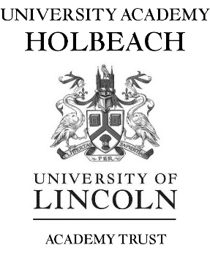

Principal: Sheila Paige B.A. (Hons.)

Teacher of Health and Social Care
January 2022 or ASAP

Full time MPS

University Academy Holbeach is seeking to appoint an enthusiastic, highly motivated and inspirational teacher to join our forward thinking Health and Social Care Department. This post is suitable for an experienced or newly qualified teacher wishing to join a team of specialists who ensure a high standard of teaching, learning and achievement.

Health and Social Care is a popular subject and we are proud to run a creative, vibrant and diverse department. You will have the opportunity to teach at KS4 with our BTEC L1/2 in Health and Social Care and KS5 with our Level 2 OCR National and Level 3 BTEC Health and Social Care qualifications

Interested candidates will have:
- QTS/QTLS
- The ability to teach Health and Social Care to KS4/KS5.
- The ability to plan and deliver high quality creative lessons.
- A willingness and enthusiasm to organise and run a range of extra-curricular activities.
- The ability to motivate and achieve excellent results.
- Excellent organisational skills and an appreciation of your subject.
- The ability to form positive working relationships with staff, pupils and employers.

University Academy Holbeach is an oversubscribed school in a rural location and serves the local community and the surrounding villages. The school site is equipped with state of the art facilities including teaching walls.

The school was recently rated as ‘Good’ by Ofsted (March 2019).

For an application pack or to discuss the post further please contact the school with your details
University Academy Holbeach
Park Road, Holbeach, Spalding, Lincs. PE12 7PU
Telephone 01406 423042 Fax 01406 426144
email: enquiries@uah.org.uk

University Academy Holbeach is committed to the safeguarding and welfare of children and young people. We expect all staff at the school to share this commitment. Child protection screening will apply.
Closing date: Wednesday October 13th 2021

