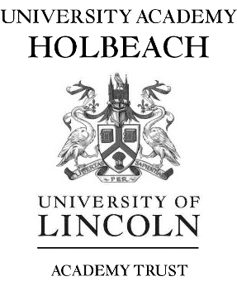

*Principal: Sheila Paige B.A. (Hons.)*

**Teacher of History**

**January 2024/Immediate Start**

University Academy Holbeach is seeking to appoint an enthusiastic, highly motivated and dynamic teacher to join our History department. This post is suitable for an experienced or early careers teacher (ECT) wishing to join a team of specialists who ensure a high standard of teaching, learning and achievement.

Interested candidates will have:

* QTS
* the ability to teach History to KS4 (there is the possibility to teach KS5)
* the ability to plan and deliver high quality lessons
* the ability to motivate and achieve excellent results
* excellent organisational skills
* the ability to form positive working relationships with staff and pupils
* the ability to work collaboratively

University Academy Holbeach is an oversubscribed school in a rural location and serves the local community and the surrounding villages. The Trust is committed to ensuring quality provision that raises the aspirations of young people in South Holland. Applications are welcomed from individuals who share and wish to contribute to our aims and vision.

The school was rated as ‘Good’ by Ofsted (March 2019).

For an application pack please visit the school website [www.universityacademyholbeach.org](http://www.universityacademyholbeach.org)

University Academy Holbeach is committed to the safeguarding and promoting the welfare of young people and expect all staff to share this commitment. All posts will be subject to an enhanced DBS disclosure, medical and reference checks. Applicants may be subject to an online presence check.

**Closing date: Monday 2nd October 2023**