

HIGH S
HASTINGS HIGH SCHOOL

Teacher of History & PSHE
Full time – Permanent
(or 0.6 FTE for one subject)
No Recruitment Agencies
Salary: Teacher MPS
Starting date: August, 2026
Application Deadline: May 25th, 2026 but applications will be reviewed as received so may close earlier.



🌐 www.hastings.school 📞 01455 239414 📍 St Catherine’s Close, Burbage, Leicestershire, LE10 2QE


LEARNING SUPPORT ASSISTANT
STARTING AUGUST 2018

HASTINGS HIGH SCHOOL
May 2026

Why join the Hastings Family?
At Hastings, we live by our motto: Care and Excellence for All.
We are a thriving, oversubscribed community school with a strong academic record and a reputation for nurturing ambition, responsibility, and self-development in every pupil.
- Ofsted: Judged “Good” with outstanding pupil behaviour and relationships.
- Academic success: Progress 8 consistently above average (+0.40 last year).
- Facilities: Multi-million investment in 2025, including 8 new classrooms, a sports hall, and redeveloped pastoral and dining areas.
- Community: A supportive, ambitious, and enriching environment for staff and pupils alike.

What We Offer You

Comprehensive induction programme – tailored support for ECTs and new staff.

Professional development – ongoing training, appraisal, and opportunities to grow.

Wellbeing focus – a culture of care and respect for staff.

Collaborative team spirit – work alongside talented, reflective practitioners.

Enriching curriculum – access to a wide range of resources, facilities, and extracurricular opportunities.

How to Apply
Please submit:
- Completed application form
- Letter of application (max 2 sides of A4, font size 11)

Send to: Mrs. Sarah Brown – HR Manager 📧 sarah.brown@hastings.school

Closing date: 9am, 25th May 2026

Interviews: As applications are received

(If you have not heard from us by 2nd June, please assume your application was unsuccessful.)
We love showing off our school! Prospective candidates are warmly invited to arrange a visit.
We very much hope you will apply and look forward to receiving your application.


Yours sincerely,


Miss C Bradley and Mr S Shipman

(Co-Headteachers)

HASTINGS HIGH SCHOOL
Care and Excellence for All

OUR HASTINGS FAMILY

All employees of Hastings High School are expected to live and breathe the school’s CARES

values so that they act as role models for our pupils and hold themselves and each other to

high standards.

Community: to demonstrate a collaborative, team working approach so that we can instil a sense of belonging to something that is greater than any one individual – the Hastings Family.

Ambition: to believe that every pupil deserves to be given the opportunity and the tools so that they may become the best version of themselves.

Responsibility: for personal professional growth and development, keeping up-to-date with national research and engaging with professional organisations.

Enriching: a commitment to helping our young people develop existing interests and try something new which will shape experiences and memories that will stay with them for life.

Self-development: demonstrates the capacity to be a self-reflective leader and practitioner and treats feedback as an opportunity to become even better.

A word from our pupils

💬 “Hastings is an amazing community of pupils and teachers who work together in striving for excellence.”

💬 “Hastings has helped me become ambitious and motivated to succeed.”

💬 “Relationships between staff and pupils are very positive. Staff are strong role models.”

HASTINGS HIGH SCHOOL
Care and Excellence for All

THE HISTORY DEPARTMENT

We are seeking a History specialist to join our enthusiastic and forward thinking team. We are looking for a colleague who is keen to support our students in enjoying History and achieving their potential.
History is taught at all levels and abilities from Year 7 to Year 11; our knowledge rich curriculum includes a combination of chronological development and deeper enquiries, alongside teaching key historical skills to give our students the tools to succeed in the classroom and beyond. Our schemes are centrally and collaboratively planned, we review them regularly and welcome new ideas and perspectives. History at Hastings is valued by students and families; there is good uptake at GCSE and our results are consistently above the national average. The department also undertakes a number of popular and successful extra-curricular trips, such as our recent Key Stage 4 residential to Washington and New York.

PSHE DEPARTMENT
Character Education at Hastings is an established, standalone subject that has been central to our curriculum for five years. We deliver a comprehensive, competencies-based program across Key Stages 3 and 4, mapping directly to the PSHE Association’s framework.
The curriculum is structured around three core pillars designed to develop key skills and attributes alongside robust knowledge:
- Independence and Aspirations: Focusing on self-awareness, goal-setting, digital literacy, financial education, study skills, and career pathways.
- Autonomy and Advocacy: Covering empathy, diversity and equality, healthy relationships, boundaries, consent, and identifying abuse or harassment.
- Choices and Influences: Addressing emotional regulation, physical health, risk management, substance education (drugs, alcohol, and tobacco), and life-saving first aid
Key Stage 3 (Years 7–9): Focuses on supporting the transition to secondary school, managing puberty and emotional wellbeing, building digital resilience, exploring future career choices, and understanding peer influence and risk management.
Key Stage 4 (Years 10–11): Prepares students for adult life, focusing on GCSE study skills, mental health management, employment preparation, financial and consumer risks (including fraud and gambling harms), relationship values, sexual health, and parenthood readiness.
The department is fully resourced with an up-to-date scheme of work that utilizes Quality Assured materials from the PSHE Association, Every Mind Matters, the NSPCC, and other specialist providers.

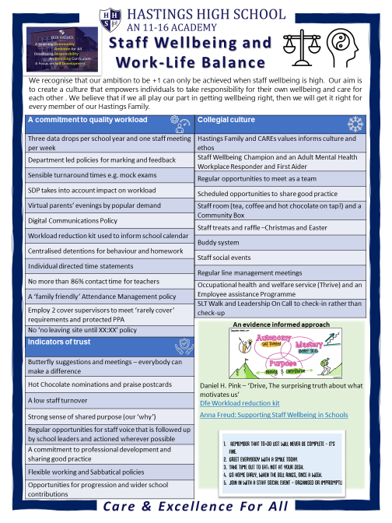



HASTINGS HIGH SCHOOL
Care and Excellence for All

TEACHER OF HISTORY AND/OR TEACHER OF PSHE

JOB SUMMARY:

To exercise responsibility for the teaching, care, control and guidance of pupils in their lessons, in accordance with national legislation and school policy and practice.

OBJECTIVES

- To continuously raise standards of pupil achievement in your classes
- To foster enjoyment and satisfaction in the participation of learning by pupils
- To deliver well prepared lessons that meet the needs of the class and national curriculum content

PRINCIPAL RESPONSIBILITY AREAS

- Teaching
- Pupil Achievement
- Individual Needs
- Miscellaneous

A: TEACHING

  - To use and implement subject/department curriculum policies and in co-operation with colleagues, work toward the achievement of the school’s goals and targets within the subject area.
  - To set and mark homework as per homework timetable.
  - To promote the general progress and well-being of individual pupils and of any class or group of pupils assigned to you, expecting the highest possible standard for each pupil. This includes responsibility for pupils identified in the SEND Code of Practice and responsibility for liaising with learning support staff to ensure the needs of all children with SEN are met within the SEN Code of Practice.
  - To communicate and consult with the parents of pupils when appropriate and to communicate and co-operate with persons or bodies outside the school when appropriate, taking account of any departmental or school policy.
  - To participate in meetings as determined in the school and departmental meeting cycles.
  - To participate in the arrangements made for professional development, review and appraisal.
  - To participate in staff training and development activities as required.
  - To ensure that, whenever possible, appropriate work is set to cover absence. This should always be done when absence is known in advance.

B: PUPIL ACHIEVEMENT

  - To develop appropriate learning experiences for each group using a variety of teaching styles (keeping abreast of current developments) and maintaining the level of discipline essential for learning to take place.
  - To assess, record and report on the development, progress and attainment of those pupils for which you have a responsibility in accordance with any agreed departmental and school policies, providing or contributing to oral and written reports as required.
  - To attend Progress Evenings as required.
  - To report on pupils’ progress as required, in line with reporting procedures and time frames.

C: INDIVIDUAL NEEDS

  - To teach pupils according to their individual educational needs, including provision for pupils with Special Educational Needs; ensuring that pupils’ work is regularly monitored, marked and recorded, in accordance with department and school assessment policies.
  - To maintain, record and mark books as required (including electronically).
  - To advise the Head of Department on recommendations for changes of group/set, as and when appropriate.
  - To advise and co-operate with the Head of Department on the preparation and development of courses of study, meeting N.C. requirements, teaching materials, teaching programmes, methods of teaching and assessment arrangements.
  - To contribute to EHCP review meetings.
  - To ensure that the school's Child Protection Policy is followed at all times and any safeguarding issues are immediately reported following the school’s safeguarding procedures.

D: MISCELLANEOUS

  - To oversee the general tidiness and condition of furniture and fabric of, and equipment in, the teaching base, including where appropriate the display of pupils’ work, thus creating an environment conducive to learning (reporting to the Site Team any issues of health and safety or damage requiring repairs).
  - Provide advice, as necessary, on Health & Safety issues to staff and pupils.
  - Alert staff as necessary to any ‘unsafe’ practices by pupils, to reduce the possibility of accidents.
  - To adhere to all policies relating to Health and Safety and carry out the duties placed on employees by the Health and Safety at Work Act 1974.
  - To adhere to the requirements of C.O.S.H.H - Control of Substances Hazardous to Health) (Amendment) Regulations 1991 and Equal Opportunities, as determined by the Governors of the school.

Please note that these responsibilities are indicative rather than exhaustive. This job description sets out the duties and responsibilities of the post at the time when it was drawn up. Such duties and responsibilities may vary from time to time without changing the general character of the duties or the level of responsibility entailed. Such variations are a common occurrence and cannot themselves justify a reconsideration of the grading of the post.

The school takes its safeguarding and child protection responsibilities very seriously and the post will be subject to an enhanced DBS clearance, agreeing to our E-safety policy, two supportive written references, social media checks and a pre-employment medical health check.



HASTINGS HIGH SCHOOL

Care and Excellence for All

LOCATION AND CONTACT DETAILS

St Catherine’s Close
Burbage
Leicestershire
LE10 2QE
Telephone: 01455 239414
Email: reception@hastings.school
Website: www.hastings.school
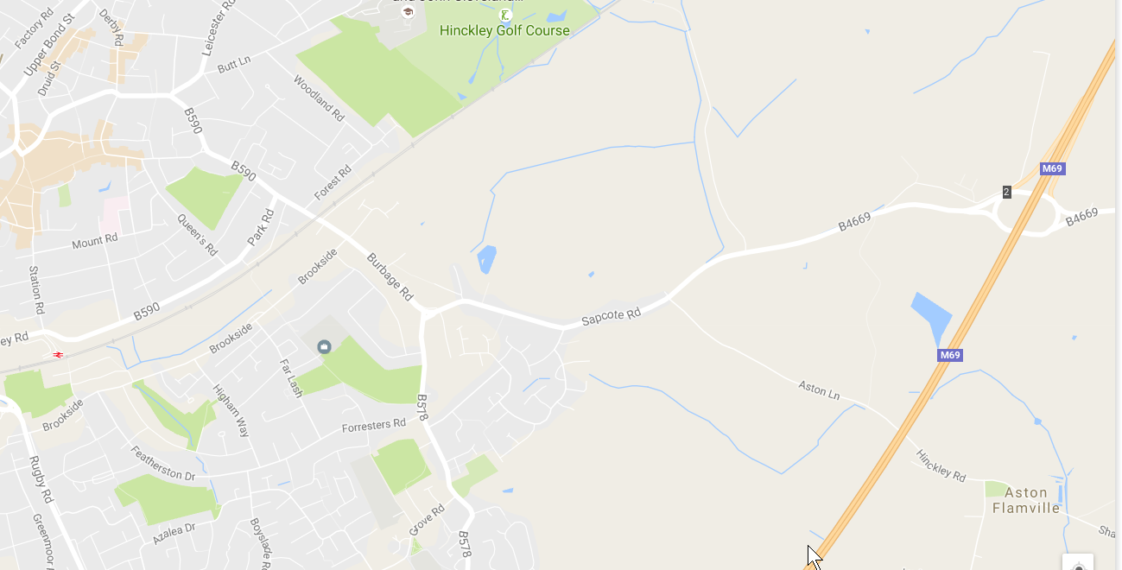
HASTINGS HIGH SCHOOL

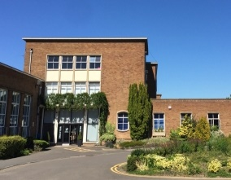
Reception:

