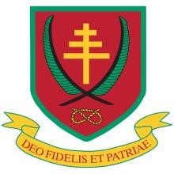Rowley Avenue, Stafford ST17 9AB

Blessed William Howard Tel: 01785 244236

Email: office@bwh.staffs.sch.uk

Catholic High School www.bwh.staffs.sch.uk

Principal: Mr K. J. Brown BSc (Hons) PGCE NPQH

# Part of The Painsley Catholic Academy

**PERSON SPECIFICATION FOR A SUBJECT TEACHER**

As a teacher in a Catholic school all staff are bound by the Catholic Education Service contract which states the following:

*You are required to develop and maintain the Catholic character of the school. You are to have regard to the Catholic character of the school, not to do anything in any way detrimental or prejudicial to the interest of the same.* [Paragraph 4.3]

The following statement is from the “Memorandum on Appointment of Teachers to Catholic Schools” published by the Catholic Education Service.

*To find Catholic teachers who combine personal conviction and practice of the faith with the required professional qualifications and experience, especially in specialist subjects, is always a high priority.*

**The above statements frame the essential qualities we seek in teaching staff. The statements below give further guidance.**

1. **Knowledge & Experience** 
   * A good honours degree in a relevant subject
   * A teaching qualification together with Qualified Teacher Status (QTS)
   * A clear philosophy on how and why the subject should be taught
   * Subject knowledge sufficient to challenge able students and achieve high outcomes at sixth form level
   * Awareness of the strategies available for improving the learning & achievement of high ability students
   * A good understanding of curriculum developments in the specific subject area
   * Familiarity with national strategies

1. **Skills & Abilities** 
   * Able to use a range of teaching & learning strategies
   * An understanding of how assessment for learning can improve student performance
   * A confident & competent user of ICT
   * Knowledge & understanding of how ICT can be used in the teaching of the subject to enhance student learning
   * Able to use student level data to raise standards
   * Able to communicate both orally & in writing to students & their parents

1. **Personal Qualities** 
   * Enthusiasm & a positive outlook
   * The ability to work independently and collaboratively as a member of a team
   * Creative in problem solving together with a willingness to take on or try new approaches & ideas
   * A positive attitude towards professional development and their own learning • Reliability & integrity
   * Good personal organisation

In addition to assessing the candidates’ ability to perform the duties & responsibilities associated with the post, the interview will also explore issues relating to safeguarding & promoting the welfare of the students.

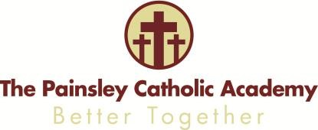

*The Painsley Catholic Academy. A Company limited by guarantee, registered in England & Wales with company number 08146661.*

*Registered office address: Station Road, Cheadle, Staffordshire, ST10 1LH*