**TEACHER OF HISTORY**

**Candidate Pack**

**Welcome Letter from the Headteacher**

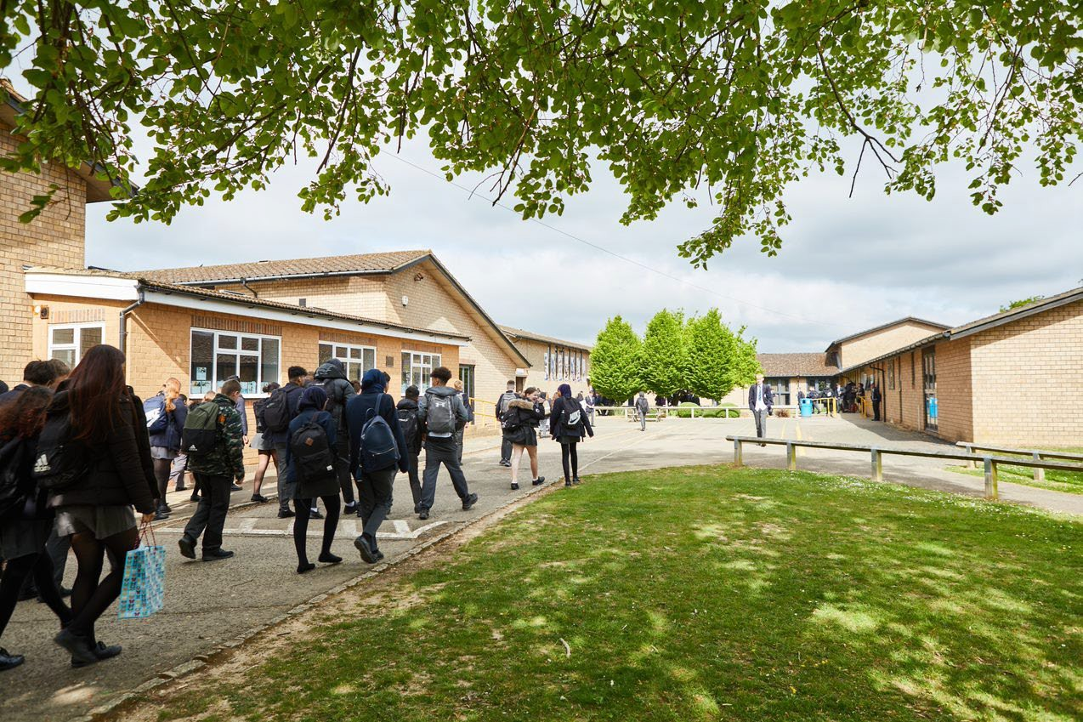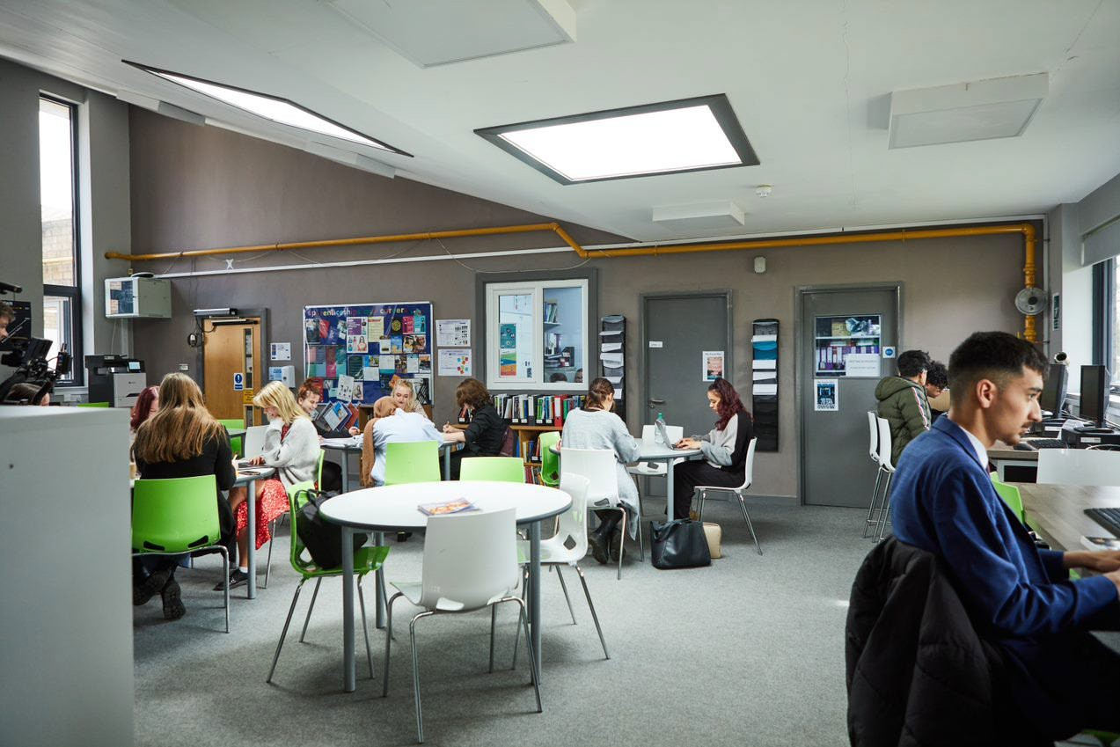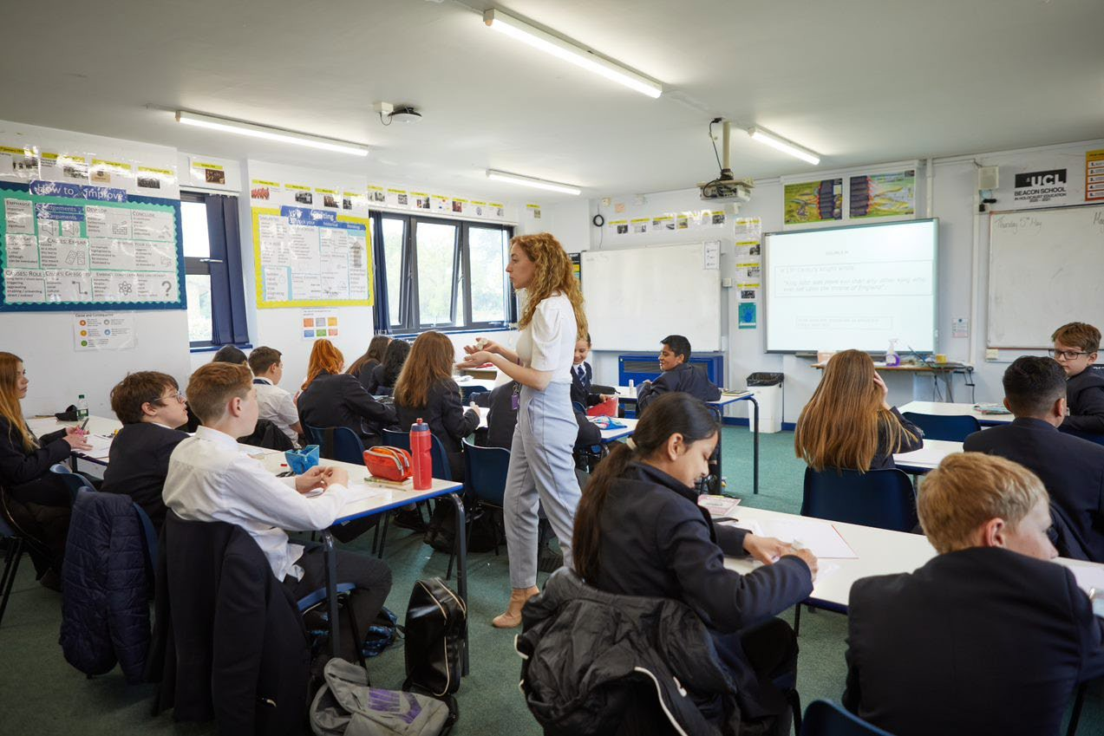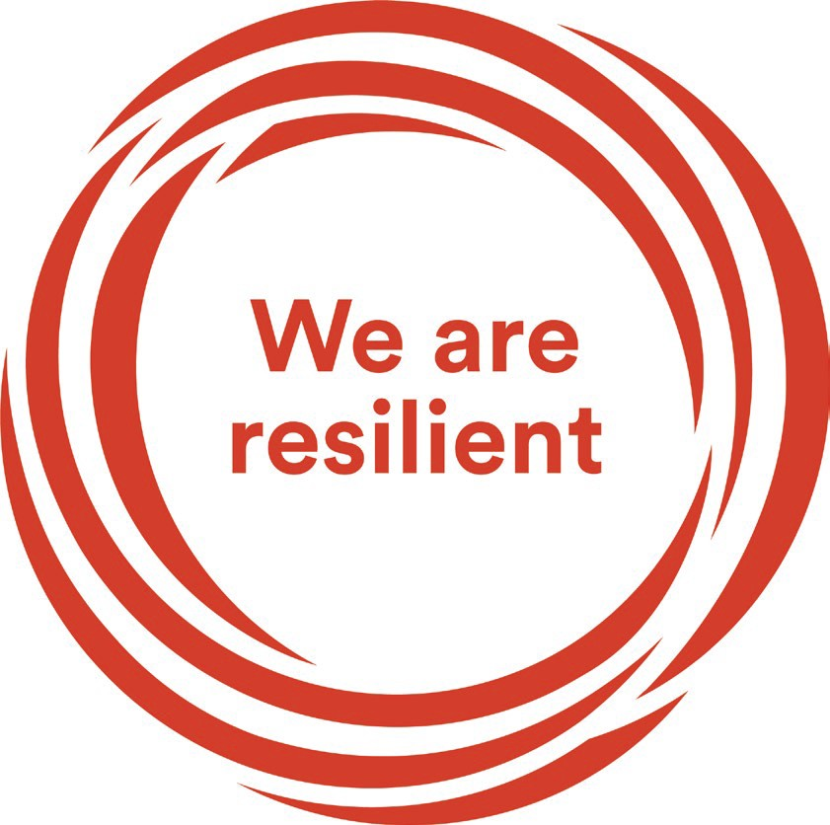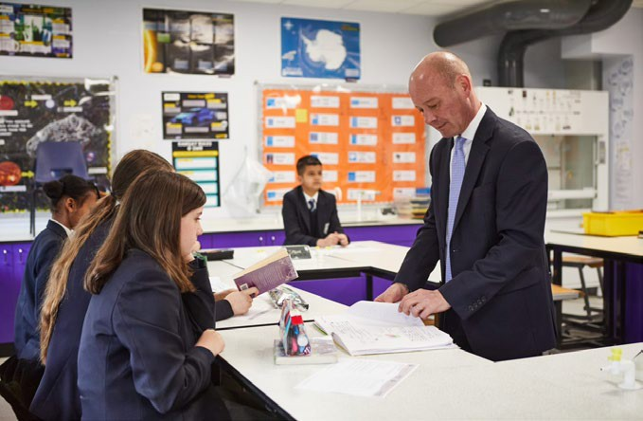

Dear Prospective Candidate

Thank you for your interest in the position of Teacher of History at Sir William Ramsay School.

I joined Sir William Ramsay School as the new Headteacher in May last year and am committed to getting the school back to ‘Good’ as quickly as possible.  Clarity, consistency and rigour are central to our plans to ensure that all students enjoy learning and make good progress. Our plans include significant developments in high quality teaching and learning, the introduction of ambitious targets, a focus on developing excellent teaching, meaningful homework and improvements in behaviour for learning.  We are also rolling out a digital learning 'One to One Device' strategy across the school to ensure that students can receive innovative teaching and access state of the art resources at both home and school.

We are looking to appoint a talented, enthusiastic and dynamic Teacher of History to join our team from September 2023. The ideal candidate will have a belief in the ability of all students to achieve and a passion for raising student achievement. You will have a desire to strive for continuous school improvement and a commitment to team work as well as a sense of fun.

If you would like to find out more about the role or to arrange a conversation with the Head of Faculty, please contact [jwolfenden@swr.school](mailto:jwolfenden@swr.school).

I will hope to meet you in the near future.

Yours faithfully

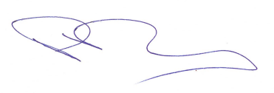

**Paul Ramsey**

**Headteacher**

**Vision and Values at Sir William Ramsay School**

***Empowering Everyone to Achieve***

**Vision**

A community where every voice counts, where talent and creativity are brought to life, where students grow in confidence, build resilience and are prepared for the rest of their lives.

**Values**

* We are respectful – we always treat people, property and the environment with kindness and consideration
* We are ambitious – we ask for help when we need it and strive to be the best we can be
* We are reliable – we do what is asked of us and deliver on our commitments
* We are resilient – we prepare for the future and adapt and grow from challenges

**Mission**

We aim to achieve our vision by:

* Raising students above the ordinary by developing and delivering lifelong learning which transforms lives
* Ensuring every person feels valued, safe and happy
* Enabling students to feel proud of themselves, and to take pride in the success of others
* Promoting a culture of mutual respect where everyone is treated as a valued member of the school community
* Encouraging positive communication so that words and actions are thoughtful, supportive and motivational
* Placing parents and carers at the heart of the life of the school
* Having highly dedicated and well-qualified staff who are committed to continuous professional development
* Adopting an ethos of continuous improvement within all aspects of school life

**Equality**

Sir William Ramsay is an inclusive and diverse community. We work to eliminate all forms of discrimination on the grounds of ethnic origin, religion, sexual orientation, gender, disability or ability. This is achieved via the following principles:

* Ensure that students have the opportunity to reach their potential in all areas of school life
* Ensure that parents, carers and students can make choices free from prejudice and stereotyping
* Oppose any form of racism, sexism, disability discrimination, homophobia or any other form of discrimination
* Value every student’s language and cultural background

**Job Description**

|  |  |
| --- | --- |
| **Job Title:** | **Teacher of History** |
| **Aim and Main Job Purpose:** | To strengthen Sir William Ramsay’s position as a diverse community school, where all students achieve.  To contribute to the improvement of student examination outcomes.  To contribute to the development of outstanding teaching across the school.  To share a vision, sense of purpose and pride in the school. |

# Teaching and Managing Student Learning

Teacher of History will:

* Be able to teach effectively across the full range of age and abilities.
* Possess high expectations of students in relation to standards of achievement and behaviour.
* Have an active input in the creation, consistent implementation and improvement of schemes of work which encapsulate key school learning strategies.
* Monitor the progress of students including those requiring additional support and challenge them to ensure students are engaged in their learning and achieve success.

# Assessment and Self-Evaluation

Teacher of History will:

* Implement policies and practices for assessing, recording and reporting on student achievement and to assist in setting targets for further improvement.
* In conjunction with the Head of Humanities, use data effectively to identify students who are underachieving and, where necessary, create and implement an effective intervention plan.

# Relationships with Parents/Carers

Teacher of History will:

* Establish a partnership with parents and carers to involve them in their child’s learning of the subject, as well as providing information about targets and attainment.
* Communicate effectively, both orally and in writing, with parents and carers.

# Managing Own Performance

Teacher of History will:

* Prioritise and manage their own time effectively.
* Take responsibility for their own professional development.
* Share good practice resulting in a tangible impact on student learning.
* Form constructive relationships with staff including team working and mutual support.
* Actively implement the key aspects of the school’s behaviour management policies.
* Be a form tutor.
* Make a contribution to the wider school life including specialist Humanities enrichment activities.
* Contribute to faculty planning and developments.

# Strategic Leadership

Teacher of History will:

* Contribute fully to the Faculty Development Plan which contributes positively to the achievements of the School Development Plan.

# Other Responsibilities

* To promote the School’s vision, values and aims.
* To be aware of and comply with the codes of conduct, regulations, policies, procedures.
* To work as part of a team.
* To be generally responsible for safeguarding and promoting the welfare of students.
* To be responsible for own and team health and safety including well-being.
* To actively participate in the School’s appraisal system.
* To do Continued Professional Learning as agreed with the Line Manager.

This job description is current at the date indicated below but, in consultation with the postholder, it may be changed by the Headteacher to reflect or anticipate changes in the post commensurate with the grade or job title.

**The Department**

History is a popular subject in which teaching staff are committed to raising standards and promoting a love of learning. Every student is encouraged to reach their maximum potential. If you are enthusiastic, flexible, enjoy challenges and are committed to delivering excellent education then please apply for the role of Teacher of History. You will be joining an established team with a good track record of GCSE and A-level results. We are also a Beacon school for Holocaust teaching.

**The History Curriculum**

Year 7 study: Norman invasion, evolution of castles, religion in medieval England, the Crusades, Everyday life in the Medieval period and the Native American Indians.

Year 8 study: The Plantagenets, Tudors – Victorians then the Industrial Revolution and British Empire.

Year 9 study: Slavery and its impact today, the civil rights movement, Holocaust and Votes for Women. We then start teaching the GCSE from AQA Democracy to dictatorship to conflict and tension from 1918 – 1939. We have a strong ethos of diversity and inclusion and incorporate teaching about diversity, including women's rights and civil rights.

At KS4 we follow the AQA specification: America 1920 -1974, Conflict and Tension in Asia, Elizabeth I and Health and the people a 1000-year study.

At KS5 students follow the AQA specification for 2O Democracy to Dictatorship – Germany 1918 – 1945 and Tudors 1C then they complete their coursework.

**How to Apply**

If you wish to discover more about this exciting opportunity, need any further information or you wish to have an informal discussion, please contact James Wolfenden [jwolfenden@swr.school](mailto:jwolfenden@swr.school) or 01494 815211.

Please email your completed application form to: [jointheteam@swr.school](mailto:jointheteam@swr.school)

Closing Date: Noon - Thursday 22nd June 2023

Interviews: Week commencing Monday 26th June 2023

Sir William Ramsay School is committed to safeguarding and promoting the welfare of children and young people and expects all staff and volunteers to share this commitment. We will ensure that all our recruitment and selection practices reflect this commitment.

All successful candidates will be subject to DBS checks along with other relevant pre-employment checks.