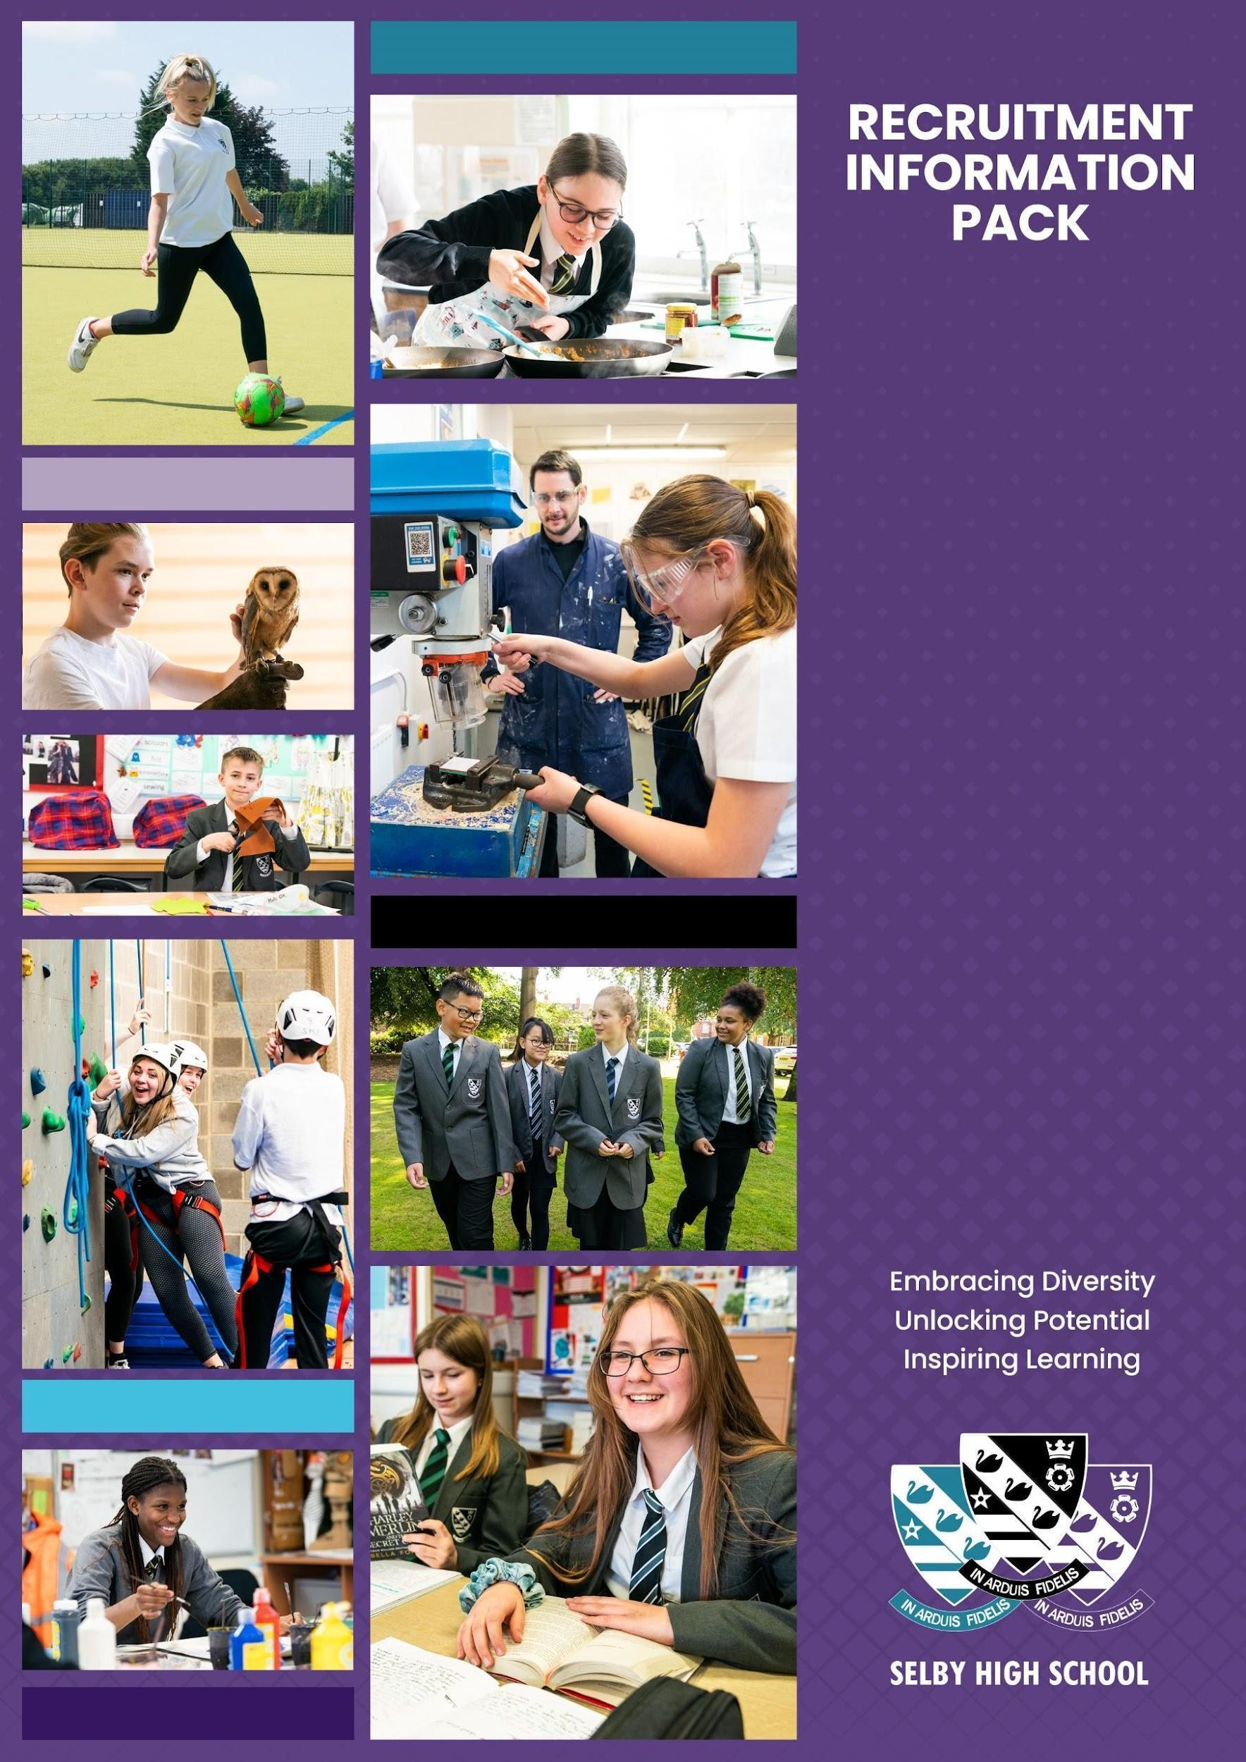

History Teacher
Maternity Cover
Starting
September, 2026

WELCOME
Dear Candidate,
Thank you for your interest in the post of teacher of History, starting in September, 2026. This is a maternity cover for the full academic year. Whether you are an Early Careers Teacher or a more experienced candidate we’d love to hear from you. Selby High School is an ambitious, forward looking, and successful 11-16 secondary school located in North Yorkshire and rated ‘good’ in our last inspection. We are proud of our school and the opportunities it provides for both students and staff. Our ambition is success for everyone through encouragement, teamwork, mutual respect and an enjoyment of learning.
We are a learning community who embrace opportunities for all our learners by securing high quality learning and teaching. We aim for all our students to achieve their full potential, both as students at Selby High School, and as considerate global citizens of the future. We always aim to be the best we can be; nothing less will do.
We are looking for a determined, enthusiastic professional, who wants to work with our young people, to ensure that, regardless of starting points or barriers to learning, they progress in History to the best of their ability. In return, we offer a comprehensive induction programme and continual professional development. As a teacher at Selby High School, we will provide you with excellent training opportunities, and encourage you to have high aspirations for your future career. History is a thriving subject at Selby High School, and is a very popular option at key stage 4; you will work in partnership with the Curriculum Area and Faculty Leaders and the rest of the team to ensure an engaging curriculum and fantastic outcomes for the students.
Selby High School is a great place to work. Please, just take a little time to look at our school website at http://www.selbyhigh.n-yorks.sch.uk/ which gives a real insight into the character of our school.
This information pack contains the Job Description and Person Specification, together with some background information about the faculty and the school. We hope this gives you a feel for Selby High School. I look forward to receiving your application.
With all best wishes.
Yours faithfully


Nick Hinchliffe
Principal

About the role
We are looking for an outstanding teacher of History with the ability to teach at Key stage 3 and 4; this is a maternity post for the full academic year. You will be joining a committed and hardworking team that achieves very good results. It is expected that the successful candidate will be able to teach across the age and ability range. An interest in teaching lessons within our Life Development curriculum, through which we deliver Citizenship and Personal, Social and Health education, will be an advantage. We simply want the best teachers for our students, and that could be you!

History at Selby High School

The Building and resources
History is primarily taught in three specialist rooms. All rooms have interactive screens and we have an extensive range of textbooks and other resources.

Key Stage 3
At KS3 History content is taught around enquiry questions to ensure all pupils can identify and understand major events, changes and developments in British, European and World history. Following the National Curriculum we cover a range of time periods, themes and ideas that allow students to investigate and communicate their understanding of cultural, ethnic and religious diversity.
History is taught in broadly chronological order with lessons based on second order concepts such as change and continuity, historical significance, cause and consequence, historical interpretations, similarity and difference and sources. A brief summary of the content studied in each year groups is outlined below:
- Year 7 (3 lessons over a two week timetable): Focuses on the foundations of history, the Norman Conquest (1066), the Silk Roads (wider-world study), the Middle Ages (Church vs. State), and the early Tudor period.
- Year 8 (4 lessons over a two week timetable): Covers the 17th-century "World Turned Upside Down" (Civil War and Witchcraze), the Industrial Revolution, Slavery and the struggle for Civil Rights in America, the British Empire (India and Ireland), and the fight for rights (Chartists and Suffragettes).
- Year 9 (3 lessons over a two week timetable): Focuses on modern history, including World War I (trench life and medicine), World War II (The Blitz and turning points), the Holocaust, and the Cold War.
By engaging with a range of historical narratives, students are encouraged to appreciate their place in the world. Content is chosen that reflects local, national and international issues and concerns. For example, through studying the history of the 19th century, Selby students are able to see the impact of migration and movement of people, the growth of industry, and the response to the poor. Pupils are taught to describe, analyse and explain sources of information including texts, pictures and artefacts. They are encouraged to think about how the past is interpreted using the work of historians, as well as develop their own ideas about significant historical events and people.

Key Stage 4
For Key Stage 4 (Years 10 and 11), the school follows the Pearson Edexcel (1HI0 FM) specification. The specific units studied are:

- Paper 1: Medicine in Britain (1250–Present) and The British sector of the Western Front (1914–18): Injuries, treatment, and the trenches.
- Paper 2: Early Elizabethan England (1558–88) AND The American West (1835–95).
- Paper 3: Weimar and Nazi Germany (1918–39).
Students studying KS4 History have 5 lessons over the two week timetable.
Beyond the classroom
The department has a long record of extra-curricular activities having previously run trips to the First World War and Normandy battlefields, as well as local trips to sites and museums such as Eden Camp. We have been involved in Holocaust Memorial Day for several years and we are a Beacon school for Holocaust teaching. We aim to provide students the opportunity to broaden their experience of History and encourage them to explore their local environment and own history. We have been actively engaged in local history projects in recent years such as Selby Cemetery Heritage Lottery project, 750th anniversary of Selby Abbey and remembering Selby soldiers from WWI. We continue to seek opportunities for local history projects that help students connect with their own and community past. Enrichment activities currently running are family history and archaeology for KS3, and KS4 GCSE support for Year 11.

ABOUT SELBY
Selby is a small market town situated 14 miles (22.5 km) south of the city of York, along the course of the River Ouse. It is dominated by the superb Abbey, founded in AD1069 by Benedict when he saw three swans on a lake in Selby which he interpreted as a sign of the Father, Son and Holy Ghost, resulting in the official crest of Selby Abbey, and subsequently, Selby High School.
Selby local government district has a population of 82,900. It is a fairly rural district with a population density well below the national average. Selby town, with a population of 24,680 is its only major settlement, with a population of more than 15,000.
Selby has a growing local economy with new housing and shops being built on the town's outskirts. The riverfront area is also being revamped with modern housing and flats. This is anticipated to bring population growth and enhanced demand for high quality educational places into the future. Selby is ideally located to a whole variety of places, facilities and activities for culture, leisure, commerce and learning. There is a wide range and variety of housing and prices are below the national average.
The district of Selby is contained within both the Leeds City Region and the York, North Yorkshire and East Riding Enterprise Partnerships. The Leeds E.P. Strategic Economic Plan (2016-2036) describes Selby as follows:  “The district of Selby sits on the eastern boundary of Leeds City Region within the county of North Yorkshire. Both the market town of Selby and the wider district are home to many highly skilled and paid employees, many of whom travel each day to Leeds, York and beyond. Its economy is characterised by manufacturing, distribution, construction and energy production; drawing its employees from the district’s market towns and villages, as well as neighbours including the East Riding, Wakefield and Doncaster.”  Looking ahead, the district has a key role to play in providing space for business growth in the Leeds City Region. The unemployment claimant count rate in Selby is around 1.3% (Sept 2016) which is well below the national average.  In terms of further education, Selby College is graded ‘good’ in all areas by Ofsted. It is a tertiary college providing the town`s sixth form as well as a small range of Higher Education courses, apprenticeship programmes and courses for adults. There is easy access to Leeds, Hull and York for Universities and it is to these centres that the majority of local, young HE entrants progress.  In short, Selby is a hidden gem, with both its own delights and very easy access to a diverse range of activities and experiences, for individuals and families of all ages. | 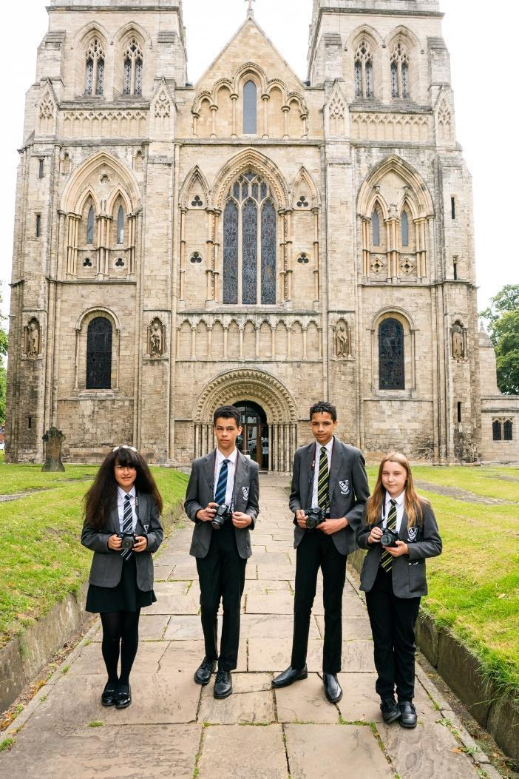  Selby Abbey has been at the heart of the community since 1069.

LIVING IN NORTH YORKSHIRE
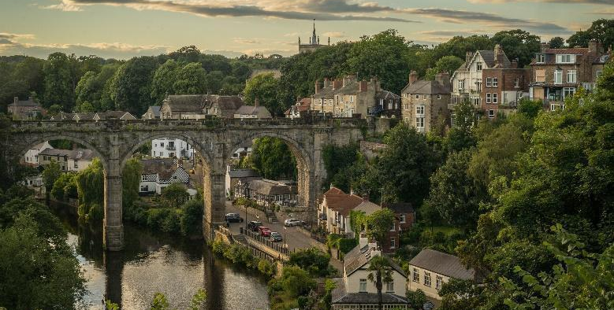
North Yorkshire is England's largest county and one of the most rural. The area comprises the Yorkshire Dales and North York Moors, three Areas of Outstanding Natural Beauty, the Pennines and a stunning coastline around Scarborough and Whitby. The area hosted the phenomenal Tour de France in 2014, and due to its success has created the Tour de Yorkshire with global recognition. There are ruined castles and abbeys, serene gardens, unique breweries, thrilling rides and industrial heritage. Something for everyone!
Knaresborough
North Yorkshire has plenty to offer the outdoor enthusiast. From the hard gritstone of Almscliff and Brimham Rocks to the limestone of Malham, Gordale and Kilnsey, climbing venues are in abundance. The Yorkshire Dales is the premier area for caving and for mountain biking; there are the bridleways of the Dales and North York Moors as well as the renowned trail centre at Dalby Forest. The Sustrans trail centres are all easily accessible for days and weekends away, as is the Lake District and the fells, crags and coast of Northumberland. There are a small number of sailing clubs on reservoirs around the county and fantastic surf sport venues and sea kayaking on the east coast.
While the county is rightly known for its wide-open spaces, it also incorporates attractive market towns including Pickering and Helmsley, traditional seaside towns, the Spa town of Harrogate and the ancient city of York - the most visited city outside of London. There are a wide range of shopping, leisure and cultural facilities as well as excellent schools, universities, road and rail links; there really is everything to offer you and your family as a place to work, live and enjoy!
Travelling further afield we have convenient connectivity, with close proximity to metropolitan cities of Leeds and Newcastle, with little over two hours commute on the main train line to London. We border the Lake District, Lancashire, County Durham, and Yorkshire & Humber regions with all they have to offer.

Whitby

SELBY HIGH SCHOOL
 | Selby High School is a thriving, successful, and popular school. The ‘can do’ ethos at the school ensures the very best for each and every one of its students. Following our successful OfSTED inspection, everyone at the school is eager to move towards outstanding in every area. Selby, located in North Yorkshire, benefits from good commuter links with York and Leeds.  Selby High School is an equal opportunities employer. We have a robust child protection policy and are committed to safeguarding the welfare of our children and young people. It is our objective to ensure that job applicants and staff are treated solely on the basis of their merits, abilities and potential. We do not discriminate against any applicants on the basis of any protected characteristics, and welcome applications from all sections of the community.
As a school we work in a positive and supportive environment with learning and teaching at the heart of all that we do. We have committed and talented staff who aim to inspire everyone in our school community with a love of learning and, by doing so, maximising students’ life chances. We provide all our staff with a laptop computer and a full professional development and induction programme, both of which have been judged to be outstanding.

Please visit our Policies page for the most up to date policies including Safeguarding & Child Protection and the Equalities Scheme which are part of the interview process.
 | Community and Culture – Our school is a community, in which we provide help and support for one another, in line with our values. |  | Prioritising high quality planning – Effective  teaching and learning is underpinned by sensible, appropriate planning that is focused on the needs of all learners.
 | High quality recruitment, retention and  development – Our commitment to Career Pathways ensures that our staff team is always of the highest quality. |  | Developmental teaching and learning – We know that teaching time is like ‘gold dust’ and all staff need to be supported to deliver consistently good or better lessons.
 | Supportive staff appraisal – Aspirational targets that foster the improvement and development of all our colleagues, across the school. |  | Communication commitment – We strive to ensure that whole school communication is clear, timely, useful and manageable for all.
 | Streamlined data and report management – A  sensible approach that avoids duplication and leads to meaningful improvements for students. |  | Wellbeing – A welcoming place to work – We are an inclusive school community, committed to equality and diversity and a place where staff are happy in their work.
 | Marking that is manageable and meaningful – Time invested in marking and feedback should be proportional to the impact on student progress. |  | Managing workload – We believe that time well  spent is that which has the highest impact on raising standards, rejecting things that create unnecessary burden for little gain.

STAFF BENEFITS
 | Vivup is a provider of employee benefits in partnership with North Yorkshire County Council  North Yorkshire County Council recognise there is more to pay than just salary and they offer access to a wide range of competitive benefits.  The Vivup website provides colleagues with access to a host of voluntary benefits including discounts on goods and services such as your day to day shopping, days out, travel, electrical goods, leisure activities as well as links to salary sacrifice schemes.
Lifestyle Savings

Explore a huge range of discounts to help you save money across hundreds of the UK’s favourite high-street and online retailers.

Support & Wellbeing

Access expert help and support for life’s ups and downs 24/7, 365 days a year. Make the most of the schemes available to help your money go further.

DISCLOSURE
All successful applicants are required to complete an enhanced DBS check and any offer of employment will be subject to satisfactory references and checks.
HOW TO APPLY
If you decide to apply, and we do hope you will, please complete the application form. This should be returned by e-mail to Caroline Airth at admin@selbyhigh.co.uk
Closing date: 3pm on Friday, 27th March

JOB DESCRIPTION

GRADE: MPS/UPS (Full time, although part-time will be considered.
RESPONSIBLE TO: Curriculum Area Leader, History
RESPONSIBLE FOR: Teaching History
Key Stage 3 & 4 Teacher of History
To secure and account for effective learning, appropriate achievement and educational, social and personal progress of all students in the assigned area of responsibility, consistent with the aims of the school and the unique needs of each individual learner.

Main Activities

• To deliver History from Year 7-11 using a range of teaching methods and the agreed subject area schemes of learning and contributing to the SMSC development of students through the specified curriculum.
• To ensure progress is made against student targets.
• To remain aware of the changing requirements of this work through attendance at meetings and careful attention to other forms of communication, including electronically.
• To take on an individual responsibility for at least one aspect of the work of the subject area, sharing expertise with other subject area members.
• To support the work of the subject area through extra-curricular activities and engagement activities. Show commitment to educational trips and visits.
• To plan, prepare and deliver lessons to a range of classes, ensuring a positive working environment in classrooms.
• To mark work, giving appropriate feedback and maintaining records of student progress and development.
• To maintain up-to-date subject knowledge and devise and write new curriculum materials when required.
• To select and use a range of different learning resources and equipment.
• To undertake pastoral duties, such as taking on the role of form tutor, and supporting pupils on an individual basis as required. Undertake duties as part of the published rota.
• To prepare pupils for qualifications including external examinations.
• To manage student behaviour in the classroom and on school premises, following school policies.
• To support the work of teaching assistants, trainee teachers and Early Careers Teachers (ECTs) as required.
• To participate in parents', carers’ and guardians’ consultations including published evening events and whole school training events.
• To liaise with other professionals, such as the SENDL, Personal Support Team, Learning Mentors, Careers Advisers, Educational Psychologists and Education Welfare Officers.
- To participate in the school quality assurance (QA) processes.
- To participate in regular in-service training (INSET) as part of continuing professional development (CPD).
- To follow school policy and procedures consistently and meet both internal and external deadlines.

Safeguarding
- Be responsible for promoting and safeguarding the welfare of children and young people that you are responsible for and come into contact with.
- Have awareness and basic knowledge, where appropriate, of the most recent legislation.
- Be able to recognise when a child or young person is in danger or at risk of harm and take action to protect them.
- Make considered judgements about how to act to safeguard and promote a child or young person’s welfare.

Data Protection

Comply with the County Council’s policies and supporting documentation in relation to Information Governance this includes Data Protection, Information Security and Confidentiality.

Other

Duties may be varied to meet the changing demands of the school at the reasonable discretion of the Headteacher.

This job description does not form the contract of employment. It describes the way the post holder is expected and required to perform and complete the duties set out above.

To fulfil all of the requirements and duties set out in the current Pay and Conditions Documents relating to the conditions of employment of teachers.

To achieve any performance criteria or targets related to this leadership post arising from the School’s Performance Management arrangements

This job description will be reviewed annually.

Person Specification

 | Essential | Desirable | Criteria
Teaching Experience | Experience of KS3  KS4 teaching including History GCSE including proven record of good or outstanding teaching. | Teaching across the ability range, including mixed ability teaching.  Ability to support and challenge students from all different starting points. | 
Qualifications | Qualified teacher status and a recognised degree or equivalent appropriate to the subject.  Evidence of CPD | Additional relevant qualifications and/or experience. | 
Skills & Knowledge | Effective and confident classroom teaching.  Knowledge of the major current education initiatives.  Command of formal written English.  Familiarity with, and enthusiasm for the specified subject area.  Awareness of the needs of students with different learning skills and abilities.  Good ICT skills.  React to data about students and respond through different teaching strategies.  Confident familiarity with Programmes of Study and examination specifications at both Key Stages.  Ability to make high quality reasoned decisions based on available information.  Clear expectations of student behaviour and discipline.  Resilience and the ability to deal with, at times, larger volumes of work | Experience of teaching aspects of PSHE (which we cover through our Life Development lessons.)  Evidence of keeping up to date with educational thinking and knowledge.  Willingness to do extra-curricular activities.  Involvement in extra-curricular activities related to this subject area or the wider school community.  A personal interest in and knowledge of some specialist area related to the effective teaching of the specified subject.  Some knowledge of QCA/Eduqas examination specifications. | 
Personal Qualities | Reliability and punctuality.  Initiative.  Ability to work consistently with the policies and procedures of the school.  Commitment to succeed and to see others succeed. Commitment to further development of self and others.  Ability to work well with colleagues.  An enthusiastic, positive, encouraging classroom presence. | Sense of humour, resilience and resourcefulness.  Imagination, innovation and initiative.
Health | Good general health.  Good attendance.

Application | Reference | Lesson | Interview
 |  |  | 

