MOULTON SCHOOL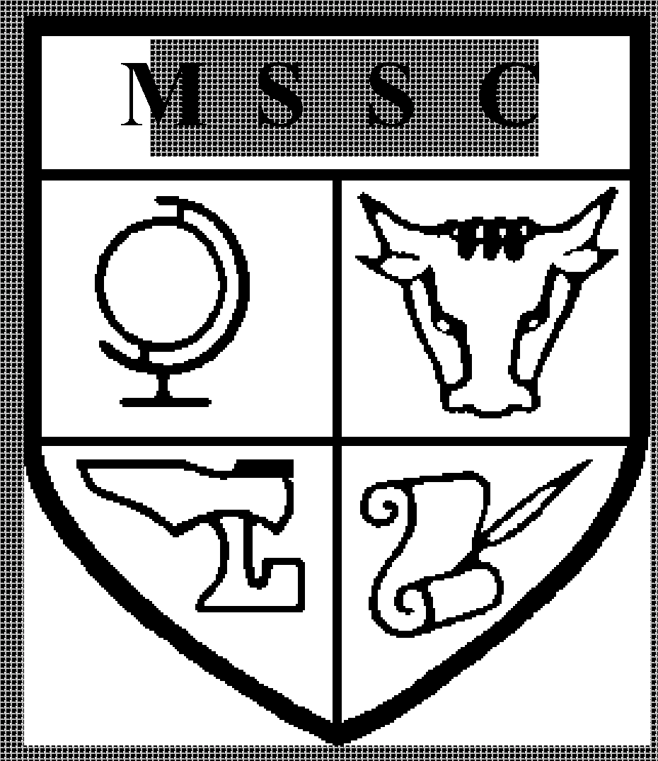

AND SCIENCE COLLEGE

**TEACHER OF HISTORY (WITH R.E)**

**Full Time**

**Teachers’ Professional Scale | £25,714 - £41,604**

We are seeking to appoint from January 2023, or earlier if possible, a talented, engaging and enthusiastic teacher of History. This is an exciting opportunity to join our successful History Department.

This post offers the opportunity to teach Key Stages 3 and 4, with the possibility of A level teaching for a suitably qualified and experienced candidate. Furthermore, the successful candidate will ideally have experience of teaching some religious studies. This position offers the successful candidate the opportunity to make a positive contribution to a Department that strives to keep the curriculum we offer vibrant, engaging and relevant. Applications from ECT’s are welcome.

**THE HISTORY DEPARTMENT**

Our History department is located on the recently refurbished Humanities floor in the main school building with four specialist teaching rooms. There is a spacious shared Humanities office and we are able to offer teachers their own classroom. Although the Humanities are set up as three separate departments, collaboration between them is strong and there is a great community feel to the H floor, as well as a shared purposefulness.

The History department is a welcoming, experienced and supportive team. We currently benefit from the enthusiasm and experience of four Historians which include the Subject Leader, Professional Tutor and an Assistant Headteacher. We are keen to develop and improve, both as individual practitioners and as a team. As such, the History department contributes to the training of new teachers as part of the Grand Union Teacher Training Partnership and participates in the SWAN History network.

We are looking for someone who is passionate about History and who wants to play an active part in continuing to develop a relevant and engaging curriculum that promotes outstanding outcomes. We offer a number of enrichment activities that have included day visits to Warwick Castle, the Black Country Museum and the FWW Battlefields. The team’s dedication to providing stimulating lessons continues to be rewarded with large numbers of students opting to take History at GCSE and A Level. Many of our A-Level students go on to study History related degrees at University.

**THE HISTORY CURRICULUM**

We want all of our students to leave enthused and inspired by history, with a broad narrative of British and world history and a range of historical concepts and skills that create critical thinkers. With our students, we strive for excellence in all that we do. We want our students to aspire to lifelong learning in history be that through books, documentaries and films and/ or excellence in an academic study of History at GCSE, A level and university. We draw heavily upon the National Curriculum and exam specifications but we also look to create an even challenging and ambitious curriculum by going beyond this either within the classroom or through homework activities. The department is well resourced with regularly updated schemes of work, accompanied by a range of resources.

**Key Stage 3**

In Years 7 - 9 students are taught in mixed ability groups and receive 3 History lessons every fortnight. Our study of history starts first with consolidating students' prior knowledge of the past and creating a secure chronological framework. This is then extended by exploring the big stories in History - power, everyday life and global connections. We start by looking at these stories in the context of British history, expanding to more global history as students’ progress through the school. This curriculum provides students with a historical framework to understand the importance of being respectful, considerate and open-minded citizens who have a sense of pride in the diverse world in which they live. From their KS3 studies our students will ‘takeaway’ a chronological narrative of the big stories (power, everyday life and global connections), a sense of period, and an understanding of Britain’s place in the wider world. While there is an emphasis on British history, we also incorporate European and global studies including France, Germany, the USA, Africa and Asia.

**Key Stage 4**

History is a very popular GCSE option and there are typically five GCSE groups of mixed ability in each year group. Students have 5 lessons per fortnight. We follow the Edexcel GCSE History course and we study the following units:

• Medicine Through Time and Historic Environment- the Western Front

• Elizabethan England

• The Cold War

• Germany 1918-1939

We take a broadly chronological approach to the course which allows us to interleave the different units and ensure students have exposure to all the skills required for the course throughout the Key Stage. Our curriculum is ambitious and goes beyond the specification to create opportunities for more diverse voices to be heard in the narratives we teach.

**Key Stage 5**

History continues to be popular at post 16 and we typically have two groups in both Year 12 and Year 13. Students have 9 lessons per fortnight and as with our other key stages, we take a broadly chronological approach. We follow the OCR A-level History course, which capitalises on specialisms within the team and we teach the following options:

* Pitt to Peel 1783-1846
* The Cold War in Asia 1945-1993
* Russia and its Rulers 1855 -1965
* NEA Vietnam War

**THIS JOB DESCRIPTION** reflects the major tasks to be carried out by the post holder and identifies a level of responsibility at which they will be required to work. In the interests of effective working, the major tasks may be reviewed from time to time to reflect changing needs and circumstances. Such reviews and any consequential changes will be carried out in consultation with the post holder.

Ensure that reasonable care is taken at all times for the health, safety and welfare of yourself and other persons, and comply with policies and procedures relating to health and safety within the School. Demonstrate awareness/understanding of equal opportunities and other people’s behavioural, physical, social and welfare needs.

To carry out any other duties which fall within the broad spirit, scope and purpose of this job description.

PERSONNEL SPECIFICATION

**TEACHER OF HISTORY**

|  |  |  |
| --- | --- | --- |
| **CATEGORY ITEM** | **ESSENTIAL** | **DESIRABLE** |
| Experience | * Teaching of History at KS3 and KS4. * Experience / awareness of role of tutor / pastoral role. | * Experience of teaching to A Level. * Experience of comprehensive education. * Experience of teaching RE |
| Education and Training | * Degree in History or equivalent. * Qualified teacher status | * Evidence of a commitment to further professional development. |
| Aptitudes | * Ability to set high standards and to motivate pupils and staff * Ability to work co-operatively within the department in the on-going production of resources, schemes of work, assessment systems, planning documents etc. * Ability to maintain high standards of discipline. * Effective classroom manager * Good organisational skills and resource management skills. * Ability to use ICT for personal and classroom purposes. * Ability to monitor and evaluate progress. * Willing to help support extra-curricular activities, e.g. trips, revision clubs. * The ability to converse at ease with members of the public and provide advice and information in accurate spoken English is essential for the post. |  |
| Disposition | * Committed and enthusiastic * Highly motivated * Imaginative and innovative * Willingness to learn and share insights (a reflective practitioner) * Enjoys working effectively in a team * Shows initiative * Co-operative and flexible * Empathy with pupils of all abilities and dispositions * Suitability to work with children * Sense of humour |  |

July 2022