02 March 2023

Dear Candidate,

RE: Teacher of Humanities
TMS
Required for September 2023

Thank you for your recent enquiry in respect of the above vacancy.

Enclosed/attached is an application form and recruitment pack setting out the duties and responsibilities of the post, which I hope you will find helpful. Please note to be considered for this post you must fully complete the Application form and Recruitment and Monitoring form and return them to me by Thursday 23rd March 2023, 12.00 noon.

In addition, write a letter in support of your application which includes a brief description of your educational philosophy and your approach to teaching Humanities within a 13-18 High School. Your letter should be no more than two sides of A4.

If you require any further clarification or information relating to this post please do not hesitate to contact my P.A., Mrs M Barnes on 01785 337400.

This school is committed to safeguarding and promoting the welfare of children and young people/vulnerable adults and expects all staff and volunteers to share this commitment.

This position is subject to an Enhanced Disclosure check under the Rehabilitation of Offenders Act 1974. Further details regarding this check are available from school or by visiting www.crb.gov.uk.

Yours sincerely,
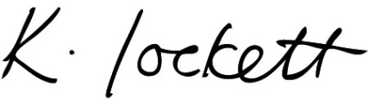

Ms K Lockett
Headteacher

