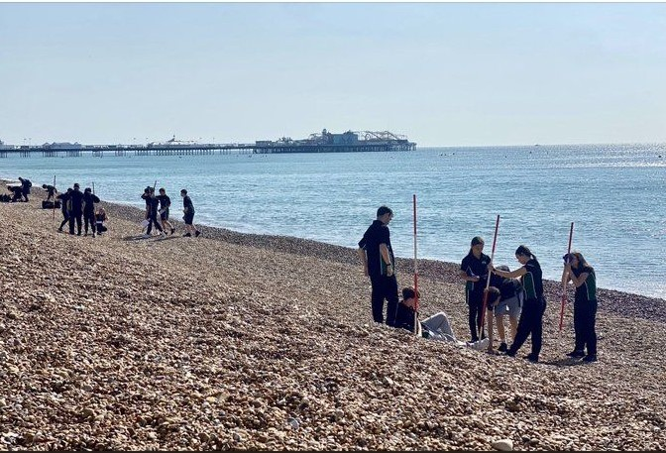

**Teacher of Humanities**



“Life in all its fullness” (John 10:10)

We are seeking to appoint an exceptional and inspiring teacher of Humanities (Geography preferred).

The Humanities Department at Altwood is a forward-looking team who work collaboratively to create a positive and practical learning environment. We aim to inspire confident and capable communicators who approach their work with enthusiasm, dedication, and confidence. We develop all our students’ individual talents so that they can learn a practical skill and gain a wider understanding of the world. Our Humanities curriculum aims to prepare students for adult life by giving them an awareness of and respect for other people and cultures.

The department consists of a team of subject specialists who share a passion for both achieving the best for our students and instilling a love of their subject. We pride ourselves on our strong commitment to students both academically and in becoming well-rounded global citizens. The department has a very positive and energetic atmosphere and continues to develop in new and exciting ways. Teachers’ expectations of our students are high, and we encourage them to challenge themselves in lessons. We use a variety of innovative, dynamic, engaging, and collaborative teaching and learning methods in the classroom.

Humanities is a key element of our school community; our curriculum is designed to inform and inspire our students with a desire to challenge themselves to go above and beyond what they believed was possible. All our rooms have audio-visual equipment and interactive whiteboards. The department also makes regular use of DVDs, websites, online resources, and other authentic materials. Our aim is to provide our students with lifelong learning skills and create a stimulating and structured atmosphere. We work to make them more responsible for their personal developments and inspire them with a love of Humanities.