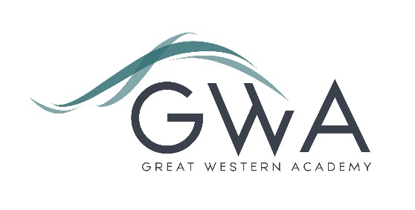

Information for Applicants

Teacher of Humanities (Full or Part-time considered)
Great Western Academy opened in brand new, state-of-the-art facilities in North Swindon in September 2018. The Academy is heavily oversubscribed in all years and has a growing sixth form to match. Humanities consists of Geography, History and P&R (philosophy and Religion) in years 7 to 13 with each department having a subject lead. Additionally, the Social Sciences department made up of Sociology, psychology, law, Criminology and Politics sits within the faculty in years 12 and 13. We operate a one week timetable with years 7 to 9 having 2 History, 2 Geography and 1 P&R lesson each week. Groups are taught in mixed ability allocated by the Humanities staff. Humanities is popular at GCSE with three GCSE classes in year 10 and year 11 in both Geography and History, whilst P&R have two classes in each year group. The Summer of 2023 saw our first ever GCSE results and the P8 scores were positive across the subjects. All students study an element of P&R in PSHE lessons in year 10 and 11. In KS5 We have strong A-level groups in both years 12 and 13 for all subjects with humanities students going onto to study at Oxford and Cambridge. The foundations we have laid in humanities are excellent; our team of experienced staff ensure students enjoy their learning, and the progress is very strong. We are a diverse and caring team that support each other, which is evident in the stability of staffing in the faculty.
An applicant’s briefing pack with full information about Great Western Academy and the role is available on the GWA website at http://www.gwacademy.co.uk/joining-us/vacancies. If you have any questions prior to application you are very welcome to contact us to discuss any subject or faculty specific details or general questions you may have.
Application process

Please complete the application form and equalities form supplied and enclose a supporting letter, either in the space provided on the application form or as a separate document. The application form should be completed in full in black ink or type. A CV is not required and should not be submitted as part of the application.

Your supporting letter should be no more than 2 sides of A4 (with a font size no smaller than 11) and should enhance your application by providing further information, matched to the person specification, about your suitability for the post. This should include evidence of the impact on student outcomes you have made in your career to date.

Applications should be submitted electronically to recruitment@gwacademy.co.uk by 9am on Monday 15th April 2024. Interviews will take place as soon as possible after this date. Please note we may interview before the closing date (and close the advert early) depending on the suitability, and number of, applicants.

The interview process will include observation of your teaching, and a variety of other tasks and activities.
Great Western Academy is committed to safeguarding and promoting the welfare of children, young people and vulnerable adults and we expect all staff to share this commitment and undergo appropriate checks. All posts within the Trust are therefore subject to an Enhanced DBS and barred list check.

References: References will be taken up prior to interview.

