# Post of

# Teacher of Humanities

## January 2023

## Information for Candidates

# Welcome to the Aylesbury Vale Academy

## **Thank you for expressing your interest in the post of Teacher of Humanities. This is a school where we aim to go beyond the expected to ensure that students' life chances are enhanced.**

We are proud of our non-selective, fully inclusive status and believe that children and young people, regardless of their background, ability or circumstances can thrive and succeed here. That is why we place **respect**, **aspiration** and **resilience** at the heart of everything we do.

As a large all-through school, we can offer learners an ambitious range of opportunities in and beyond the classroom. We place significant importance on academic excellence through high expectations but value, just as highly, the wide range of experiences learners can access. It is this balance which helps to ensure that learners are fully rounded individuals who can make a positive contribution to society.

To improve the life chances of all the learners we serve at AVA we:

* Ensure our **teaching** and **all our work** with young people is grounded in **high expectations** so that learners achieve exceptionally well.
* Deliver a **broad, ambitious and rich curriculum**, going beyond the expected.
* **Close all gaps** between the performance of different groups of learners.
* Empower learners by developing their **character** so that they are **resilient**, **aspirational, respectful** and have excellent attitudes to their learning.
* Inspire **attendance** to be consistently above the national average.

We look forward to welcoming you for an informal visit prior to your application. Please do contact us if you would like to arrange one or if you have any questions about the post.



**Mr Gavin Gibson**

**Academy Principal**

## Our Staff Community

The Aylesbury Vale Academy is a large, vibrant and warm community of over 200 staff. Staff wellbeing, happiness and job satisfaction is essential to ensuring the school achieves its goals.

We look for staff who want to share in our vision for children and young people but who also want to work as part of a close-knit caring and supportive staff team.

## How to Apply

All applicants are asked to complete the Buckinghamshire Council Teaching Application Form as fully as possible. Applications should be returned, by the closing date to:

Mr Gavin Gibson

The Aylesbury Vale Academy

Paradise Orchard,

Aylesbury,

Buckinghamshire,

HP18 0WS

Or by email to [vacancies@theacademy.me](mailto:vacancies@theacademy.me)

For further information contact Mrs E Perrin, HR Manager at [vacancies@theacademy.me](mailto:vacancies@theacademy.me).

Closing date: **Noon 30 November 2022**

Invitations to interview will be sent out within a week of the closing date along with an outline of the interview programme.

Our commitment to safeguarding and promoting the welfare of our children will be reflected throughout the recruitment process and the successful applicant will be subject to an enhanced DBS check.

## The Post – Teacher of Humanities

We are a highly supportive school with strong subject and senior leadership to help you develop. We are looking for a highly ambitious, committed and dynamic professional to join our Humanities department; someone who is passionate about their subject, communicates well with young people and makes a positive impact on their learning. The Humanities department currently comprises of 10 full-time teachers, two of who are part of the Senior Leadership Team. We work collaboratively to support each other both with the demands of our work and our wellbeing.

The successful applicant will have a passion about learning, have strong inter-personal skills, be resilient, be an excellent teacher and have great subject knowledge including experience of a number of GCSE specifications. They will be able to deliver Humanities up to KS4.

## Teacher of Humanities Job Description

JOB PURPOSE

* To carry out the professional duties of a teacher as described below.
* Meet the Professional Standards for Teachers and actively support the vision, ethos and policies of the Academy.
* To ensure that the aims of the Academy are put into practice and that high standards of work and behaviour are maintained.
* To ensure all students reach their potential through delivery of high quality teaching and learning alongside effective monitoring, assessment and target setting.
* To undertake any reasonable task as directed by the Principal.

ORGANISATION

* Demonstrate an attention to detail.
* Have the ability to self-manage in such a way that tasks are achieved and targets met.

COMMUNICATION

* Have excellent written and oral skills.
* Display a clear sense of vision.

PROFESSIONAL

* Be a graduate with a teaching qualification.
* Be an excellent classroom practitioner.
* Have a wide interest and knowledge of the use of ICT.

PERSONAL

* Have a passion for teaching and learning.
* Have integrity, optimism, flexibility and resilience.
* Have the stamina to cope with the demands of the post.

DUTIES AND RESPONSIBILITIES:

* Encourage and enable all students to achieve the highest possible standards of learning by:
  + Setting and sharing clear aims, goals and purposes.
  + Planning, conducting, reviewing and evaluating learning experiences with regard to continuity and progression content, activities, resources, feedback.
  + Making sure the learning environment in the teaching space is stimulating, well organised, attractive, safe and secure.
  + Ensuring that the best possible quality resources are used.
  + Ensuring that a variety of teaching methods and styles are used with students.
  + Making sure that all students have an equal opportunity to succeed.
  + Undertaking accurate, relevant and regular assessment, recording and reporting of achievement.
  + Deploying support staff and other adults effectively in the classroom, involving them, where appropriate in the planning and management of students’ learning.
* Secure a high standard of student behaviour in the classroom by establishing appropriate and high expectations and dealing with inappropriate behaviour in the context of the Behaviour Policy of the Academy.
* Support team commitment, through collaborative planning and by sharing good practice to create a stimulating learning environment for teaching and learning.
* Evaluate your own teaching critically and use this to improve your effectiveness. Take responsibility for drafting performance management objectives and ensuring agreed evidence is available for review against agreed criteria. Take a positive attitude to professional development.
* Comply with the Academy’s Health and Safety policy, to undertake risk assessments as appropriate.
* Lead or be involved in an after school activity as appropriate

## How We Look After Staff Well-Being

At Aylesbury Vale Academy we see the importance in Wellbeing. To us Wellbeing means having a sense of community, being listened to and heard, and having a sense of purpose. When we prioritise wellbeing we feel positive, respected, happy and appreciated. This allows us to achieve our tasks and work together to achieve a common goal. (Wellbeing Ambassadors and Wellbeing Working Party, February 2022)

We have a Staff Wellbeing Party that meets regularly to discuss staff wellbeing as well as a regular staff voice throughout the year. Staff also have access to a 24/7 helpline if required – Employee Assistance Programme.

## What Staff Benefits Are Available?

There are a wide range of staff benefits that are available to all members of staff employed directly by The Aylesbury Vale Academy. Some of the benefits include:

* Priority admissions for children of staff in our Primary and Secondary phases.
* Staff receive 10% off all wrap around care in the Primary phase.
* Access to high quality professional development.
* Disaggregated INSET days.
* Access to the Employee Assistance Programme, a support service for all staff, as well as partners and dependent children. Experienced, professional advisors are available to speak to you confidentially 24 hours a day, 365 days a year.
* Access to a well-equipped Academy Gym.
* All teaching staff have access to the Teachers’ Pension Scheme, whilst other staff have access to the Local Government Pension Scheme.
* Wellbeing Wednesdays where all staff receive free pastries and fruit
* Gift vouchers given to celebrate life events such as on the birth/adoption of a child, or a wedding
* Contribution to eye tests and glasses
* Discount at Esquires coffee shop across the road by Sainsbury’s

## Quotations from the last Ofsted visit January 2019:

* “Outcomes have improved because of strong subject leadership.”
* “The behaviour of pupils is good. There is an atmosphere of mutual trust and respect across the school. Pupils’ conduct is calm and orderly.”
* “Staff morale is high. They believe that leaders and governors take staff members’ well-being and workload into account and they feel well supported by the school.”
* “Staff new to the school feel very well supported by their more experienced colleagues and the packages of training and support on offer.”
* “Comprehensive induction and training programmes offered by senior leaders and the link advisor ensure that they very quickly establish themselves in their posts.”
* “Pupils show a well-developed understanding and tolerance for others who are different from them. Tolerance and diversity are promoted well at Aylesbury Vale Academy.”

## Testimonials

“The school has been very helpful and supportive in helping us to catch up with work whenever we are training or competing during term time. I would highly recommend the school as it has great facilities and members of staff, making it a wonderful place to learn.” Jessica and Jennifer Gadirova, Olympic and European gymnastics medallists and Year 13 AVA students.

“There is an atmosphere of mutual trust and respect across the school. Pupils’ conduct is calm and orderly.” (Ofsted 2019)

“Primary and secondary teachers know their classes very well.” (Ofsted 2019)

“We believe that the Aylesbury Vale Academy will create an achievement climate where our daughter can be an active participant in their learning and have opportunities to flourish.” (Year 7 Parent)

“I made this choice because my daughter is very good at performing arts and this school has an exceptional drama, dance and music department. The teachers are lovely and friendly and the atmosphere is very positive. My daughter felt really happy when we went to visit it.”



“I like the way the lessons are planned; it helps me to learn and progress in the subject we are studying. The teachers are understanding and obviously care for our education and that is something I am truly grateful for. “(Current student)

“My favourite thing about the lessons is that they are fun and interesting and a good learning environment for me to develop my skills.” (Current student)

“The things I like about AVA is that there is always a teacher you can go to.”

## Tutor Groups

In order to provide a clear focus on the highest levels of achievement for your child, the Academy has a horizontal tutoring system. This enables experienced tutors to help students develop the skills relevant to their age group, allowing them to become confident and knowledgeable learners.

Our tutor programme ensures that students have the best possible start to the day. Students are involved in activities such as reflection, year group assemblies, literacy and numeracy activities, debating and discussion. We also use this time in the day to answer any questions students have resolve any issues and to check uniform and equipment.

## Behaviour for Learning

We have very high expectations of behaviour based on our values of Respect, Aspiration and Resilience. We believe that good behaviour leads to good academic achievement, welfare, wellbeing and all aspects of learning

## The AVA Curriculum

The Aylesbury Vale Academy (AVA) is an all-through academy and the curriculum we follow develops and grows with our students as they move from primary school into secondary school. The aim of this curriculum is to provide a broad, balanced and ambitious education which prepares our students by giving the best possible chances for their future life choices and helping them to discover their role in society, where they will make valued contributions. In order to meet these aims the AVA curriculum has been designed to have three threads running through it which we refer to as the 3 Cs: **Cognition, Culture** and **Core.**



We believe that the 3 Cs are integral to meeting the needs of our students. AVA is a large community and our students benefit from being taught how to become effective independent learners. The AVA Curriculum aims to teach students how to learn effectively and with an ever-increasing degree of independence.

## The Cognition Curriculum

The Cognition Curriculum teaches students how to become effective learners by developing the key skills of **Reciprocation, Resilience, Resourcefulness, Reflectiveness** and **Recall**. We teach these skills explicitly because they help our students become faster, better and more confident learners.



## The Culture Curriculum

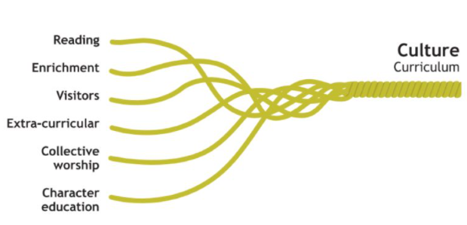The Culture Curriculum is what we add to the National Curriculum to develop AVA students into well-balanced citizens and it is underpinned by our drive to ensure our students read widely and regularly, both for enjoyment and to learn. Students take part in local and international visits, can access a wide range of clubs, and meet regular visitors and speakers to stretch their learning.

## Core Curriculum for Key Stage 3

The Aylesbury Vale Academy offers its students a broad, balanced and ambitious curriculum.

During Key Stage 3, all students access courses in English, Mathematics, Science, Art, Design Technology, Drama, Information and Communication Technology, Computer Science, Geography, History, Modern Foreign Languages (Spanish *and* French), Personal Health and Social Education, Religious Studies, Music, and Physical Education.

## 

## Core Curriculum for Key Stage 4

At Key Stage 4 students have an element of choice which allows them to personalise their Key Stage 4 curriculum.

English, Maths and Science along with core Physical Education are compulsory subjects for all students. The remainder of each timetable is composed of a variety of option subjects including Art, Information and Communication Technology, Music, Media, Business Studies, Health and Fitness, History, Geography, Modern Foreign Languages, Religious Studies, Physical Education Health and Social Care, Engineering, Design Technology, Spanish, French and Hospitality and Catering.

## Core Curriculum Post 16

Our courses in Years 12 and 13 currently offer a vocational route for further study. Students follow ‘pathways’ leading to further education, university or a specific career path. Within these ‘pathways’ students choose from a range of BTEC Level 3 courses such as Business Studies, Media Studies, Information Technology, Sport, Applied Science, Psychology, Mathematics, English Literature, and Health and Social Care. Alongside this they have the opportunity to take part in the national Young Enterprise scheme, Sports Leaders and to complete an Extended Project Qualification. Year 12 and 13 also take part in Physical Education.

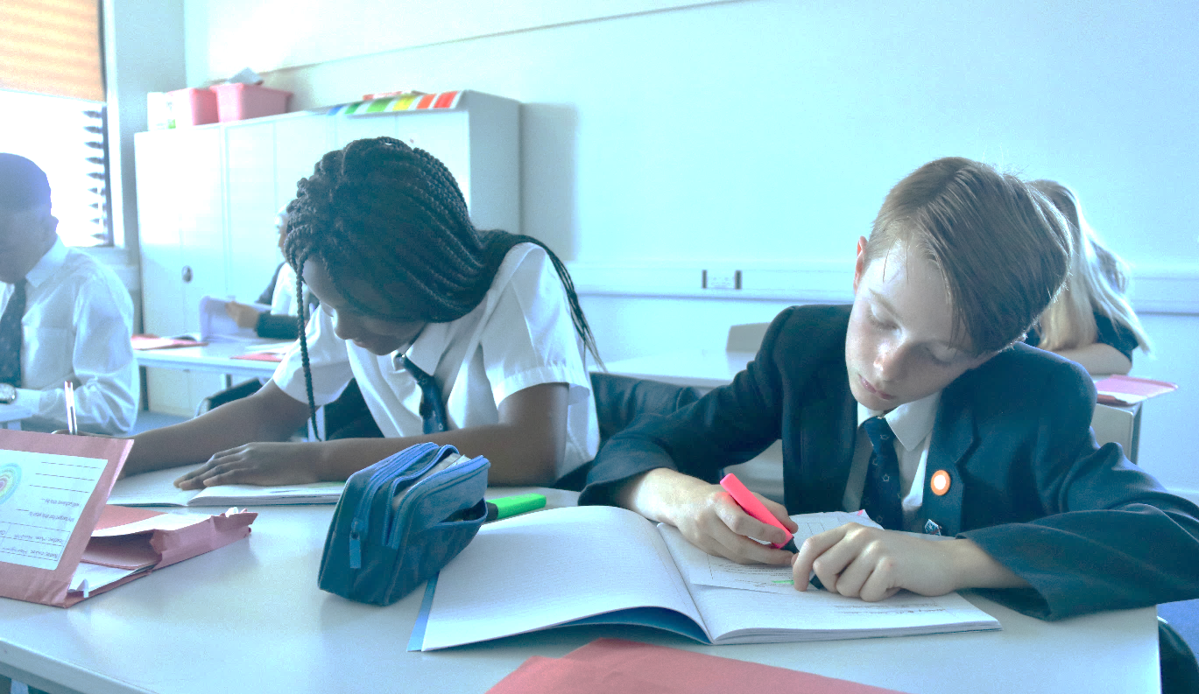**100%** of all our Post 16 students who applied to university in 2022 received an offer from their first choice university and had the grades to take up that place.

## Enrichment Programme

We have a strong enrichment programme available to all students aimed to broaden student experiences outside of their timetabled subjects, develop life skills, build their cultural capital and embed a love of lifelong learning. The range of activities on offer runs not only through the different core curriculum subjects but also as after school clubs in Years 7-8 as well as our Extended Schools programme for Years 9-11.

The Extended Schools programme complements our enrichment opportunities and involves Years 9 and 10 having an extended school day that runs until 4pm two days per week.

Year 9 and 10 students will use this extended day to take part in enrichment activities that they have chosen alongside study sessions where they are encouraged to develop their independent study skills by completing homework, revision or additional work for their Key Stage 4 courses.

.

