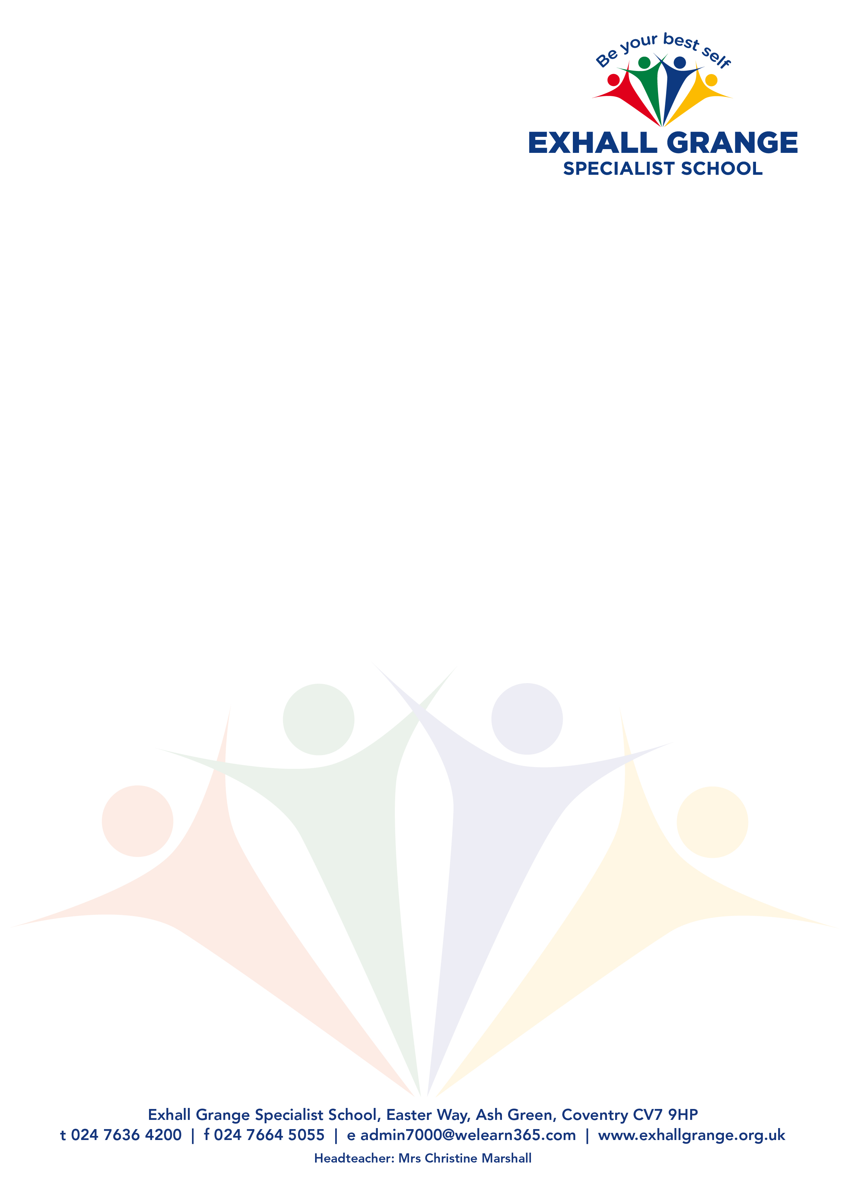

CM/pk

21 April 2021

**Re: Post of Humanities Teacher (SEND)**

Thank you for your interest in the above vacancy at Exhall Grange Specialist School. I hope that the following information is of interest and that you decide to apply. The closing date for applications is **9.00 am on Wednesday 5 May 2021.**

Exhall Grange Specialist School is a county-wide specialist provision for pupils aged between 2 and 19. The school meets the needs of pupils who are unable to access the curriculum in a mainstream school owing to their sensory impairment or physical disabilities or the impact of long-term illness or social communication difficulties including autism.

We offer a mainstream curriculum and endeavour to break down barriers to learning. Through high quality teaching and personalised support, we aim to unlock the potential of every pupil so that they leave our school as well-rounded citizens, ready to embrace the next step of their journey.

We are seeking to appoint for September 2021, a Humanities teacher with a relentless drive to pursue the best possible outcomes for all our pupils in Key Stages 3 and 4. The successful applicant will demonstrate a determination and dedication to achieving success for all of our pupils.

This is an excellent opportunity for a newly qualified teacher to start their career or an experienced teacher to broaden their teaching experience. We are looking for a practitioner who is able to teach engaging and challenging lessons that promote students’ abilities to learn independently and to respond effectively to feedback.

Exhall Grange Specialist School is committed to Safeguarding Children in line with the Keeping Children safe in Education Policy, and the post holder will be subject to all of the relevant pre-employment screening checks including an Enhanced DBS with barred list check.

**Successful candidates will be contacted via email where possible and references will be sought prior to interview.**

We look forward to receiving your application.

Yours sincerely,

Christine Marshall

Christine Marshall

Headteacher