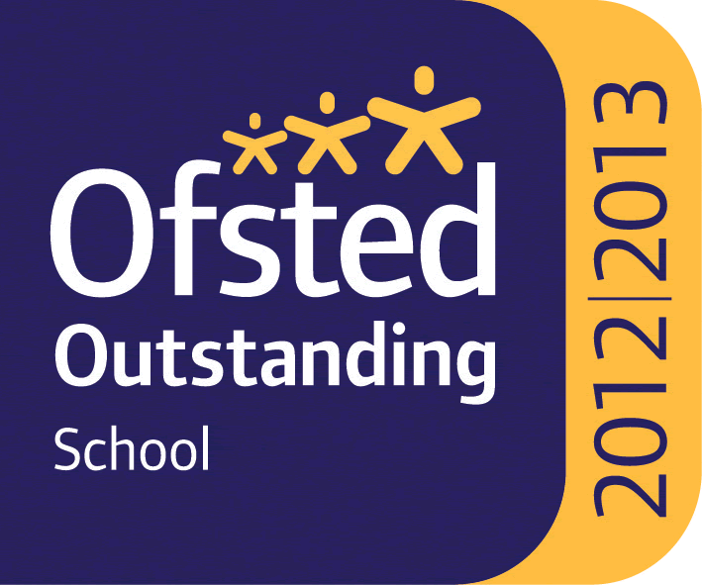

WHITLEY BAY HIGH SCHOOL
13-18 Mixed Comprehensive; NOR 1702 (590 in Sixth Form)

Deneholm, Whitley Bay, Tyne and Wear, NE25 9AS
Headteacher: STEVE WILSON

Outstanding – OFSTED May 2013
National Teaching School

TEACHER OF ICT and/or COMPUTER SCIENCE

We require for September 2021, or as soon as possible after this date, a teacher of ICT and/or Computer Science to join this very successful and supportive department. Both ICT and Computer Science are popular and growing subjects within the school. In ICT currently 59 students study the subject at KS4 and 60 at KS5. In Computer Science 91 students study it at KS4 and 49 at KS5.

The school is heavily oversubscribed, achieves very high standards and has benefited from substantial investment to improve facilities over recent years.

All staff who join the school benefit from a carefully structured programme of training and support. Any applicant should be committed to making a significant contribution to the wider life of the school.

Please find the job description, application form, application details and school information on the school website ‘Vacancies’ section at: www.whitleybayhighschool.org

Completed applications and a letter (800 words maximum) explaining why your experiences to date have prepared you for this role at Whitley Bay High School, should be sent to jackie.patterson@whitleybayhighschool.org before the closing date below.

Closing date for applications is Friday 25th June 2021 at 10.00am.

We are committed to safeguarding and promoting the welfare of children and expect all staff to respect this commitment. This post is subject to an enhanced DBS check.

