



Teacher of IT

Applicant Information Pack

June 2025

Headteacher’s welcome

Thank you for your interest in working at Q3 Academy Great Barr.

Whether you are beginning your teaching journey or looking for the next post in your career, we all know being a teacher is a demanding job that requires passion and energy. If you have a genuine interest in helping young people learn and develop, then our students will pay you back in spades. The passage below, from our website, sets out our philosophy and the following pages will give you some flavour of how we go about our work. Please feel free to contact us for an informal chat or visit. I look forward to meeting you.

**Mr Chris Bury, Headteacher**

*Our educational philosophy is simple. First and foremost, we want every child to feel happy and excited about coming to the Academy. Only when each child feels secure and comfortable can we challenge them to grow and learn together. We want our students to return home telling their families of the memorable exciting learning experiences they have enjoyed. Experiences that make it easier to recall the detail necessary for exam success and experiences that develop their character as much as their academic potential.*

*Our passion is helping young people to flourish and become confident capable adults ready for the world ahead.*

*This passion creates a genuine warmth that supports every member of our community. Our traditional family values and Trust ethos, ‘Life to the full in pursuit of what is good, right, and true’ helps to keep the academic and well-being of every child sharply in focus and drives our ambition for continual improvement.*

*Only if our staff can say that what we provide is good enough for their own children is it good enough for yours and I’m proud to say this commitment to care, coupled with high academic ambition is helping all our young people to succeed.*

**

About our Academy

As a mixed comprehensive academy with a dynamic Sixth Form, Q3 Academy Great Barr serves a vibrant and culturally diverse community of nearly 1,200 wonderful students.

Our gorgeous new buildings are surrounded by open, picturesque fields and woodlands, and the Academy offers a stimulating setting for teaching and learning. Our facilities are designed to inspire, with state-of-the-art classrooms and resources that support a rigorous, knowledge-rich curriculum. This curriculum is carefully crafted to challenge students, develop critical thinkers, and prepare them for successful futures.

Professional growth is embedded in our culture, and Q3 Academy Great Barr presents unparalleled opportunities for students and staff. If you are an educator passionate about shaping the future generation, you will be joining a community where education is valued, diversity is celebrated, and personal development is prioritised. This is a place where your talents will be valued, and your career can flourish.

We are proud to be part of The Mercian Trust, which provides us with access to wider resources, professional development, and a network of educators focused on pioneering teaching and learning methods, including digital transformation. Join us for an opportunity to be at the forefront of a transformative educational approach that champions collaboration, innovation, and excellence in teaching and learning.

Why work here?

* Join an incredible team of friendly and supportive staff
* Work with our amazing students in a positive learning environment supported by a centralised behaviour system
* Manageable marking
* Supportive feedback culture with no high-stakes observations
* Rich culture of professional learning, with a high-quality CPD programme
* Fully resourced curriculum
* Three-week Christmas break and three ‘buy back’ days of extra summer holiday as thanks for contributing to the wider life of the Academy
* Visible and supportive SLT
* Modern laptops for staff and visualisers in every classroom
* Connect and unwind with regular social activities
* Access to Simply Health benefits, supporting your optical and dental care needs and including a free annual flu vaccination
* Free car parking on site
* Enjoy exclusive discounts and benefits through Edenred, including a cycle to work scheme



“Q3 Academy Great Barr is a great place to work because students appreciate you as a teacher. Often students will thank you for your lesson and I love working with them as a team. It is not just a workplace but a hub of professionals who are always happy to support and encourage others. I feel part of a family rather than one of many.”

*– Teacher of Science (2024)*

“Lots of places promote the idea of students and staff being at the very heart in all that they do. Well, come see a place that actually does that. Visit us and see the smiles, you won’t want to leave!”

*– Teacher of French (2024)*

“I am grateful for the amazing opportunity to work as a teacher at Q3 Academy Great Barr. What sets us apart is the unwavering support from all staff members, from teachers to administrators. Everyone is approachable and always willing to help, making me feel valued and appreciated. Every day is a joy to come to work.”

*– Teacher of Geography (2024)*

Staff testimonials

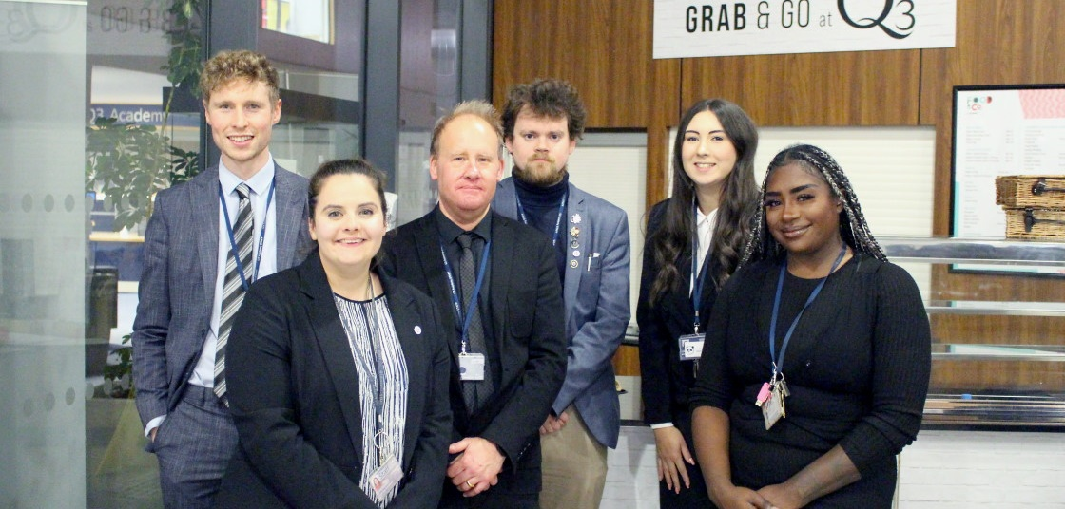

The English Department

**Our Mission**

The English Department is committed to enhancing students' education by deepening their understanding of language and literacy. We emphasise the importance of critical reading, effective writing, and the exploration of diverse literature, both historical and contemporary. Our team comprises a variety of specialists who collaborate effectively to ensure that our curriculum reflects our vision and meets the needs of our students.

**Our Vision**

We aim to teach students to speak, read, and write effectively. Students are encouraged to think critically and to reflect on their learning. We strive to instil a passion for learning and a deep respect for education.

**Our Values**

We value rigorous and comprehensive study of language, literacy, and literature; development of critical reading and reflective skills; creation of high-quality writing across various forms; understanding how studies in language and literature can transform our perceptions of local, national, and international communities; and teaching that prepares our students to be informed and responsible members of society.

**Building Citizens of the World**

Our curriculum is designed to reflect British Values within the texts studied, examining how these values manifest in contemporary literature, with particular attention to the Academy's SMSC (Spiritual, Moral, Social, and Cultural) obligations. Careers, while explicitly covered through Enterprise, are also explored through the lens of successful writers and dramatists.

The Mathematics Department

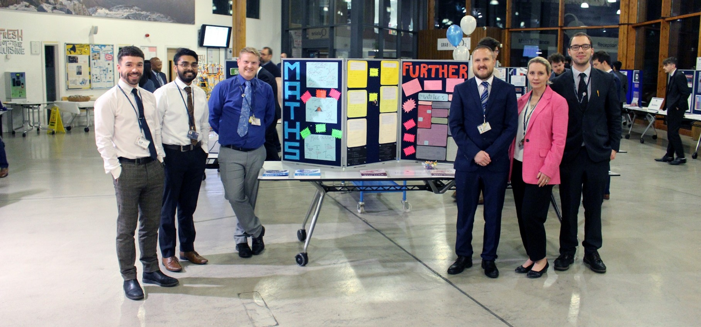

At Q3 Academy Great Barr, we feel very lucky to work with the team that we have here. We are a hardworking group but we also understand the importance of working together to support each other and help manage workload. As a department we are very settled, with the majority of staff having been at the Academy for at least five years.

We have worked hard over recent years to develop a rigorous, knowledge-rich curriculum with supporting resources available for staff. We have also tried to ensure we get a good balance between fluency and problem-solving and continue to refine the scheme to support how staff deliver content and how students are able to learn.

We subscribe to a variety of different online tools. For example, we use MiniTest to mark most assessments online, providing effective feedback and sharing this with parents/carers in a very quick and manageable way. We use Sparx Maths to engage students with effective homework, and we buy in to various other packages such as Integral Maths and MathsBox to support with planning.

We understand the importance of our job and take it very seriously, but we also understand the value of working together and developing as a team. We have an open department where people regularly and freely share their resources as well as tips and advice. There is a lot of experience within our department and we are all happy to share that.

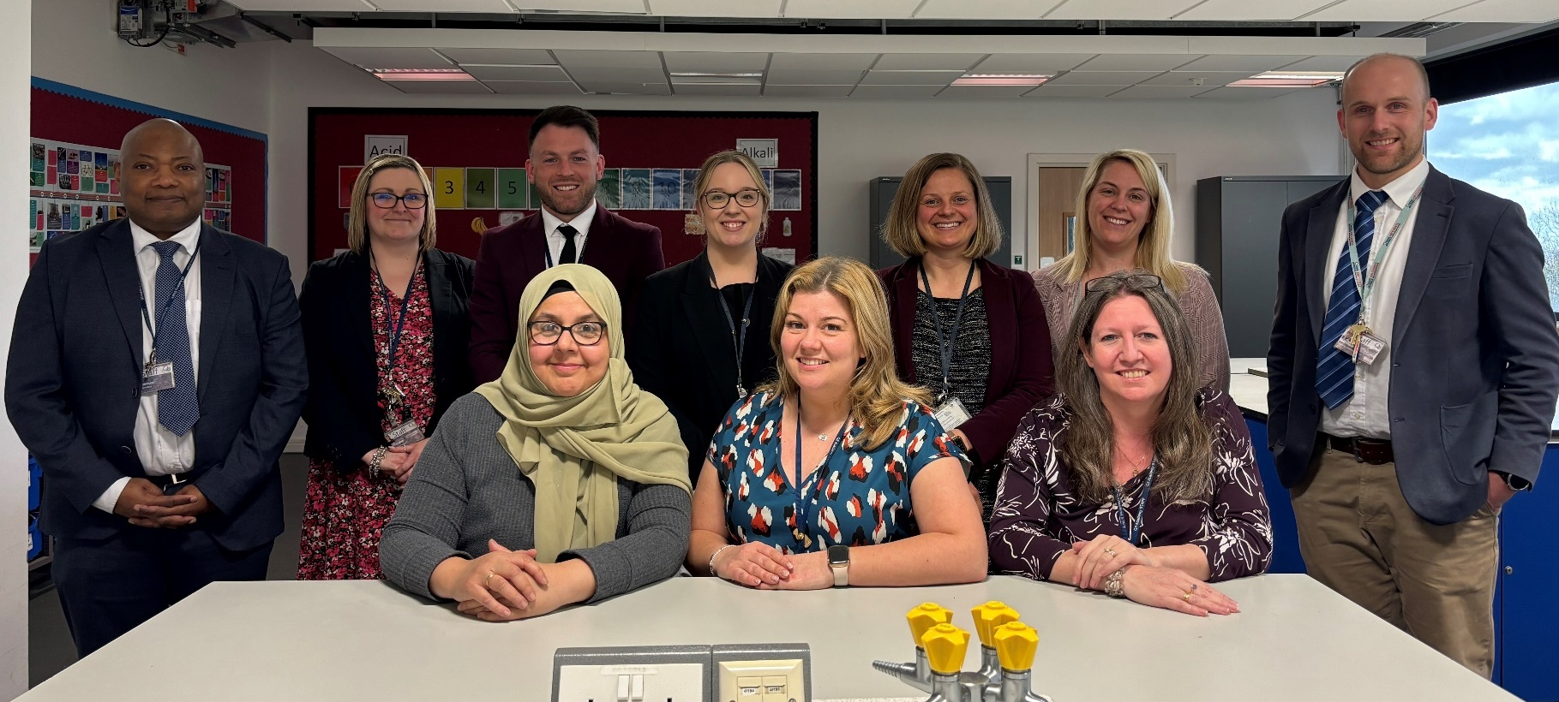

The Science Department

The Science Department is dedicated to fostering a deep understanding and appreciation of scientific principles in our students. We aim to equip students with the critical thinking skills and practical abilities necessary to excel in science and to apply their knowledge in real-world situations.

**Facilities and Resources**

* **Laboratories**: We have well-equipped laboratories for Physics, Chemistry, and Biology, each designed to support specific practical experiments aligned with the curriculum with the support of our Science Technicians.
* **Technology**: We incorporate technology into our curriculum with interactive software, simulations, and online platforms that enhance learning and engagement.
* **Shared resources and planning**: Resources for KS3 and KS4 are planned and shared across the department. This reduces staff workload whilst ensuring all students receive a high-quality curriculum in science.
* **Online marking**: The use of online marking during mocks reduces staff workload whilst being able to generate tailored feedback to students on their next steps for improvement.

**The Team**

The department is staffed by a team of experienced and passionate teachers, each specialising in different areas of science. Regular professional development sessions are held to ensure that our teachers are up to date with the latest educational practices and scientific discoveries. It is a department that is regularly recognised for our supportive and collaborative ethos to ensure we are a team that will always strive provide the best curriculum and experience for our students.



The Art & Design Department

We are proud to have a strong and ambitious department, with specialist teachers delivering Key Stage 3-5 courses including Fine Art, Photography, Textile Design, 3D Design, Design & Technology, and Food Preparation & Nutrition.

Art and Design at our Academy inspires creativity, innovation, and practical skills. The curriculum combines traditional artistic techniques with modern design principles, encouraging students to explore a wide range of media, materials, and processes. Students develop their visual literacy, problem-solving abilities, and critical thinking through hands-on projects, collaborative work, and independent study.

**Facilities and Resources**

* **Specialised studios:** Our department features bespoke studios for painting, textiles, and digital arts, along with two well-equipped workshops. These spaces are enhanced by the support of our two department technicians.
* **Collaborative resource planning:** We take a collaborative approach to resource management, with KS3 and KS4 resources developed and shared department wide. This strategy not only reduces staff workload but also ensures that all students enjoy a rich and varied curriculum.

**The Team**

Our department is powered by a dynamic team of passionate and skilled educators, each an expert in different disciplines. We are known for our supportive and collaborative ethos, and we are dedicated to continuously advancing our curriculum and enriching the student experience in the arts.

If you're looking to inspire and be inspired, to innovate, and to make a significant impact on the next generation of artists and designers, our department is the place for you. Join us in shaping a creative future.

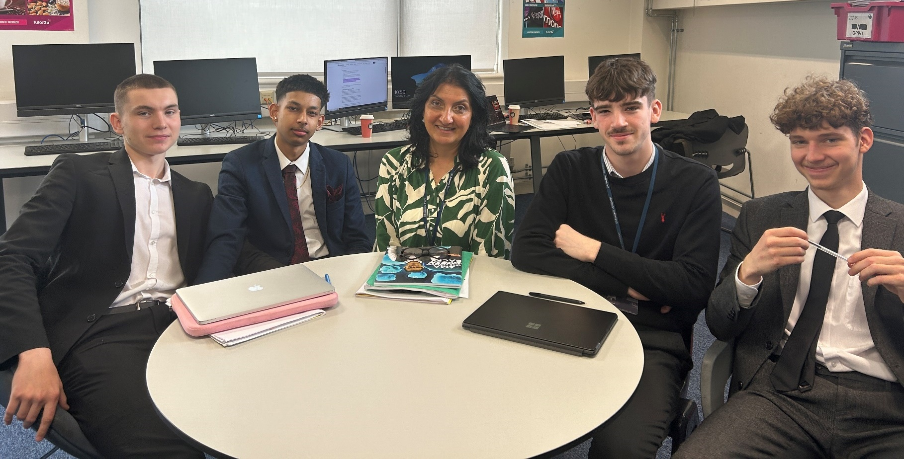

The Business Department

At Q3 Academy Great Barr, Business Studies is a very popular subject and classes are full of positive, motivated students who often want to pursue a career in business. Students, especially at sixth form, are highly driven to achieve the best grades in a subject with which they connect easily.

Our curriculum is well-planned and structured. The students are always willing to take part in partner work, group work, and whole class simulations. Our business classrooms are a place where business comes alive.

We have planned our Schemes for Learning, so that key concepts and themes are delivered in the first year of the course and the more interconnected nature of business is focused on in the second year.

Key skills for success in business are cultivated from the start of the course. Communication both verbal and written, developing analytical or evaluative responses and understanding the key terminology that underpins our discipline are part of lesson delivery.

As every subject we teach is examined, preparation for exam success is also vital and students comment how well prepared they feel for the examination season.

Many of our students go on to pursue an apprenticeship or a degree in a business-related subject. It is a department both students and staff enjoy being a part of!



The French Department

We are a forward-looking and enthusiastic team who are dedicated to promoting the joy and utility of learning foreign languages. At Q3 Academy Great Barr, we believe in developing students not just to meet examination criteria but to become outstanding linguists who can thrive in a multicultural and interconnected world.

At Key Stage 3, all students are introduced to French, laying a foundation that is built upon in Key Stage 4. Our teaching strategies are designed to stretch the most capable while supporting those who find the subject more challenging. Lessons often extend beyond the basic curriculum or exam specifications, leveraging our teachers’ strong subject knowledge to enhance student understanding and engagement.

The ethos of our department is centred on developing ‘world citizens’ – confident individuals who view themselves as part of a diverse, respectful global community. Our curriculum is crafted to foster curiosity and deepen students' understanding of the world. This involves enhancing students' ability to understand and respond to spoken and written language from various authentic sources, encouraging confident, fluent, and spontaneous speech, developing writing skills across a range of contexts, using a variety of grammatical structures, and cultivating an appreciation for a range of literary works in the target language.

We maintain a high profile across the Academy with an ambitious agenda that includes a broad range of extracurricular activities. Notably, our annual overseas trips provide invaluable real-world exposure, enhancing the linguistic skills and cultural understanding of our students. The use of technology in and out of the classroom also plays a crucial role in making language learning accessible to all students, enabling them to practise and improve their skills.

Our commitment to these principles contributes significantly to our students’ acquisition of cultural capital, preparing them to navigate and contribute to the world with knowledge, respect, and empathy.

The History Department

At Q3 Academy Great Barr, we develop students’ ability to ‘do history’ as opposed to learning some facts about history. We give an understanding of the nature of historical interpretations and embed these in the curriculum. We promote a cultural literacy that enables genuine engagement with the world. We creatively use a wide variety of interesting primary sources to illuminate the work of the historian and finally. We go further than the textbook or specification at every Key Stage to bring the past to life for our students.

As a team, we have worked tirelessly to produce a history scheme that uses elements of the National Curriculum but also allows us to be creative as an Academy and teach topics that we feel will enhance students’ overall historiography.

At Key Stage 4, we teach People’s Health 1250-Present Day, Elizabethan England 1580-1603, History Around Us, Living Under Nazi Rule 1933-1945, and Making of America 1789-1900.

At A-Level we offer Tudor England 1485-1603, Democracy & Nazism 1918-1945, as well as a Non-Exam Assessment where students write an extended piece on a passion project of their choosing.

In addition, we also teach A-Level Government & Politics which covers a range of topics including government of the UK, politics of the UK, politics of the USA, and political ideas. We feel these work brilliantly together with our history curriculum and boost students’ knowledge.

The department is staffed by passionate, diligent, and experienced teachers who have worked for the department for a combined 60 years! This has allowed us to be stable and successful at the same time whilst also growing with each other. We have seen the department flourish into an exciting place to work where we will be delighted to have you on board.

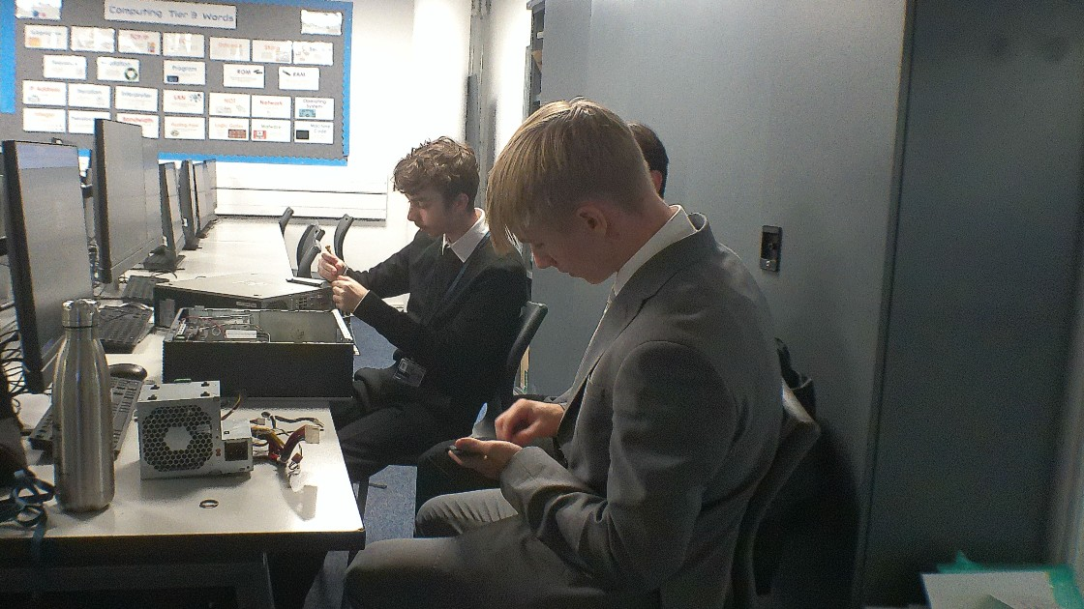

The Computer Science Department

The Computer Science department at Q3 Academy Great Barr offers an outstanding opportunity for an ambitious and passionate individual to make a genuine impact while building on strong and well-established foundations. We currently deliver qualifications in both Computer Science and Creative iMedia — subjects that are consistently among our most popular options, as students increasingly recognise the pivotal role of these disciplines in the modern economy. Our students are motivated, enthusiastic, and eager to develop their technical knowledge and practical skills in these dynamic fields.

Our provision spans across Key Stages 3, 4, and 5, allowing us to foster a deep and lasting understanding of the subject over time. We are committed to delivering a knowledge-rich curriculum that equips students for success both academically and in their future careers. Within the department, we take great pride in our collaborative ethos: we work closely together, share resources generously, and provide strong support networks for all colleagues, including those new to the profession.

As we look to expand the amount of specialist Computing teaching within the Academy, we are excited by the opportunity to innovate and continually refine our practice. We actively embrace new ideas, celebrate best practice, and are committed to professional growth and excellence. This is a fantastic time to join a forward-thinking, supportive, and thriving department — and to be part of shaping the future of our Computing education.

Job Description

**Title:** Teacher

**Reports to:** Curriculum Leader

**Grade:** Main Scale/UPS

**Key Duties and Responsibilities**

* To be responsible for adding value to every learner in each teaching group benchmarked against national criteria and data;
* to deliver, plan, and prepare lessons in accordance with the planned curriculum;
* to deliver learning by utilising Academy Policies;
* to work as part of, and contribute to, an exceptional area that ensures creative and innovative learning and teaching occurs in every lesson.

**Teaching and Learning**

* Use a variety of learning and teaching strategies to deliver outstanding lessons to all students ensuring pace and challenge are maintained;
* understand and integrate the use of new technologies into learning experiences in order to raise levels of achievement;
* plan lessons and extend learning opportunities in line with Schemes for Learning;
* ensure curriculum intent is clear;
* to differentiate learning appropriately, taking into account individual learner needs;
* make use of extended learning opportunities;
* participate in the Academy’s Quality Assurance programme and its agreed framework;
* work effectively and creatively using the full range of resources available, including other adults and mentors;
* provide a positive learning climate within lessons to promote a meaningful staff – student relationship and interaction;
* adhere to the Trust’s Positive Behaviour Policy and ensure implementation in everyday life at the Academy;
* regularly evaluate the progress of students in relation to their prior attainment and use data to inform teaching and learning;
* report, as required, in line with the Trust’s reporting processes to a variety of stakeholders including students, parents/carers, and the Senior Leadership Team;
* mark work in accordance with the Academy’s assessment practice providing both formative and summative feedback on a regular basis;
* to take responsibility for individual professional development and use the outcomes to improve learning and teaching;
* to demonstrate a thorough and up-to-date knowledge of learning and teaching taking into account wider curriculum developments, which are relevant to your work, e.g. National and Department for Education initiatives;
* to be aware of the Trust’s Anti-Bullying Policy and support students as necessary;
* to maintain good order and behaviour for learning among students, particularly in regard to Health and Safety, both on the Academy premises and when engaged in authorised activities elsewhere.

**Wider Professional Effectiveness**

* Participate and actively engage in CPD;
* demonstrate ongoing improvement in your role as a result of Professional Development;
* liaise appropriately with colleagues.

**Role Model**

* Ensure that ‘no student is left behind’, in their academic and personal development;
* conform to the Academy’s Dress Code for staff and demonstrate exceptional standards of presentation, conduct, and time keeping;
* build team commitment amongst students and staff alike;
* engage and motivate students and staff to do their best by doing your very best;
* demonstrate a positive approach to your professional duties.

**Additional Components**

* To consistently uphold the Academy’s aims and strive to attain Academy targets;
* to work in an enthusiastic, cooperative. and polite manner to enhance the Academy’s reputation;
* to work with students in a courteous, positive, caring, and responsive manner;
* play a full part in the life of the Academy’s community, to support its distinctive mission and ethos, and to encourage staff and students to follow this example;
* carry out duties in line with all policies and promote a positive, harmonious working environment;
* the job purpose and key task statements above are indicative and by no means exclusive. The need for flexibility amongst staff is therefore considered important.

**Health and Safety Responsibilities**

* All staff have a responsibility to be aware of, comply and act upon the Health and Safety Policies of the Academy and Trust, and to undertake risk assessments as appropriate;
* the Academy site is a designated no smoking site.

|  |  |
| --- | --- |
| **Criteria** | **Essential (E) or Desirable (D)** |
| **Education &**  **Qualifications** | * Qualified teacher status (E) * Good honours degree (E) * Continuing good record for professional development (D) |
| **Skills, abilities, and experience** | * Achievement of high standards (D) * Awareness of the value of assessment data in raising standards (D) * Use ICT to enhance learning (D) * Effective verbal and written communication (E) * Ensure that the educational needs of all children are met (E) * Skills to teach all Key Stages (D) |
| **Curriculum Knowledge** | * Planning for all areas of learning meets the needs of all students (E) * Assessment procedures used to inform planning for teaching and learning for all students (E) * Understanding effective inclusion practice (E) * A broad and balanced curriculum for all students (D) |
| **Disposition** | * Clear understanding of how students learn and how their needs can be met (E) * Clear understanding and commitment to equality principles and practices (E) * Determination to overcome barriers, including attitudinal barriers to the effective inclusion of all students (E) * A commitment to high standards for all (E) * A commitment to self and Academy improvement (E) |

**The Mercian Trust is committed to safeguarding and promoting the welfare of children. All post holders are subject to a Satisfactory Disclosure & Barring Service Check. Satisfactory employment references and identification and qualification checks will be required before commencing duties.**

Person Specification

To apply for this role, please submit an application form on our [**recruitment portal**](https://ce0218li.webitrent.com/ce0218li_webrecruitment/wrd/run/ETREC179GF.open?WVID=617104FK7u).

How to apply

**Key dates**

|  |  |
| --- | --- |
| Deadline for applications | Sunday 29th June at 11:59pm |
| Interviews | Week commencing 30th June |

**Visiting the Academy**

If you would like to arrange a visit before you apply, please contact Mr J Mills, Assistant Headteacher, at [j.mills@GBR.merciantrust.org.uk](mailto:j.mills@GBR.merciantrust.org.uk)

