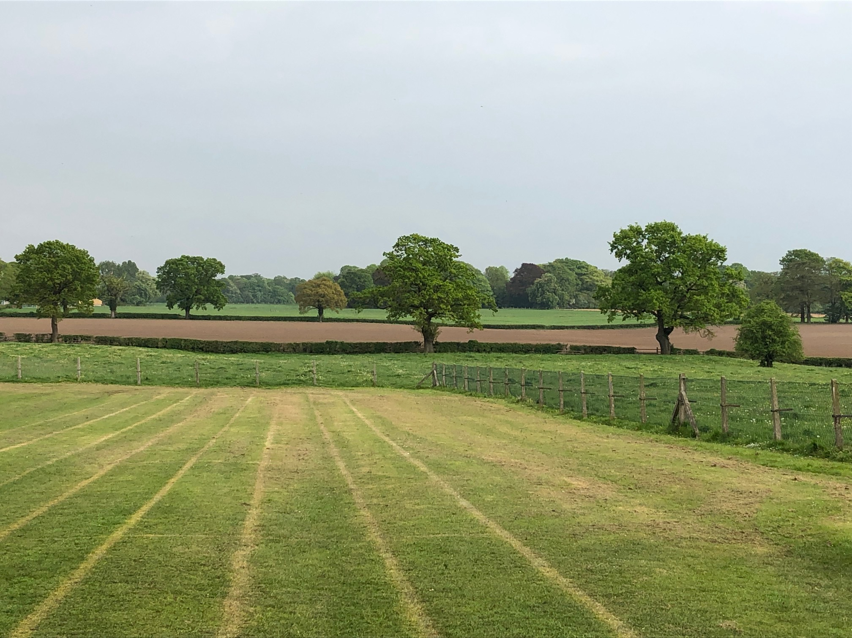

MOBBERLEY CHURCH OF ENGLAND PRIMARY SCHOOL

Church Lane, Mobberley, Cheshire, WA16 7RA

Headteacher: Mr D Stenson B.Ed NPQH

T: 01625 800 920 • E: [admin@mobberley.cheshire.sch.uk](mailto:admin@mobberley.cheshire.sch.uk) • W: www.mobberley.cheshire.sch.uk



**KS1 and KS2 Maternity Cover Teaching Vacancies**

**(2 Teachers Required)**

|  |  |
| --- | --- |
| **School:** | Mobberley C of E Primary School |
| **Headteacher:** | Mr Damien Stenson |
| **Address:** | Church Lane, Mobberley, WA16 7RA |
| **Telephone Number:** | 01625 800 920 |
|  |  |
| **School Email Address:** | admin@mobberley.cheshire.sch.uk |
| **School Website Address:** | http://www.mobberley.cheshire.sch.uk |
| **Position Advertised:** | 2 Positions - KS1 and KS2 Teacher  (Full Time Maternity Cover – 5 Days Per Week,  Starting Sept 2024) |
| **Salary:** | MPS |
| **Closing Date:** | Friday 17th May (12 noon) |
| **Shortlisting:**    **Interviews:**  **Applications to be obtained from:** | Monday 20th May    Friday 24th May  School website / admin@mobberley.cheshire.sch.uk |
| **Applications to be returned to:** | admin@mobberley.cheshire.sch.uk (deadline) |
| Mobberley C of E Primary School is a vibrant and progressive learning community. Our caring village school is a place where a love of learning is fostered, friendships are valued and achievements are celebrated.  The Head Teacher and Governors are seeking to appoint 2 committed, enthusiastic and creative teachers to join our team. The maternity cover would be for one year, starting September 2024. Applications are welcomed from experienced teachers and ECTs.  The successful candidate will be a strong classroom practitioner with a focus on improving pupil outcomes. It is essential that they are sensitive to the needs and abilities of our pupils while ensuring that each pupil is appropriately challenged to achieve their potential. We are looking for someone knowledgeable and passionate about Primary Teaching with a personal drive to enable high quality classroom experiences and strong outcomes.  In return, Mobberley School can provide friendly children, a welcoming team of strong professionals, a stimulating working environment, supportive parents and a strong CPD offer.  Mobberley C of E Primary School is committed to the safeguarding and welfare of children within our care. Suitable candidates will be subject to stringent enhanced checks as part of the selection process.  If you would like to visit, please contact the school office on 01625 800 920 or email admin@mobberley.cheshire.sch.uk.  Application packs (including Person Specification) can be obtained from the school website / school office – admin@mobberley.cheshire.sch.uk | |