****job description

**Teacher of Law**

**reports to:** Deputy Principal

**hours:** Part time 0.5 over 4 days, permanent. Larger fraction of 0.75 possible if able to deliver English Language.

**salary:** T1-T9 £16,089-£24,862, 0.5 salary (£32,178-£49,725 FTE)

**start date:** Tuesday 19th August 2025

**about the role.**

We seek to appoint a committed and hardworking teacher who is a specialist in Law. This role is to teach BTEC Applied Law and also potentially teach on the A-level Law course. This is a permanent position on a part time basis with a 0.5 fraction. The days of work would be Monday, Thursday and Friday mornings and Tuesday afternoons. A larger fraction would be considered if you are able to teach A-level English Language in addition to Law.

BTEC Applied Law is a very popular course choice in the College, with over 170 students studying the course across both year groups. In addition, the department also offer A-level Law which over 140 students study. The department follows the Pearson specification for the BTEC course and the OCR specification for the A-level course.

The suitable candidate will be an individual who is immersed in their subject and loves imparting this passion onto their students. Not only will they be highly effective in the classroom but they will also drive the process outside the classroom, maintaining up to date records of work submission, student performance, attendance and promptly tackling issue as they emerge.

We are looking for an individual with a strong passion for Law and eager to inspire the next generation of lawyers. Both experienced teachers and NQTs are encouraged to apply. Whatever your experience you will be supported in a way that best supports your development, in a College renowned for its innovation as well as the exceptional progress of its students.

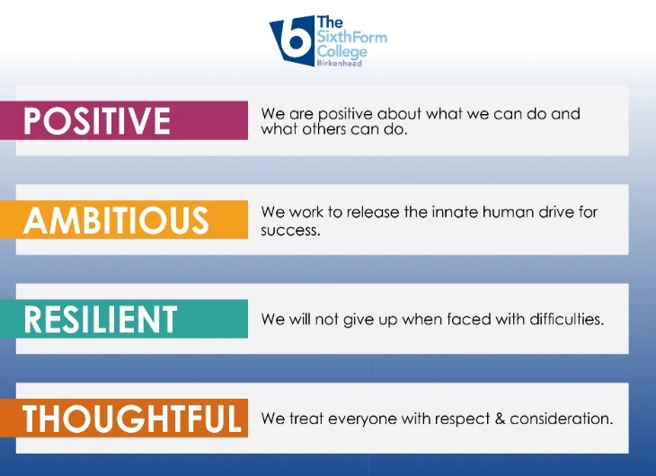**Our values.**

The College is committed to its core values of **Positivity, Ambition, Resilience** and **Thoughtfulness**, and these values shape everything we do.

Our mission is to open up academic study to more students than most and provide them with excellent teaching and unrivalled support to excel. The ethos is centred on the scientific evidence that tells us that everyone can achieve success through purposeful hard work as opposed to the talent myth. This enables learners to make rapid progress unshackled by any limits previously placed upon them.



**person specification.**

|  |  |  |
| --- | --- | --- |
| **Qualifications** | **essential** | **desirable** |
| Degree in Law or related qualification | **** |  |
| Recognised teaching qualification or willingness to work towards | **** |  |
|  |  |  |
|  |  |  |
| **Experience** |  |  |
| Experience of teaching Law | **** |  |
| Experience of teaching or examining for BTEC Law or A-level Law |  | **** |
| Experience of working in a demanding environment where high levels of organisation are required | **** |  |
|  |  |  |
|  |  |  |
| **Knowledge / Skills / Abilities** |  |  |
| A passion for Law | **** |  |
| An outstanding teacher that inspires others | **** |  |
| An individual who has very high expectations of their students and what they can achieve. | **** |  |
| Ability to teach A-level and BTEC Law | **** |  |
| Ability to be adaptable and flexible | **** |  |
| Ability to form & maintain appropriate relationships & personal boundaries with young people | **** |  |
| Ability to prioritise & meet deadlines | **** |  |
| Ability to use Information Technology effectively | **** |  |
| Excellent communication, interpersonal & organisational skills | **** |  |
|  |  |  |
| **To demonstrate a commitment to** |  |  |
| The Colleges values of Positivity, Ambition, Resilience & Thoughtfulness | **** |  |
| Personal development and training | **** |  |
| Safeguarding & promoting the welfare of students | **** |  |
| Equality & diversity | **** |  |
|  |  |  |



**how to apply.**

**If you are ambitious and determined to make a meaningful difference in one of the country’s leading sixth form Colleges then we would be thrilled to have you join our team.**

**Please complete the teacher application form**

**This is on the College website:** [**www.bsfc.ac.uk**](http://www.bsfc.ac.uk) **under Job Vacancies and looks like the box below.**



Please email these to: hrdept@bsfc.ac.uk

**closing date: midday on Friday 28th March 2025**

**Selection and Interviews to take place on Thursday 3rd April 2025**

**General Information**

Birkenhead Sixth Form College has a commitment to safeguarding and promoting the welfare of students and expects all staff and volunteers to share this commitment. If you are invited for interview, your suitability to work with children will be explored as well as your suitability for the post.

All posts are subject to Enhanced Disclosure Clearance through the Disclosure & Barring Service.

The College is an Equal Opportunities employer and all members of the College have a personal responsibility to implement the policy, to carry out their responsibilities in accordance with it and to maintain an equality of opportunity for all.

The Governors and staff of the College take their duties under the Disability Discrimination Act (as amended by the Special Educational Needs Act 2001) very seriously. They will ensure that all reasonable adjustments are made to ensure that disabled people are treated fairly and that they are not placed at any substantial disadvantage. The College is committed to interview all applicants with a disability who meet the minimum criteria for the post and to consider them on their abilities.

**Reference Checking**

On the application form, you are asked to provide details of two employment referees (preferably your line manager from your current and previous or most recent employer/s), who can comment on your suitability for the post. References from relatives or individuals writing in the capacity of friends will not be accepted.

The College will seek references on short-listed applicants before interview, and will approach previous employers for information to verify suitability for the post, dates of employment, particular experience or qualifications, attendance / punctuality history and details of any disciplinary offences.

In addition, if you are currently working with children or young people, on either a paid or voluntary basis, your current employer will be asked about your suitability to work with children and any disciplinary offences relating to children or young people. This will include any offences for which the penalty is time expired (that is where a warning could no longer be taken into account in any new disciplinary hearing for example) and whether you have been the subject of any child protection concerns, and if so, the outcome of any enquiry or disciplinary procedures. If you are not currently working with children but have done so in the past, that previous employer will be asked about those issues. Please note providing false information is an offence and could result in your application being rejected, or dismissal without notice if you have been appointed and possible referral to the police.