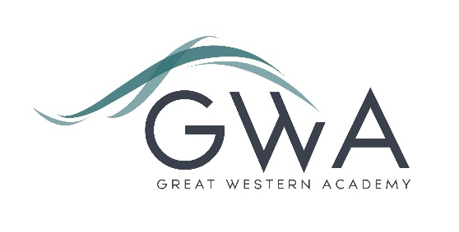

Information for Applicants

Teacher of Mathematics
Full-time or Part-time, Main/Upper Pay Scale
Great Western Academy opened in September 2018 and now accommodates over 900 students in years 7 to 11 and the Sixth Form. The results of our first three A-level cohorts in summer 2021, 2022 and 2023 were excellent and enabled 98% university applicants to take up their offers, including three to Oxford and Cambridge; students have also secured prestigious apprenticeships with companies such as Airbus and Rolls Royce. Our first GCSE results in summer 2023 showed that the progress made by the large majority of our first cohort of year 11 students has been excellent, particularly in English and Maths. This includes students of all abilities.

Application process

Please complete the application form supplied and enclose a supporting letter, either in the space provided on the application form or as a separate document. The application form should be completed in full in black ink or type. A CV is not required and should not be submitted as part of the application.

Your supporting letter should be no more than 2 sides of A4 (with a font size no smaller than 11) and should enhance your application by providing further information, matched to the person specification, about your suitability for the post. This should include evidence of the impact on student outcomes you have made in your career to date.

Applications should be submitted electronically to recruitment@gwacademy.co.uk by 9am on Monday 18th March 2024. Interviews will take place later that week.
However, we may interview before the closing date (and close the advert early) depending on the suitability, and number of, applicants.

Great Western Academy is committed to safeguarding and promoting the welfare of children, young people and vulnerable adults and we expect all staff to share this commitment and undergo appropriate checks. All posts within the Trust are therefore subject to an Enhanced DBS and barred list check.

References: References will be taken up prior to interview.

