Lady Manners School

Mathematics Curriculum Area

AIMS AND OBJECTIVES
The Mathematics Curriculum Area is part of the innovative and forward thinking Business and Mathematics Faculty. Collaboration is encouraged and students are encouraged to see the links between maths and business with the real world applications of maths in business used to enhance students' understanding and application.

At the heart of our practice is our key aim of ensuring every student makes progress in every lesson. We achieve this by teaching well-scaffolded lessons, considering the differing needs of pupils and adapting our teaching as appropriate. Our mathematics curriculum is designed to ensure students develop problem solving skills and resilience as well as preparing them for their future beyond school.

We aim to interest and motivate our students in their mathematical studies by ensuring they experience success using a wide range of courses and a variety of teaching and learning styles.

We aim to maximise the personal mathematical potential of each of our students, and enable them to achieve good examination results by challenging them to work hard and consistently in an ordered environment.

We aim to ensure that students feel at ease with any basic mathematical concepts encountered either inside or outside the classroom. Students are exposed to a wide variety of relevant and useful mathematics.

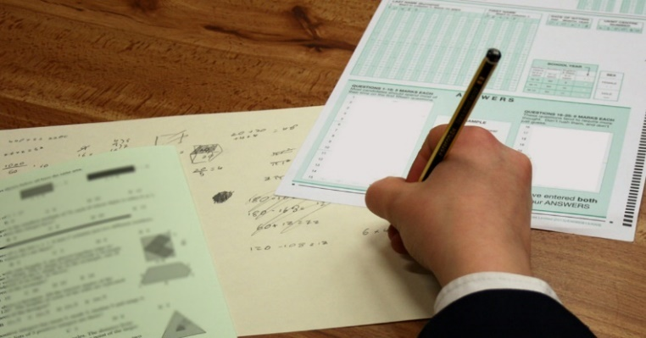
We aim to arouse a sense of mathematical wonder in our students by sharing our enthusiasm and exploring mathematics for its own sake, as well as challenging them by enabling them to take part in national competitions such as the UKMT Maths Challenge.

We aim to prepare our students for the wider responsibilities of adult life by a classroom ethos which encourages responsibility, initiative, concentration, perseverance, co-operation and respect for others.

CURRICULUM AREA OVERVIEW
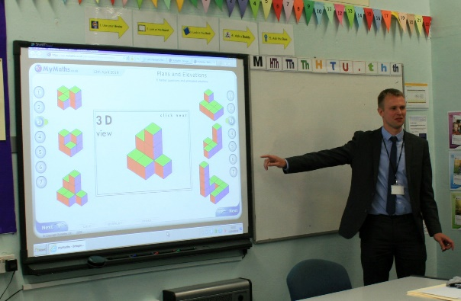
The curriculum area consists of 10 teachers. It is led by two Curriculum Leaders who work collaboratively but lead on separate areas - Curriculum & Assessment and Teaching & Learning. The Director of Learning provides leadership for the faculty as a whole.

The current team has a wealth of teaching experience and some have experience of other professions and skills. There is a high level of understanding of teaching and learning and this is a key element in the success of the curriculum area.

The curriculum area promotes a caring environment where we strive to respond to the needs of individual students. There is a strong belief that our students are capable, that very good results can be achieved and that the effectiveness of the curriculum area can help bring about that success.

PROCEDURES
New members of staff are introduced to the curriculum as a whole, shown how curriculum 'building blocks' are used to sequence student learning, with clear schemes of work and knowledge builders giving clarity on how student knowledge is to be developed.

Curriculum area and faculty meetings are held regularly. These are seen, not only as an opportunity to give and receive information and discuss the day to day business but, as an avenue for sharing resources and good practice.

Regular testing is used to inform the teacher, students and parents of the progress made with learning.

Homework is an integral part of our teaching and is set regularly, varying in length and difficulty to suit the age and abilities of the students and careful marking is conducted in line with school policy, ensuring that improvement points help students know how to make further progress.

In the area of target setting we are making extensive use of available data. We track the progress of groups and individuals in all three key stages and where appropriate put support and interventions in place for students who are under achieving.

MATHEMATICS FACILITIES AND EQUIPMENT
The curriculum area has the use of seven base rooms which are located close to the mathematics office. However, particularly in KS4, there are more than seven sets operating and so other rooms around the building are used.

We are well resourced in terms website subscriptions, basic equipment and textbooks. We have a class set of graphical calculators and each room has a computer and interactive whiteboard.

We also make use of visualisers and class sets of mini whiteboards.
THE MATHEMATICS CURRICULUM
KS3
In Key Stage 3 students are set by ability in half years in Year 7, 8 and 9. The scheme of work prepares students for future GCSE success by allowing space for students to encounter problems and develop mathematical resilience as well as covering content. We teach a knowledge-engaged curriculum using knowledge builders as an integral part of this and incorporate regular retrieval practice to ensure transfer of knowledge to long term memory. We use a variety of electronic resources as well as having the MyMaths textbooks available. We have placed particular emphasis on ensuring that active learning is a key feature of all lessons with a variety of resources used.

KS4
In Key Stage 4 students are set by ability into one of nine teaching groups. Currently we are using an adapted Edexcel Linear Syllabus with all sets and the scheme of work is objective led. We continue to use knowledge builders with a key focus on regular retrieval practice. We teach the 9-1 scheme of work from the start of Year 9 as a 3 year scheme of work. Again, we use a variety of electronic resources as well as the new 9-1 Collins textbook. We offer the AQA Level 2 Further Mathematics qualification to our top set students.

Sixth Form
Both Mathematics and Further Mathematics are popular options in the Sixth Form and a steady flow of students go on to read the subject, or related subjects, at university.

In each year group we have 2 or 3 Mathematics groups and 1 Further Mathematics group.

We run well attended drop-in sessions at lunch times which result in a vibrant atmosphere of mathematical discussion and study.

We have invested in new Hodder Textbooks for each student to accompany the new A-Level and also make extensive use of the Integral Maths website. We have chosen to use AQA exam board for A-Level and have continued to see excellent levels of success.

EXAMINATION RESULTS
Results are higher than national and local standards.

At GCSE, 80% of students gained Grade 9-4 in 2023 and 55% Grade 9-5.

With regard to A-level Mathematics, 83% of our students achieved Grade A*-B in 2023 (ALPS Grade 2).

Greater detail about our results is available on the school's website.

THE FUTURE
The curriculum area is committed to achieving the best possible performance from students and has high expectations, which are translated into daily practice.

It is an area that is characterised by dedication, professionalism, energy and enthusiasm. The curriculum area is effective because teachers are prepared to share their successes and failures with one another and welcome each other into the classroom. The opinions and expertise of all members are valued and resources are shared equally.

The development of the Business and Mathematics Faculty offers the chance to build on the many strengths of the curriculum areas and the successes already achieved, through increased collaboration, joint projects and shared expertise.

Each member of the faculty has a part to play in its continuing development. The post offers the opportunity to contribute to the development of the Mathematics Curriculum Area and beyond, involving professional development within an established and forward thinking team.

We offer the experience of teaching across the whole age and ability range including A-level and we look forward to working with and supporting a new colleague.

