Our Maths Department
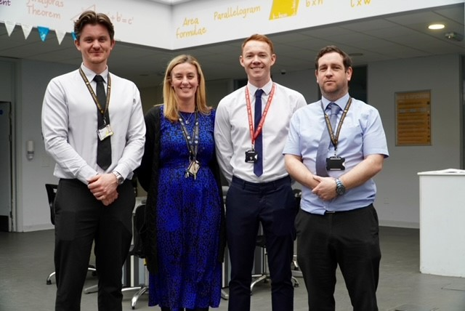
The Department consists of 14 full time teachers with a range of experience and levels of responsibility both within the department and across the Academy. It is led by Emma Van Deventer, Curriculum Leader and overseen by Chris Welch, Assistant Principal with responsibility for Data. Each key stage is also managed by a:
• KS5 Co-ordinator
• KS4 Co-ordinator
• KS3 Co-ordinator
• Lead practitioner for Teaching and Learning
Mathematics is a thriving department, achieving good results, and encouraging students to study both Maths and Further Maths at A-Level. All members of the department are supportive of each other and have an excellent team ethos. We are constantly striving to improve and we are truly invested as a team in providing the best possible outcomes for our students. We have a growing cohort in our Exponentials pathway in KS5 and we are striving to role this out into the lower key stages. We have forged strong links with AMSP and Liverpool University and try to offer as many enrichment opportunities as possible. Students at NLA will openly say that Maths is their favourite subject.
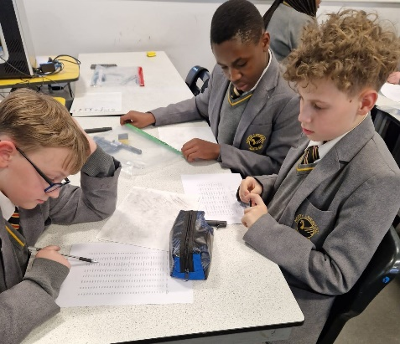
Key Stage 3

Key Stage 3 Mathematics provides students with the opportunity for three years, to explore and experience a variety of mathematical areas. Whether students are going to follow a career in mathematics or whether they will require skills in order to follow alternative pathways, maths is key to understanding and modelling the world round us.

Numeracy and Problem Solving are the focal points of Key Stage 3 at North Liverpool Academy, as we aim to provide all pupils with the tools necessary to be prepared for GCSE Mathematics. Regardless of their starting point, it is our aim to instil high aspirations into every student so that they leave Year 9 engaged, enthused and resilient; ready for the next steps of their academic journey. We endeavour to provide a fully inclusive KS3 curriculum which has a strong emphasis on problem solving, with stretch and challenge opportunities integrated throughout. It is our aim to ensure our students develop a deeper understanding of Mathematics.
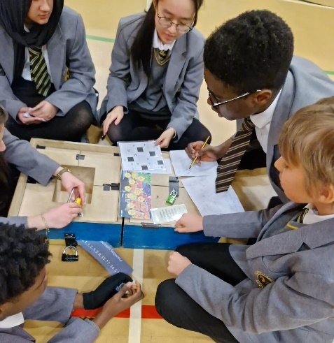
Key Stage 4
Our core purpose at KS4 is to deliver an engaging and challenging curriculum through outstanding teaching and learning. We aim to give students the best opportunities to learn the KS4 curriculum, to have the best possible outcomes for their GCSE examinations in Year 11 and to make them confident and responsible members of the school and the wider community.
We follow Pearson Edexcel GCSE (9-1) which aims to provide evidence of students’ achievements against demanding and fulfilling content. We provide a strong foundation for further academic and vocational study and for employment, and aim to give students the appropriate mathematical skills, knowledge and understanding to help them progress to a full range of courses in further and higher education.
The curriculum path is differentiated to either Higher or Foundation and also within topics in order to match the pace and challenge with the needs of the students

Key Stage 5

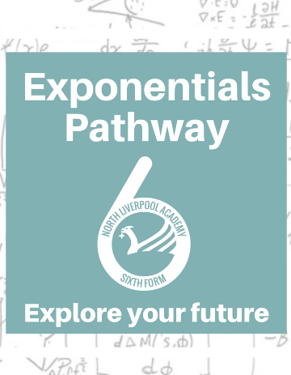
EDEXCEL ALEVEL Maths and Further Maths
Students in our Exponentials pathway, enjoy working with specialist teachers, in Mechanics, Statistics and Pure Mechanics. They work in a creative and engaging environment to develop the additional skills of collaboration, communication and presentation. Exponentials is much more than working on complex equations, it is about learning how to be a professional mathematician for a successful future career.
Maths A-Level and Further Maths A-Level are offered post 16 at 5 lessons each per week to strong cohort sizes


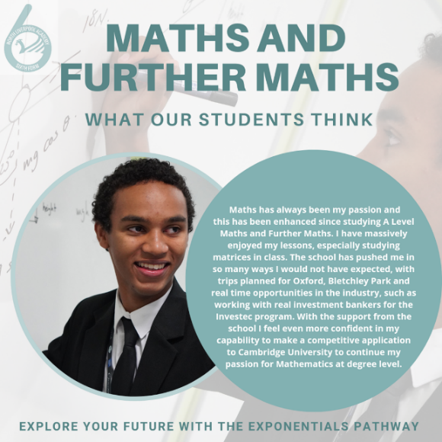
AMSP
We have developed strong links with AMSP allowing KS4 and sixth form. The AMSP run enrichment events and produce materials to encourage students to study Maths beyond GCSE and offer support doe students preparing for university maths tests. We also currently host the Year 10 Maths Feast.
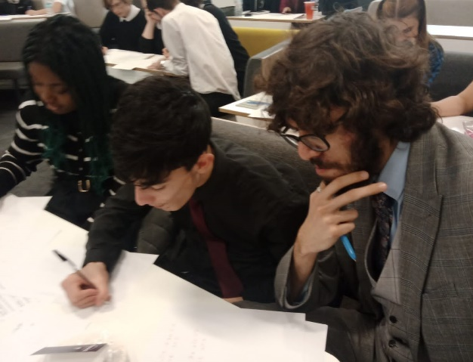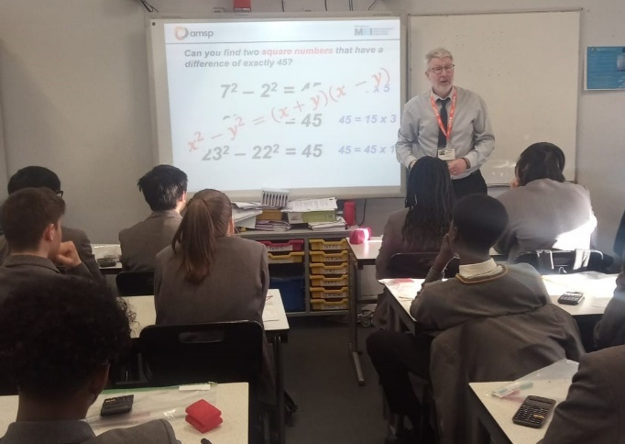
Alumni
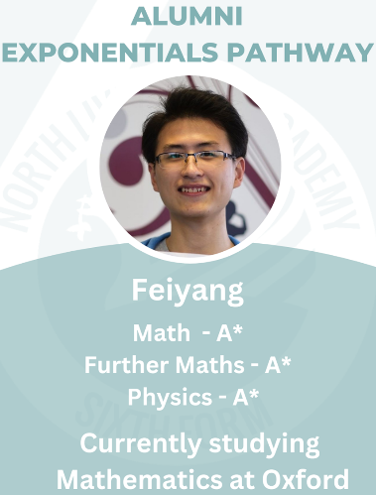
Feiyang is an example of one of our hard-working students. He studied Maths and Further Maths throughout his Key Stage 5 career. Gaining an A* in both. In September 2022 he began the next part of his Maths journey to specialise in Maths at the University of Oxford. Feiyangs’s dream career is to be the best in the world of whatever he chooses to do!

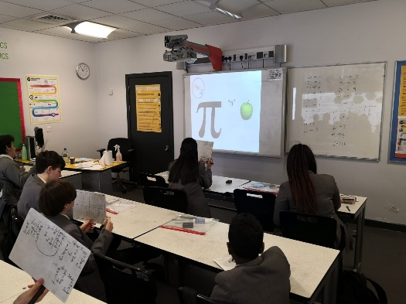
House Competitions & Enrichment
The department believes in supporting all students in becoming ‘mathematicians of the future’ and offers an extensive extra-curricular provision to all students. All members of the department are supportive of each other and have an excellent team ethos. We are constantly striving to improve and we are truly invested as a team in providing the best possible outcomes for our students.
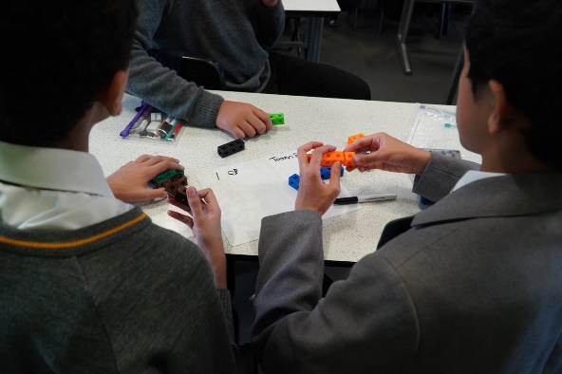
Each half term we celebrate different Maths events such as:
NSPCC Number Day
Pi Day
Liverpool Maths Party

We have a growing Chess community and have worked in collaboration with Liverpool: Chess in Schools to host their Secondary School Chess Tournament
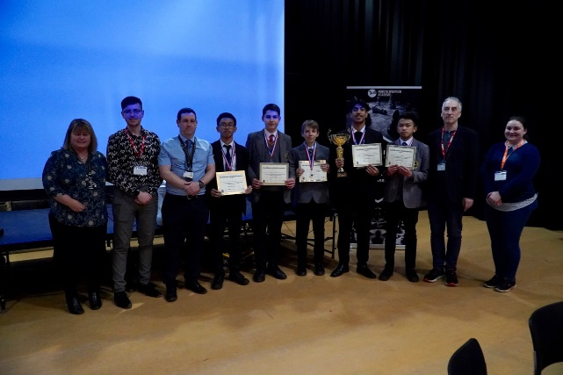

Come and Join the Team

