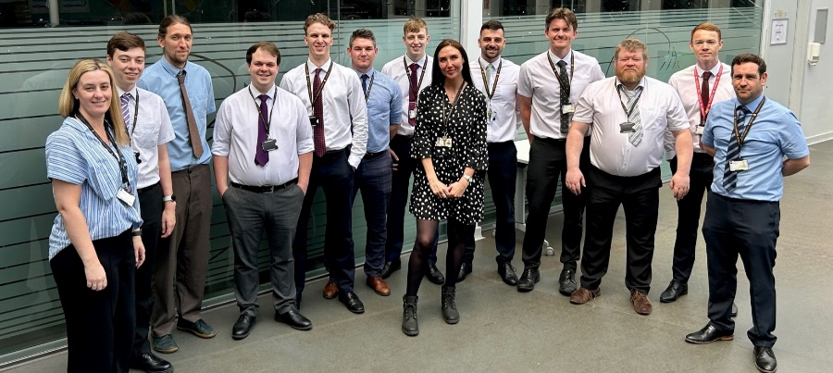

Thank you for your interest in the Maths department at North Liverpool Academy. We hope, after reading about us, you will be keen to apply and bring your talents and enthusiasm to the team.

An exciting opportunity is available for the right candidate to join our teaching team at North Liverpool Academy. We are looking to appoint an enthusiastic, dynamic and well-qualified teacher of Maths who is committed and passionate about meeting the needs of our students to help them achieve their potential. We are passionate about our subject and our students are proud to announce that they love Maths too. We are a supportive and friendly department.
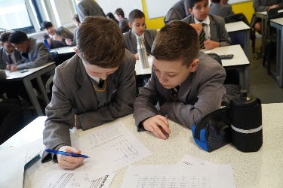
We are extremely proud of the hard work we do with our students to instil in them the love and enjoyment of Maths. Our students gain excellent outcomes through from KS2 to KS5, including Further Maths, which have led to many successful pathways in Maths beyond school including the best Universities in the country. Our recent Ofsted visit confirmed what we already knew – we are a good school; a great school, with the potential and drive to take our outcomes and the opportunities provided to learners to the next level.

We strive to improve by implementing regular subject specific CPD that draws upon the latest pedagogy and practice and provides the bespoke learning our students need to excel. If you join us, we will ensure that you have access to training in order to further develop your skills and progress in your career.
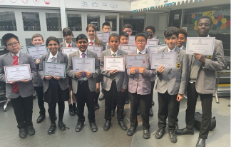
We have had great success in UKMT Maths Challenges across all difficulties, including up to Kangaroo Level, regularly compete and win ASMP Maths competitions and have a thriving extracurricular program, that features an extremely success Chess club which competes nationally. We also run successful maths challenges for the primary schools in the local area.

If you would like to work in a department that really makes a difference to the student’s future by enabling them to achieve their full potential, and be the best that they can possibly be, we look forward to receiving your application.
Please do not hesitate to contact me with any questions or to arrange a tour via email at e.vandeventer@northliverpoolacademy.co.uk

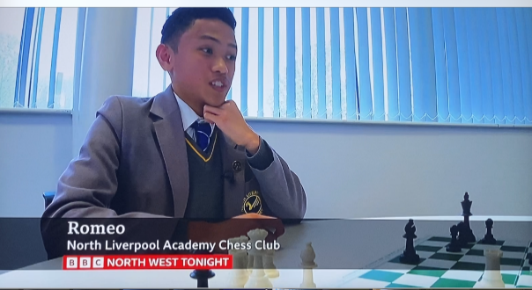
I am looking forward to hearing from you

Emma van Deventer
Curriculum Leader for Maths

