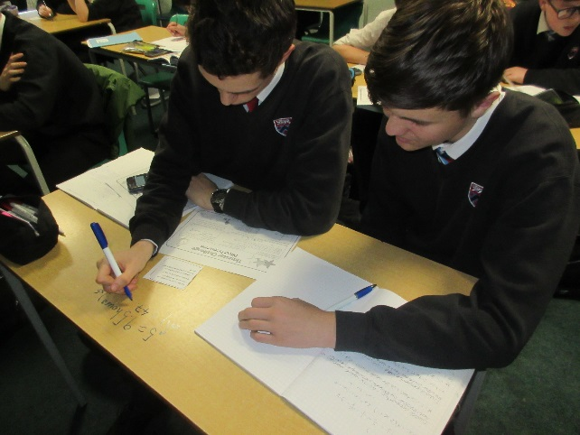

Department Results
The Mathematics Department at Carnforth High School performs consistently well with a history of good results. The department have made recent changes to improve the 9-5% figure and ensure the best possible outcomes for all students.

Current Curriculum
The Mathematics curriculum follows a 5 year plan. Students study several units each year that cover the key aspects of the curriculum; number, ratio & proportion, algebra, geometry and statistics. The units build on prior learning and have been designed so that the interlinking nature of Mathematics topics can be seen, as well as providing opportunities to recall previous work.
Students currently sit the Edexcel GCSE qualification at the end of year 11. A range of interventions take place to ensure that students are fully prepared for their exams.
Across all key stages we aim to develop resilience, link learning to real contexts, and incorporate problem solving into lessons.

Resources

The Mathematics Department has 5 classrooms all sited in one area of the school. All rooms are fitted with a dual screen computer, projector, speakers and interactive whiteboard as well as one or two ordinary whiteboards.
We try to ensure that each teacher has their own classroom for their lessons and that they are able to individualise their classroom space to suit their own teaching styles.
There is also an office with 2 computers for members of the Mathematics Department to use, as well as a large storeroom with various resources for the teaching of mathematics.

Department Development
The Mathematics Department has responded to the changes to both GCSE and A Level mathematics. We link Higher tier skills to the A level syllabus to promote further study in mathematics.
We are fortunate to have two learning assistants that are attached to the Mathematics Department, and contribute to the teaching and learning of mathematics. They help to deliver our current interventions such as Success@arithmetic and Peer Maths for years 7 & 8. At KS4, small group or individual sessions are run to help students catch up and make progress. Moving forward, we would like to further develop our intervention strategies so that even more students make good progress and attain a 9-5 grade at GCSE.

