Chesterton Community
Sports College

‘Be The Best You Can Be’

Maths Department Information
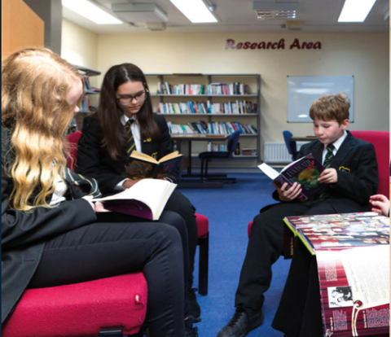
The Maths department at Chesterton Community Sports College is one of the leading and largest departments in the school, with six full time teaching staff and a dedicated member of Learning Support. We are looking to increase the department to seven full time members of staff as the school continues to be oversubscribed.
We are driven by the desire to ensure that every child achieves their full potential and we are passionate about making ‘Mathematicians of the Future.’ For this reason, we set very high standards for staff to ensure that all pupils are making expected progress and above, whilst engendering intrigue and an enjoyment of Mathematics.
The department has large and spacious classrooms that are fully equipped with large TV displays, Wi-Fi connection and the latest Apple Mac technology, including Apple TV, as well as more traditional resources such as white boards and display areas. All staff at CCSC have their very own personal Mac Book Air and iPad: these are essential tools in the development of modern education. Combined with this, all pupils have personal iPads that can be used in lessons to facilitate and engage learning further.

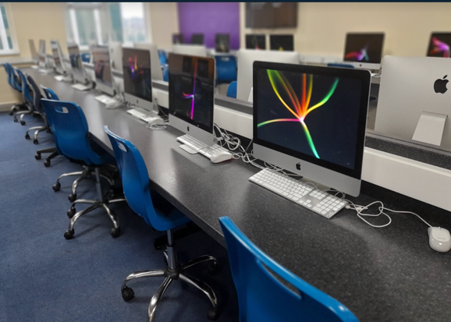
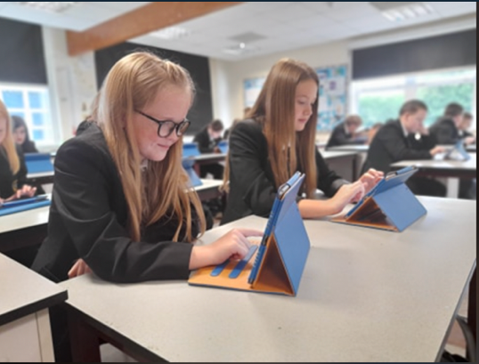

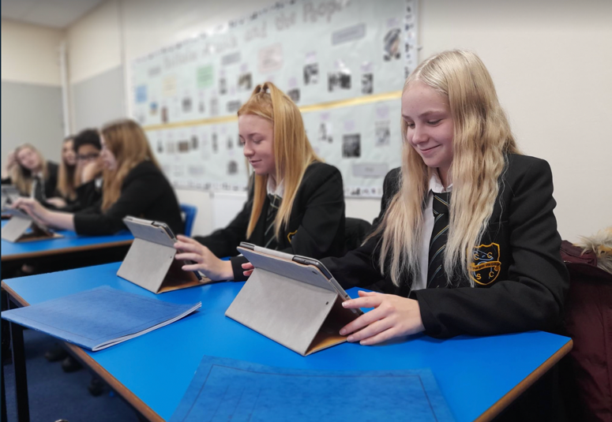
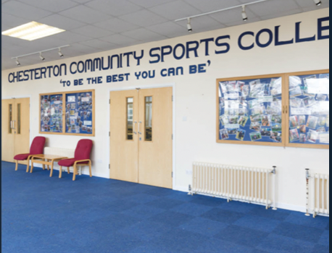
We have school subscriptions to various online resources and websites such as Educake, Maths Whizz, Maths Box, Kahoot, Kerboodle and EEDI, which are used in most lessons as well as for extended learning. The department prides itself on being ahead of the times in terms of modern technology and pupils’ organisation of work. At Chesterton Community Sports College, the Maths department makes use of electronic class notebooks using Microsoft OneNote, alongside traditional exercise books for certain tasks and assessments. The electronic notebooks provide us with a brilliant tool for student feedback and marking. We also operate Microsoft Teams for our teaching groups which allows seamless communications to all of our pupils.
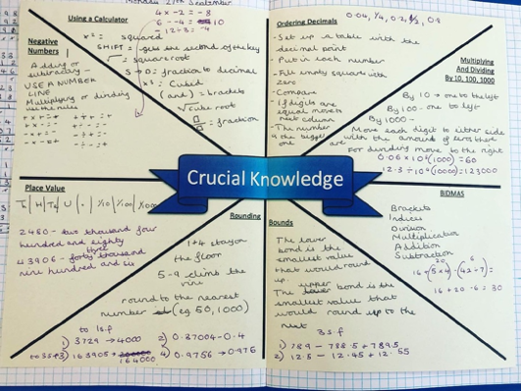
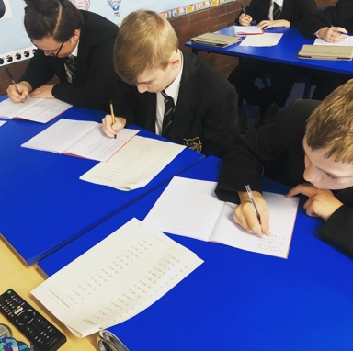

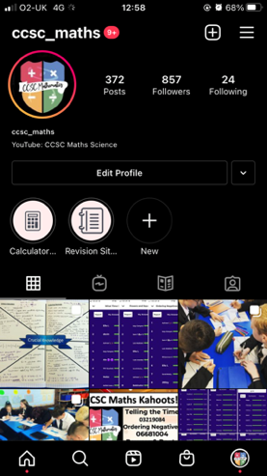
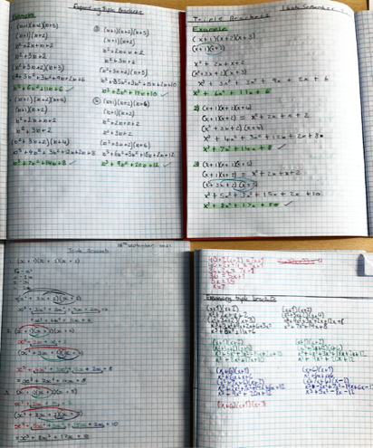
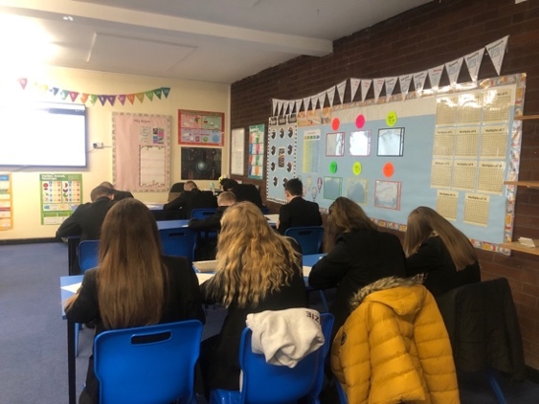

The GCSE Maths results have been excellent over many years. We produce excellent results either in line or above National Average, and this has continued with the new specification and grading system. The Maths department contributed greatly to the school’s overall results, which have been fantastic for years, and especially good within the new Progress 8 measure.
In line with the school’s innovative curriculum, the Maths department run a two-year KS3 programme. At KS3, we follow the Oxford University Press Specification, with an emphasis on mastery and the retention of crucial knowledge: this provides a thorough foundation of content and skills in readiness for KS4. Students start KS4 in Year 9 and embark on the GCSE 9-1 Maths programme, following the OCR J560 specification. Every student in KS4 follows the same scheme of work, split into Higher and Foundation tiers. Staff and pupils have access to a shared resource bank to complement our existing resources and to promote learning beyond the classroom. As a collaborative department, new staff are strongly encouraged to involve themselves in the further development of this collective resource.

