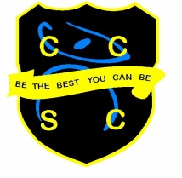

School Information
Teacher of Maths

Chesterton Community Sports College is an exciting school to work in with a dynamic, enthusiastic team of teachers. We are the lead school of the Collective Vision Trust and have an excellent reputation in the area for developing teachers and leaders of the future.

We are an oversubscribed school with a record of excellent progress and results. We have a warm and friendly learning environment with a hard working ethos and both staff and pupils strive, ‘To be the best they can be.’

We are looking for a Teacher of Maths to join a successful department here at CCSC. We encourage applications from NQTs or experienced members of staff who are looking for opportunities in a proactive, positive and success driven environment.

The post will be advertised on our website http://www.ccsc.staffs.sch.uk
with the closing date: 9am on Friday 15th October and interview date on Thursday 21st October 2021.

You are welcome to come and visit, prior to interview, to see our wonderful school.

We look forward to hearing from you and hope you are excited by this fantastic opportunity to join our staff team and further your career in teaching!

This position is subject to an Enhanced Disclosure check under the Rehabilitation of Offenders Act 1974. Further details regarding this check are available from the school or by visiting www.dbs.gov.uk
This School is committed to safeguarding and promoting the welfare of children and young people/vulnerable adults and expect all staff and volunteers to share this commitment.

