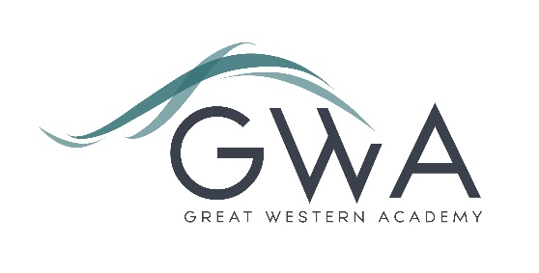

Information for Applicants

Teacher of Mathematics
Full-time or Part-time, Main/Upper Pay Scale + Recruitment and Retention payment
Are you looking to join a high-performing and ambitious team of Mathematics teachers in a thriving, growing school? Due to the continued expansion of our successful school we are able to offer a new post to increase capacity in our Maths faculty. The post would suit a new entrant to the profession or a more experienced practitioner equally well.
Great Western Academy opened in September 2018 and now accommodates nearly 900 students in years 7 to 11 and the Sixth Form. The results of our first two A-level cohorts in summer 2021 and 2022 were excellent and enabled nearly all university applicants to take up their offers, including three to Oxford and Cambridge. The progress made by our first cohort of lower school students, who are now in year 11, has been exceptional in both English and Maths, as measured by external assessments. This includes students of all abilities, with the progress made by those with lower prior attainment being particularly striking.
We now have five groups of A-level Mathematics/Further Mathematics. The foundations we have laid in Mathematics are excellent; our team of six experienced staff ensure students enjoy their learning, and the progress made by our students is excellent.
This role will provide the successful applicant with the chance to further develop and teach an exciting Mathematics curriculum in KS3 and KS4 as well as the option to teach A-level Mathematics, Further Mathematics and Core Mathematics if desired. You will be part of a dynamic and growing Mathematics teaching team and you will therefore have the chance to significantly shape the experiences of our students in the subject as they progress through our growing school. You will also be well supported to enjoy and develop your own practice.
There is the potential for this role to develop as the school and Sixth Form grows, with various leadership opportunities becoming available in future years, both subject and whole-school based. Our priority is very much to recruit the best classroom practitioners who can ensure our students arrive at the Academy excited about the day ahead and leave each day talking about the excellent learning they have experienced.
The successful candidate will also have the chance to contribute to our enrichment programme which runs for all students from 3.10 to 4.15pm Tuesday to Thursday. This provides opportunities to work with students in an area of your own interest to broaden and deepen their range of experiences at school.
Great Western Academy aims to radically improve the life chances of every student who attends. Our brand new building and state-of-the-art facilities help us to achieve this, but it is the fantastic team of staff who turn our vision into reality. If you have the proven ability to inspire students in the classroom and beyond then this provides you with an exciting opportunity to further shape your practice and develop your career.
A recruitment and retention payment may be available for the successful applicant for this position.
Additional benefits of working at GWA include:
- Excellent CPD opportunities
- State of the art facilities
- Leading edge ICT, including a laptop provided for all staff
- Free parking
- Medical and Wellbeing Support Service
Further details are available on the Academy website www.gwacademy.co.uk and in the information documents attached.
Application process

Please complete the application form supplied and enclose a supporting letter, either in the space provided on the application form or as a separate document. The application form should be completed in full in black ink or type. A CV is not required and should not be submitted as part of the application.

Your supporting letter should be no more than 2 sides of A4 (with a font size no smaller than 11) and should enhance your application by providing further information, matched to the person specification, about your suitability for the post. This should include evidence of the impact on student outcomes you have made in your career to date.

Applications should be submitted electronically to recruitment@gwacademy.co.uk by 9am on Friday 9th June 2023. Interviews will take place the following week. However, we may interview before the closing date (and close the advert early) depending on the suitability, and number of, applicants.
Great Western Academy is committed to safeguarding and promoting the welfare of children, young people and vulnerable adults and we expect all staff to share this commitment and undergo appropriate checks. All posts within the Trust are therefore subject to an Enhanced DBS and barred list check.

References: References will be taken up prior to interview.

