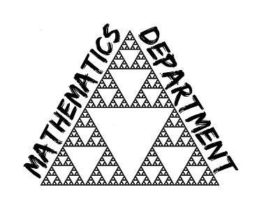 | Information for  Mathematics  Applicants  March 2022
Mathematics Department, Katharine Lady Berkeley’s School

The Mathematics department consists of 13 teachers, most of whom teach all key stages and ability, and one maths-specialist teaching assistant. The post would suit an inspiring, enthusiastic teacher, either an ECT or somebody with previous teaching experience. We pride ourselves on our friendly, hard-working department with a highly supportive atmosphere. The department has two deputies who are each responsible for the day-to-day management of KS3 and KS4, and also a KS5 manager.

The mathematics curriculum at KS3 loosely follows the Kangaroo Maths stages. We have adapted these to suit our students at KLB to ensure they are best prepared with the skills and knowledge they need for the GCSE course. One aspect of the kangaroo scheme we particularly like is that students are returning to content regularly, reviewing and building on understanding and knowledge. This aspect has been particularly useful with recent gaps students have had due to Covid lockdowns. We have recently introduced cultural capital tasks, and are trialling the use of different styles of homework task.

At KS4 we enter all students for Edexcel GCSE Mathematics. A few students are also entered for OCR Entry Level Mathematics and a few for OCR Additional Mathematics, these being taught alongside their GCSE courses. In 2019 we had exceptional GCSE results with 89% achieving a grade 4 or higher and 26 students (11%) achieving grade 9.

A very high number of students continue onto A-level Mathematics, for which we also follow the Edexcel course. We always have three classes in year 12 and a separate group for students studying both Mathematics and Further Mathematics. The department are an extremely experienced A-level teaching team and all teachers who wish to teach A-level are given the opportunity to do so. Our A-level results reflect this strong and experienced teaching with 60% of students achieving grades A/A* in 2019.

If you would like further information or have any questions then please feel free to contact me using the email below.
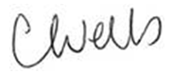
Caroline Wells
Head of Mathematics
cwells@klbschool.org.uk

