Lady Manners School

Mathematics Department

THE DEPARTMENT AIMS AND OBJECTIVES

At the heart of our practice is our key aim of ensuring every student makes progress in every lesson. We achieve this by teaching well-scaffolded lessons, considering the differing needs of pupils and adapting our teaching as appropriate. Our mathematics curriculum is designed to ensure students develop problem solving skills and resilience as well as preparing them for their future beyond school.

We aim to interest and motivate our students in their mathematical studies by ensuring they experience success using a wide range of courses and a variety of teaching and learning styles.

We aim to maximise the personal mathematical potential of each of our students, and enable them to achieve good examination results by challenging them to work hard and consistently in an ordered environment.

We aim to ensure that students feel at ease with any basic mathematical concepts encountered either inside or outside the classroom. Students are exposed to a wide variety of relevant and useful mathematics.
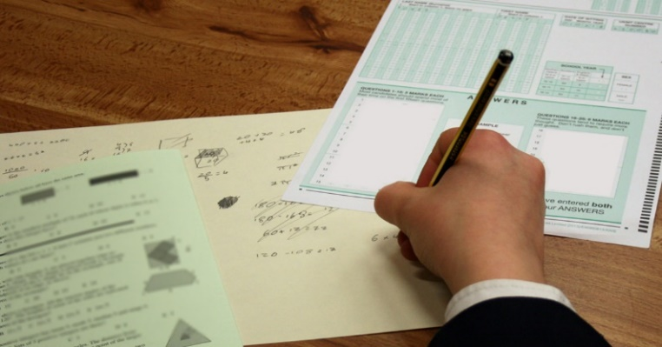
We aim to arouse a sense of mathematical wonder in our students by sharing our enthusiasm and exploring mathematics for its own sake, as well as challenging them by enabling them to take part in national competitions such as the UKMT Maths Challenge.

We aim to prepare our students for the wider responsibilities of adult life by a classroom ethos which encourages responsibility, initiative, concentration, perseverance, co-operation and respect for others.

THE DEPARTMENT
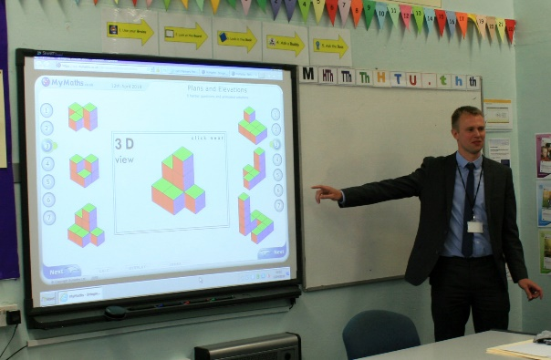
The department consists of 11 teachers. There is a Director of Mathematics and two Assistant Curriculum Leaders with responsibility posts for work in KS3 and KS4.

The current team has a wealth of teaching experience and some have experience of other professions and skills. There is an extremely high level of understanding of teaching and learning and this is a key element in the success of the department.

The department promotes a caring environment where we strive to respond to the needs of individual students. There is a strong belief that our students are capable, that very good results can be achieved and that the effectiveness of the department can help bring about that success.

DEPARTMENTAL PROCEDURES

The department has produced a comprehensive handbook. This gives clear, unambiguous guidelines in relation to all aspects of the delivery of the mathematics curriculum.

Departmental meetings are held regularly. These are seen not only as an opportunity to give and receive information and discuss the day to day business but as an avenue for sharing resources and good practice.

Regular testing is used to inform the teacher, students and parents of the progress made with learning.

Homework is an integral part of our teaching and is set regularly, varying in length and difficulty to suit the age and abilities of the students and careful marking is conducted in line with school policy, ensuring that improvement points help students know how to make further progress.

In the area of target setting we are making extensive use of available data. We track the progress of groups and individuals in all three key stages and where appropriate put support and interventions in place for students who are under achieving.

MATHEMATICS FACILITIES AND EQUIPMENT

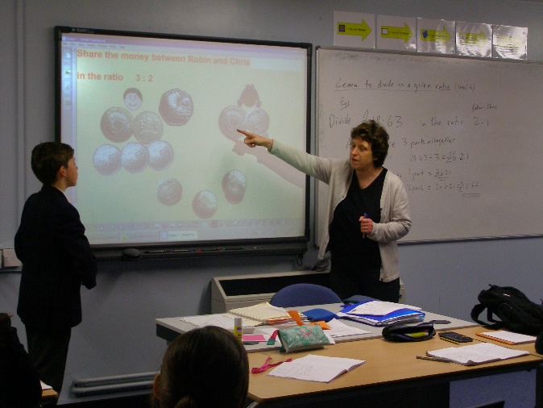
The department has the use of six base rooms which are located close to the departmental office. However, particularly in KS4, there are more than six sets operating and so other rooms around the building are used.

We are well resourced in terms of textbooks and basic equipment. We have a class set of graphical calculators and each room has a computer and interactive whiteboard.

We also make use of visualisers and class sets of mini whiteboards.

THE MATHEMATICS CURRICULUM

KS3
In Key Stage 3 students are set by ability in half years in Year 7 and 8 and in Year 9 the whole year group is set into ability groups. The scheme of work prepares students for future GCSE success by allowing space for students to encounter problems and develop mathematical resilience as well as covering content. We teach a knowledge-engaged curriculum using knowledge builders as an integral part of this and incorporate regular retrieval practice to ensure transfer of knowledge to long term memory. We use a variety of electronic resources as well as having the MyMaths textbooks available. We have placed particular emphasis on ensuring that we use a variety of resources and teaching and learning styles within lessons.

KS4
In Key Stage 4 students are set by ability into one of nine teaching groups. Currently we are using Edexcel Linear Syllabus with all sets and the scheme of work is objective led. We continue to use knowledge builders with a key focus on regular retrieval practice. We teach the 9-1 scheme of work from the start of Year 9 as a 3 year scheme of work. We again use a variety of electronic resources as well as the new 9-1 Collins textbook.

Sixth Form
Both Mathematics and Further Mathematics are popular options in the Sixth Form and a steady flow of students go on to read the subject, or related subjects, at university.

In each year group we have 2 or 3 Mathematics groups and 1 Further Mathematics group.

We run well attended drop-in sessions at lunch times which result in a vibrant atmosphere of mathematical discussion and study.

We have invested in new Hodder Textbooks for each student to accompany the new A-Level and also make extensive use of the Integral Maths website. We have chosen to use AQA exam board for the new A-Level and have continued to see excellent levels of success.

EXAMINATION RESULTS

Results are higher than national and local standards.

At GCSE, 88% of students gained Grade 9-4 in 2019, 62% Grade 9-5 and 25% were Grade 9-7 (ALPS Grade 3).

With regard to A-level Mathematics, 71% of our students achieved Grade A*-B in 2019 (ALPS Grade 2).

Greater detail about our results is available on the school's website.

THE FUTURE

The department is committed to achieving the best possible performance from students and has high expectations, which are translated into daily practice.

It is a department that is characterised by dedication, professionalism, energy and enthusiasm. The department is effective because teachers are prepared to share their successes and failures with one another and welcome each other into the classroom. The opinions and expertise of all members are valued and resources are shared equally.

This time is an interesting one in education with changes taking place that offer the chance to build on the many strengths of the department and the successes already achieved.

Each member of the department has a part to play in its continuing development. The post offers the opportunity to contribute to the development of this key department and professional development within an established and forward thinking team.

We offer the experience of teaching across the whole age and ability range including A-level and we look forward to working with and supporting a new colleague.

