Teacher of Mathematics

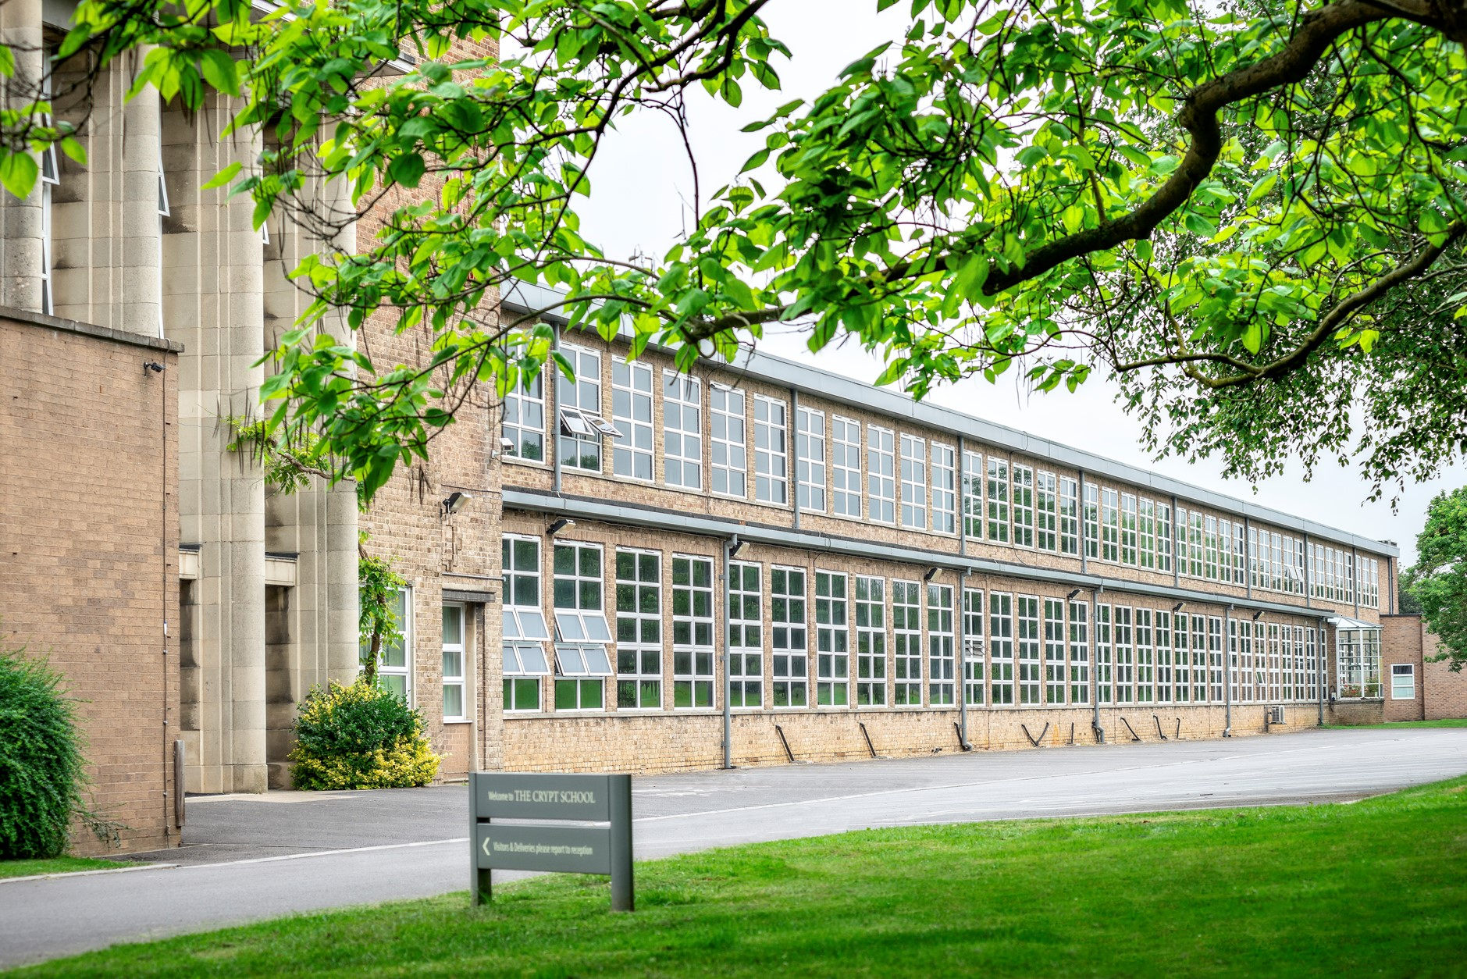

If you would like any further information on the role, please contact Sharon Bailey, HR Administration on sbailey@crypt.gloucs.sch.uk or T: 01452 530291.

The closing date for applications: Noon, Monday 1st February 2021

Interview date: Term 4, date to be confirmed

Due to the current global situation interviews may take place remotely, if necessary; however, that remote interview will try to replicate as far as possible what would have occurred if candidates had been in school.

If you are invited into school, we have covid-19 procedures in place, temperature checks, hand sanitiser, one way system, social distancing and wearing of a face mask in all communal areas.

The Crypt School is committed to safeguarding and promoting the welfare of children and young people in its recruitment and selection of job applicants and expects all staff to share this commitment.

The successful candidate will be required to undergo an enhanced DBS check.

Message from the Headmaster – Mr. Nicholas Dyer

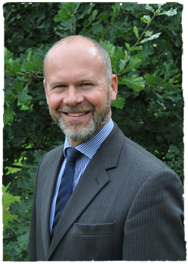
I am delighted that you are considering a role here at The Crypt School. I hope that you find this information helpful and we look forward to receiving your application.

The School is located just outside of the City of Gloucester in the West of England. Gloucester is known for its 11th century Cathedral and close; for Blackfriars, which is a stunning example of a 13th century medieval priory site; the British Waterways Museum, which celebrates the city’s industrial past, and now the vibrant Gloucester Quays, which has a selection of shops and restaurants. Gloucester is a vibrant and growing city, and the School is conveniently located close to the City, and close to good road and rail links to Cheltenham and the surrounding region, including Bristol for example.

Founded in 1539, The Crypt School’s vision is derived from its Latin motto “Floreat Schola Cryptiensis”: floreat means “to flourish” and at The Crypt we wish all our pupils and our young adults in the sixth form, as well as our staff, to flourish in all that they do both in school and in their later adult lives.

We are a vibrant co-educational selective school, a place where learning is valued for its own sake within an environment of strong pastoral care. At the centre of our school life, is a powerful sense of community, where pupils are supported and encouraged to learn and engage with each other. Confident, friendly and respectful, the high quality of our pupils’ personal development is remarkable and is one of the greatest strengths of the School.

We recognise the time and thought that goes into an application and we will certainly give yours our serious consideration.

If you have any further questions or wish to visit the School prior to sending in an application, please contact Sharon Bailey via sbailey@crypt.gloucs.sch.uk who will be able to assist you.

With best wishes
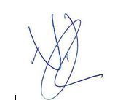
Nicholas Dyer

The Appointment

A well-qualified teacher of mathematics is required with the ability and enthusiasm to teach across the age range including to GCSE and A level. This post is suitable for NQTs, or equally those colleagues with more experience seeking a new challenge.

In September 2018, the School became fully co-educational in its intake and most of its year groups are now co-educational; however, we must continue to work hard to ensure we meet the academic, pastoral and wider needs of all the young people within school.

The Mathematics Department is highly successful and one of the leading departments in this outstanding co-educational selective school. Academic results are very strong at both GCSE and A Level and all pupils make exceptional progress in their learning.

The Department currently comprises five full-time and three part-time Mathematics specialists and is housed in six specific teaching rooms, five of which are situated in the new Engineering block. In addition, there is a departmental office and many textbooks and resources at the teacher’s disposal. It is a strong desire of the Department to fully incorporate ICT into the Mathematics teaching; the Department is well stocked with IPads and has either HDMI touch screens or electronic whiteboards in all the classrooms. The work of the Head of Mathematics is supported by a second-in-department, as well as a strong team of maths specialists.

Key Stage 3

The department closely follows the new KS3 Curriculum and is developing closer relationships with the School’s feeder schools in order to ensure that the transfer from Key Stage 2 is as productive as possible. Pupils receive six one-hour lessons over the two-week timetable and the department uses the KS3 mymaths textbooks. Many pupils are also entered for the Junior Mathematics Challenge and the most able for the Intermediate or Senior Challenges. Pupils are set by achievement from Year 8 onwards and movement up or down is reviewed regularly.

Key Stage 4

Again, pupils are set by achievement into 6 sets, with the option of movement up or down and pupils receive seven one-hour lessons over the two-week timetable. We follow the AQA course (8300) entering students for the Higher tier. Again, we are using the mymaths textbooks designed for the new GCSE curriculum. In addition, during Year 11 the top set takes Level 2 Further Maths. Many pupils take the Intermediate Mathematics Challenge and the best ones also attempt the Senior Mathematics Challenge.

A-Level

The Department offers the AQA Specification. Mathematics is a popular subject and students are offered a variety of courses to suit their needs. In Year 12, 65 students take Mathematics, and 12 students take Further Maths. In Year 13, just under 50 students take Math’s and eight takes Further Math’s. We offer Further Mechanics and Further Statistics within the Further Maths A level. It is the Department’s policy to ensure all teachers who wish to teach A level Maths get the chance to.

Personnel

The Department is successful and combines a healthy mixture of youth and experience. Morale is high and members of the Department have a ‘can do’ attitude with good communication skills. We continue to encourage professional development, particularly through external courses and this position offers the opportunity for comprehensive professional development within an established, well-qualified and well-organised Department. The appointee will therefore have the scope to contribute to the wider academic and intellectual development of the School as a whole.

Job Description
Teacher of Mathematics

Name
Post | Teacher of Mathematics
Scale | MPS (incl: UPS), with possible enhanced salary, RR allowance and relocation package for the right candidate
Relationships | The postholder is responsible to the Director of Maths
Purpose | The role of the subject teacher is to provide learning opportunities to which all students can respond with enthusiasm and commitment, and demonstrate real progress in their learning
Duties and responsibilities | Your duties and responsibilities are contained in the ‘School Teachers Pay and Conditions Document’ and in The Crypt School contract

Guidelines for the post of Subject Teacher

The subject teacher:

- under the guidance of the Head of Department, the subject teacher ensures curriculum coverage, continuity and progression in the subject for all students;

- plans lessons with clear objectives for learning outcomes, understands the sequence of teaching and learning in the subject, and effectively communicates such information to students;

- uses appropriate teaching and learning methods to meet the needs of the subject and of different students;

- ensures that there are opportunities for effective development of students’ literacy, numeracy and information communication technology skills through the subject;

- uses the school and departmental policies and practices for assessing, recording and reporting on students’ achievement, and uses this information to recognise achievement and to assist students in setting targets for further development;

- ensures that information about students’ achievement in previous classes and schools is used effectively to secure good progress in the subject;

- sets expectations and establishes clear targets for students’ achievement, and evaluates progress and achievement in the subject by all students;

- ensures that there are opportunities for the effective development of students’ individual and collaborative study skills necessary for them to become increasingly independent in their work and to complete tasks independently when out of school;

- is aware of the subject’s contribution to students’ understanding of the duties, opportunities, responsibilities and rights of citizens;

- establishes a partnership with parents to involve them in their child’s learning of the subject, as well as providing information about curriculum, attainment, progress and targets;

- ensures that there is a safe working and learning environment in which risks are properly assessed;

- responsible for the safeguarding and promoting the welfare of students;

- contributes to the extracurricular activities and support sessions that the department offers

As a form tutor the subject teacher:

- plays a key role in supporting, guiding and motivating students;

- monitors academic progress and attendance;

- monitors students’ planners;

- liaises with the Head of Year / Head of Key Stage;

- embodies the vision for the school

We are committed to safeguarding and promoting the welfare of children and young people and expect all staff and volunteers to share this commitment. This post will be subject to an enhanced DBS disclosure. The Crypt School values the diversity of our workforce and welcomes applications from all sectors of the community. As part of the application process please read the following policies that can be found using the link
- Safeguarding
- Recruitment, Selection and Disclosure Policy and Procedure
https://www.cryptschool.org/parents/parents-hub/policies-forms
The Crypt School
January 2021

