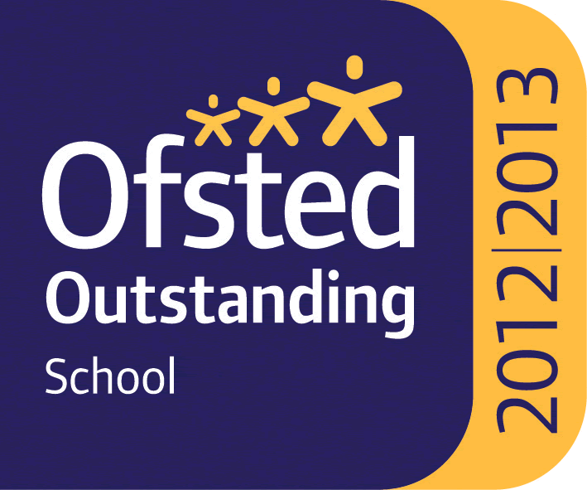

WHITLEY BAY HIGH SCHOOL
13-18 Mixed Comprehensive; NOR 1702 (590 in Sixth Form)

Deneholm, Whitley Bay, Tyne and Wear, NE25 9AS
Headteacher: STEVE WILSON

Outstanding – OFSTED May 2013
National Teaching School

TEACHER OF MATHS
MPS/UPS

We require for September 2021 a teacher of Maths to join a very successful and supportive department. Candidates must be able to teach the full age and ability range including A’ Level. A’ Level Maths is one of our most popular Post 16 subject with 82 students studying it in Year 12 and 85 in Year 13. A further 29 students study Further Maths. Such numbers reflect how much students enjoy studying Maths at KS4 and KS5 at this school.

The school is heavily oversubscribed, achieves very high standards and has benefited from substantial investment to improve facilities over recent years.

All staff who join the school benefit from a carefully structured programme of training and support. Any applicant should be committed to making a significant contribution to the wider life of the school.

Please find the job description, application form, application details and school information on the website ‘Vacancies’ section at: www.whitleybayhighschool.org

Completed applications and a letter (800 words maximum) explaining why your experiences to date have prepared you for this role at Whitley Bay High School, should be sent to jackie.patterson@whitleybayhighschool.org before the closing date below.

Closing date for applications is Monday 17th May 2021 at 10.00am.

We are committed to safeguarding and promoting the welfare of children and expect all staff to respect this commitment. This post is subject to an enhanced DBS check.

