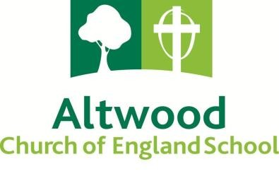

**Teacher of Maths (Full time)**

**London fringe MPS/UPS**

**(TLR available for correct candidate)**

**September 2025 start**

This is an exciting opportunity to join our successful Maths department. We are seeking a colleague, to join our Faculty of Maths. We are looking for a colleague who has excellent subject knowledge and will be energetic, enthusiastic, committed to enabling students to achieve as highly as possible and keen to join a school community where innovation is welcomed and success celebrated. We are looking to appoint a highly skilled full-time teacher to join our ambitious and forward-looking team.

Altwood Church of England School is a Good (Ofsted October 2023) school. We take pride in our learning community where our Gospel values underpin our drive for continuing success. We have recently joined the Agape multi-academy trust. This partnership was created because of our shared vision and values and our desire to collaborate and continually improve all areas of our work.

We can offer you a comprehensive induction package and CPD to support your personal progress. At Altwood Church of England School you will have the opportunity to have an impact on whole school development and make a real difference to the lives of students.

The school is situated in an extremely pleasant location 25 minutes from central London by train and well served by local road, rail and other transport links. Subsidised accommodation on the school site is offered subject to availability.

Further information about this post can be found on the school’s website. Prospective teachers are welcome to talk to Nicola Walker, PA to the Headteacher or email nwalker@altwoodschool.co.uk about this post or to visit the school in advance.

**Early application is advised using the Teacher application form found on our website as applications will be considered upon receipt. CV’s will not be accepted.**

Altwood Road, Maidenhead, Berks SL6 4PU

Tel: 01628 622236

Altwood School is committed to safeguarding and promoting the welfare of children and young people and expects all staff and volunteers to share this commitment. The successful applicant will be required to undergo the child protection screening appropriate to the post, including an enhanced disclosure from the DBS (Disclosure and Barring Service) and references from previous employers. For more information about the DBS please see <https://www.gov.uk/disclosure-barring-service-check>

Altwood School is committed to Equal Opportunities and welcomes applications from all sections of the community.