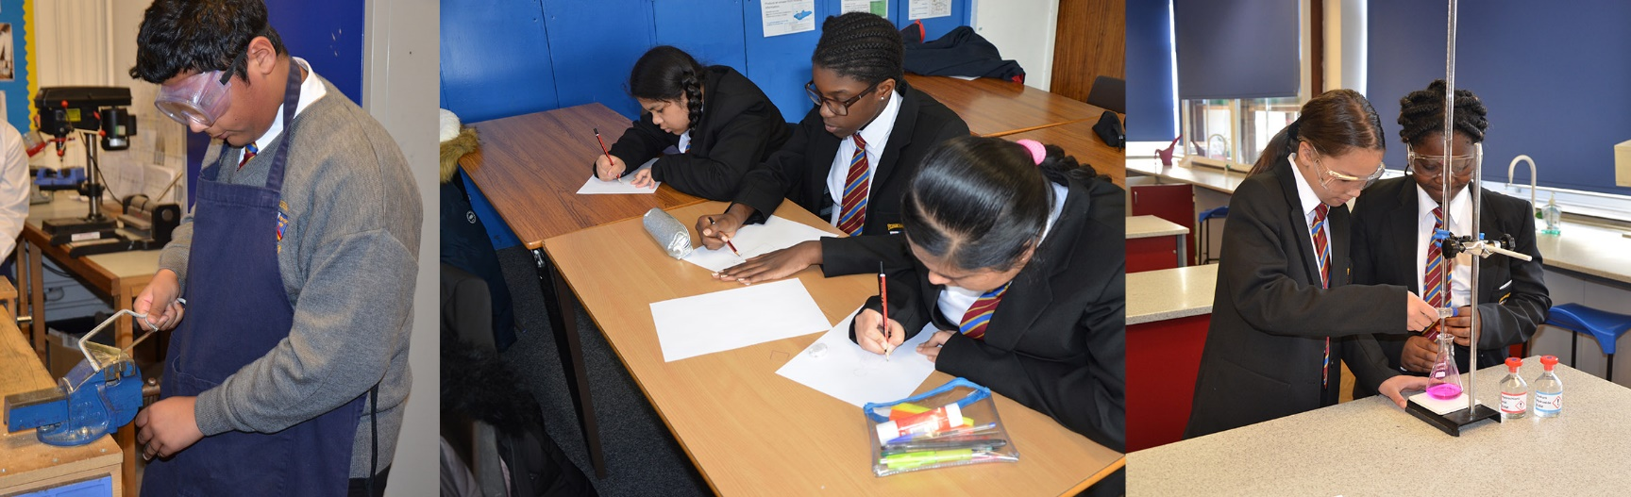

**Saint John Wall Catholic School is an oversubscribed 11‐16 school with a diverse population, serving the community of North West Birmingham. In June 2023, Ofsted judged the school Good with outstanding behaviour and attitudes and outstanding leadership and management. Over 50% of our pupils qualify for additional Pupil Premium funding, and Ofsted said ‘*leaders use the funding for disadvantaged pupils creatively and effectively*, and ‘*consequently disadvantaged pupils achieve well’*. There are many different languages spoken by school members, and Ofsted said ‘*leaders have thought carefully about the needs of those pupils’*. Ofsted also said that ‘*pupils blossom at this unique and caring school’*.**

**The Role**

* **To actively support the catholic ethos of the school and to safeguard the well-being of all pupils in school.**
* **To provide the highest quality of education in Maths to K3 and KS4.**
* **To help the Maths Department to maintain and further develop an outstanding curriculum, which will enable the highest level of education.**
* **To promote outstanding academic and personal achievement within a nurturing and rigorous environment.**
* **To host extra-curricular enrichment activities.**

**The Individual**

**You are someone who understands the difference a great education can make to pupils’ lives. You are committed to our mission statement and are a great role model for pupils and colleagues. You will need to be a great team player and teacher with a resilient character and strong personal drive.**

**Salary**

MPS/UPS

To start 1 September 2024

**Closing Date**

9.00am Monday 8 April 2024

**Informal visits**

**I**nformal visits to school prior to application can be arranged by contacting Mrs Page on 0121 554 1825 or by email to [enquiry@sjw.bham.sch.uk](mailto:enquiry@sjw.bham.sch.uk)

**Application form and Job Description can be found at** [www.sjw.bham.sch.uk\About](http://www.sjw.bham.sch.uk\About) Us\Vacancies

***As a Catholic School we will expect that you actively support the Catholic ethos, and help us to follow the highest standards of safeguarding for our pupils. The successful candidate will be subject to enhanced DBS and any other relevant employment checks.***

**Teacher of Maths (Full time or part-time)**

**Saint John Wall Catholic School** [**enquiry@sjw.bham.sch.uk**](mailto:enquiry@sjw.bham.sch.uk) **Archdiocese  
Oxhill Road, Handsworth 0121 554 1825** [**www.sjw.bham.sch.uk**](http://www.sjw.bham.sch.uk) **of  
Birmingham B21 8HH Birmingham**



**Saint John Wall Catholic School – *A Catholic School For All  
‘To educate each and every unique child in our care  
 to hear and respond to what God calls them to be’***