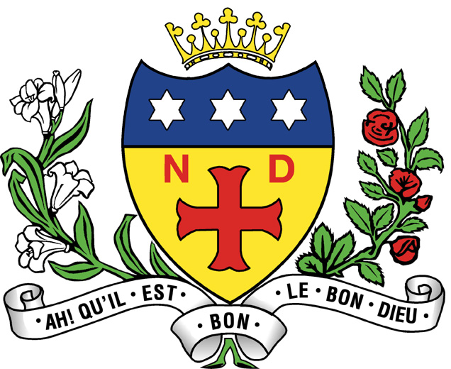

Notre Dame High School, Sheffield

Teacher of Maths
Permanent (full-time)

A well-qualified and innovative teacher of Maths is required to join a highly successful and forward thinking department. The candidate should be well motivated and willing to contribute to the development of the subject, the quality of teaching and the pastoral life within Notre High Dame School

Maths is taught in specialist rooms in the Main School for Years 7-13. There are visualisers in all classrooms and some of our rooms also have Inter-active White Boards. We benefit from a teaching room with 20 dedicated computers as well as a laptop trolley which allows for more flexible use of technology within a range of lessons.

Collaborative work is at the heart of the department. We regular meet in small groups to plan and evaluate our classroom practice, with teaching for thorough conceptual understanding the priority. In addition, staff openly share ideas and resources. For Y7 to Y11 we, in general, do not use text books. The philosophy that we adopt in lessons is, good quality questioning and assessment that meets students’ needs and moves them on.

Students are grouped according to ability throughout Years 7-11. Provision is made in each year group for all students to make excellent progress and to achieve their targets in Maths through our exciting and challenging curriculum. We look carefully at our long term planning at KS3 to ensure that students are being equipped with the skills which are needed at KS4. There are numerous opportunities for students to get extra support outside of lessons and UKMT challenges have a high uptake with our most able students from Y7 to Y13.

We are a very popular subject at A Level with 10 classes across Year 12 and 13. The ability to teach aspects of A Level Mathematics and Further Mathematics is desirable, and the successful candidate could have a third of their teaching load working with Year 12 and Year 13. Support can be given for a candidate that has no direct experience of A Level but the desire and subject knowledge required.

Appointment to this post would lead to the opportunity of working in an extremely successful, core department within a popular school.

About the school

Notre Dame is a Catholic school with a strong ethos at its heart. All staff are expected to uphold and contribute to the ethos of the school, which is what makes it a special place to work.

The ability and enthusiasm to contribute to extra-curricular activities in school would be an advantage.

Please state clearly any other subjects offered.

Notre Dame High School is committed to safeguarding and promoting the welfare of children and young people and expects all staff and volunteers to share this commitment.
This post has a high level of responsibility for safeguarding and promoting the welfare of children and young people.

Professional Development
At Notre Dame the ongoing professional development of all staff is a key priority. Our view is that we can always improve, not because we are not good enough but because we can be even better at what we do and that this in turn will ensure the very best outcomes for our students. We also aim to help staff to be ready for their ‘next step’ in their careers whatever that might be.
In order to achieve these aims we;

- have an ethos of ‘learning together’ through joint practice development which is conducted in a supportive and developmental way. Staff are encouraged to take risks and use research and evidence based approaches to improve their classroom practice.
- Encourage staff to be reflective and take the lead in their own professional development so that their individual needs are met
- Assign Learning improvement coaches to all departments to provide bespoke training and development
- Have a three year NQT and RQT programme to fully support those new to the profession. This involves meeting together in groups to share and develop best practice and working with a coach on an individual basis
Provide trainee mentoring programmes for those moving in to new positions for example middle and senior leadership

Closing date for receipt of completed applications: 9am on Thursday 22nd April 2021.
Interview date: Thursday 29th April 2021.

Notre Dame High School expects all candidates to familiarise themselves with our Safeguarding Policy which can be found on the school website at http://www.notredame-high.co.uk/index.php/our-school/item/687-school-policies

Notre Dame High School is committed to safeguarding and promoting the welfare of children and young people and expects all staff and volunteers to share this commitment. The successful candidate will be required to complete an Enhanced DBS Check.

