Dear Applicant,
Kindness Humility Integrity
Courageousness Perseverance
FINHAM PARK SCHOOL
INFORMATION FOR CANDIDATES 2023-2024
We are delighted that you are considering applying for a role at Finham Park School. I consider it a privilege to lead staff in this truly exceptional community - where our mission is to provide a "World Class" education for all our students by having the highest expectations and where we nurture every child's unique talent. Our aim is to give the children the time of their lives.
We believe that all adults who work in the school should have the time of their lives too and we hope this candidate pack will assure you that this is the case. Staff retention is very high and that is due to the working environment, excellent facilities, supportive culture and many professional development opportunities offered. The school is well established and well regarded locally, nationally and internationally. Many staff have worked in the school for most of their careers with the family ethos being evident, reflecting the culture of the school community. We value kindness, humility, integrity, courageousness and perseverance which are at the heart of all of our relationships, valuing the individual and the role we all play in school improvement and community development.
We will offer you:
- A supportive, collaborative and friendly staff environment in a supportive school setting where you will have the chance to make a real and positive impact on the lives of Finham Park School students.
- A world-class professional development programme with the school being the strategic lead for The Lion Alliance which offers a range of ITT, early careers, middle and senior leader development programmes through the National College, SSAT and the Chartered College of Teaching. There is a passion for teaching and learning evident and recent speakers have included Tom Sherrington, Dylan Wiliam, and Harry Fletcher-Wood.
- A range of health and wellbeing services through the MAT and external services.
- Free, on-site car parking.
- Staff fitness suite.
- School social events.
- A commitment to staff well-being.

We are committed to Safer Recruitment practices and procedures and shortlisted applicants will be questioned about their commitment to the safeguarding of young people. The successful candidate will be subject to an enhanced DBS clearance.
Having read the candidate information, I hope that you feel excited by both the role itself and the chance to be part of Finham Park School at a pivotal moment in its development. We welcome visits from prospective candidates and would be proud to show you round our wonderful school.

We look forward to hearing from you.

Mr C Bishop - Headteacher (NPQH, MCCT)
Our School
Finham Park School, and more recently Finham Park Multi-Academy Trust (MAT), has been a highly regarded part of the educational landscape in Coventry for over forty years. We have a long and proud history of providing the highest quality teaching; an innovative curriculum offer and a wealth of exciting extra-curricular activities for young people of all ages and abilities.
“I was fortunate enough to join Finham in 2020 having spent the first 28 years of my career at a school in Warwickshire. What struck me most was how the school used its own unique identity and made many of the important decisions needed in support of students, but that the wider support the MAT provides only strengthens the day to day running of our amazing school”. (Teacher)
As the World Class Schools Quality Mark organisation stated in July 2023 when awarding the Finham Park MAT world class status, “it’s difficult to marry high standards with humanity and kindness; Finham Park MAT does it.”
We are an 11-18 co-educational school with 9 forms of entry (270 students in each year). Our sixth form is 400 pupils strong and the largest in Coventry. The school is based at Green Lane in the Finham suburb and comprises some state of the art high-quality buildings and some recently refurbished buildings. You genuinely need to see the school in action to appreciate the high quality working environment. The school is over-subscribed and has an excellent reputation locally. In 2023, we had 650+ applications for 270 places in Year 7, mirroring an ongoing trend for a number of years.
“Diversity is a key thing, there are different socio-economic backgrounds, sexualities, races and religions, so it is nice to have it all come into discussion. Different experiences shape student life and enrich the classroom” (Year 11 student)
The school’s last inspection highlighted many of the positive things that are taking place in the school and has given us a firm platform from which to achieve our aims. Our school priorities for 2023-24 clearly focus on our culture for improvement and can be viewed on the next page.
“Finham Park MAT has provided me with a huge range of opportunities throughout my career as a teacher. Staff are incredibly supportive and the opportunities for CPD are fantastic, including a new ‘Leadership Pathways’ programme. I would thoroughly recommend working in the MAT to anyone and hope to continue to develop my career over the coming years.” (FPMAT employee)
There are over 1750 young people on roll with the likelihood of growing close to 1850 in the coming years as we continue to grow. The intake profile in both socio-economic and academic terms is that of a fairly typical comprehensive school. We are very proud of our caring school community and place great emphasis on high standards of behaviour and respect for all through our key values of Kindness, Humility, Integrity, Courageousness and Perseverance. I urge you take a look at the school – you won’t regret it.

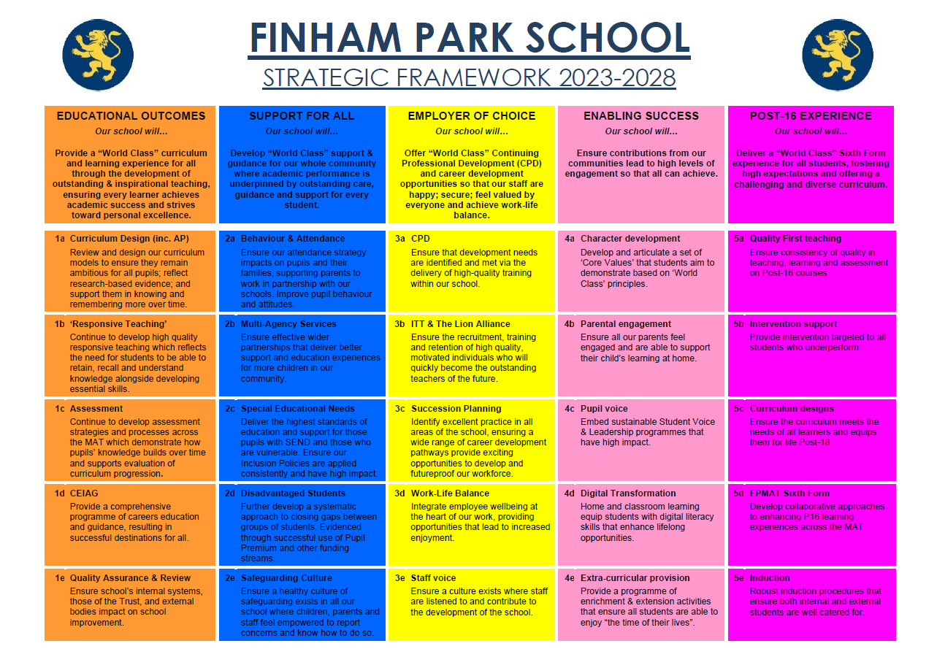

The Local Governing Body, Headteacher and SLT take the well-being of all staff very seriously. The school is a signatory to the Department for Education Staff Wellbeing Charter. The Finham Park School Staff Wellbeing Charter below takes into account all the measures we have in place.
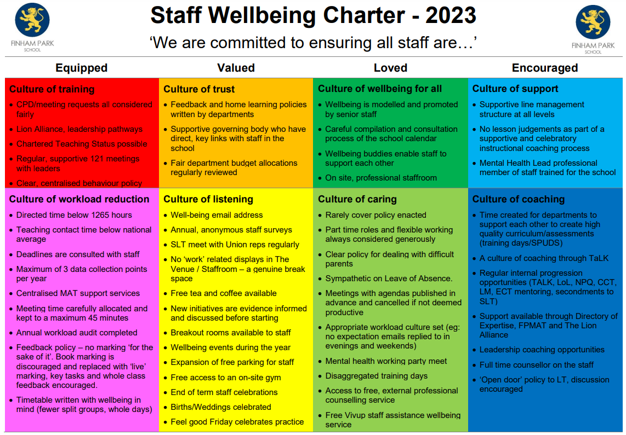

Opportunities
We fully believe in creating a ‘culture of learning’ which encourages all to enquire, develop and share collaboratively across the education sector. We have dedicated co-planning and co-construction time built into our directed time budget so that teaching staff can work collaboratively within the school and across the MAT on teaching, learning and assessment. We also offer a range of in-house and nationally accredited courses through the Lion Alliance and some of these include:
Chartered Teaching Programme | TeachMeets | Lion Leadership Courses | ECT (Early Career Teacher) Programme
We are a registered learning partner for the Chartered College of Teaching and offer the CTP to colleagues within the alliance. | We host regular TeachMeet events that draw on our expert colleagues’ knowledge. This means we can be flexible and adapt to the changing needs of staff in schools. | We have 4 strands of leadership development courses. This includes Associate, Aspiring Middle, Middle and Senior Leaders courses. | The Head of the Lion Alliance is one of the regions ECT training facilitators; able to support newly qualified teachers as they begin their career.

We also have key speakers work with a huge range of world-renowned authors and teaching professionals; inviting them to speak at our school about the latest developments in their specialist area. Guests have included:

Tom Sherrington | Tom Bennett | Oliver Caviglioli | Mark Roberts
Adam Boxer | Matt Pinkett | Nina Jackson | And many more...

We also recruit and mentor PGCE students through a school-led PGCE programme (in partnership with the University of Warwick), meaning we can offer further opportunities in:
PGCE Mentoring | Working with us as an alliance | Working with our partner universities
There are opportunities to mentor PGCE students in your subject. This involves mentor training being provided by our University partners, and is a great way to nurture the next generation of teachers. | We have regular opportunities to get involved and share your expertise with colleagues in our alliance schools. | We work with the University of Warwick, Coventry University and Birmingham City University, where there are opportunities to help support and contribute to the wider higher education community.

Find out more by visiting www.thelionalliance.co.uk

https://thelionalliance.co.uk/continuing-professional-development-cpd/

The area
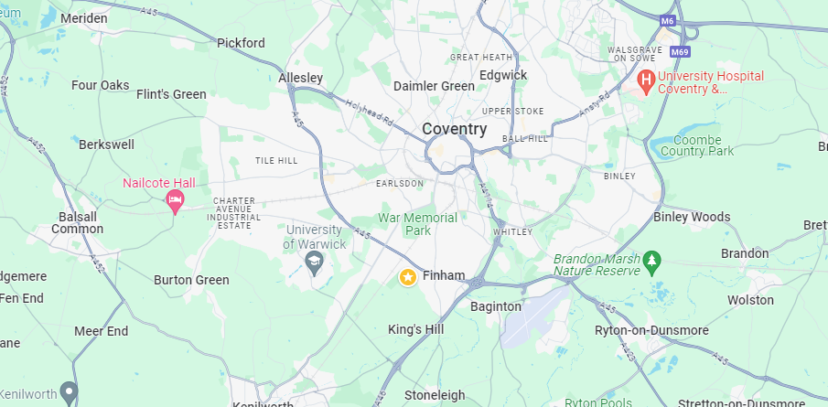
Coventry, a historically significant city with ancient Saxon and Roman origins and a vibrant heritage in industries like weaving, watchmaking and the automotive engineering, emerged from the ashes of World War II as a symbol of hope and resilience. The city's international partnerships, including twinning with 27 other towns, fostered its transformation into a centre for peace and reconciliation, while offering diverse activities, cultural attractions and excellent transportation links in a scenic Warwickshire setting. Finham Park is located in an area close to the border between Coventry and Warwick.
If you are relocating to Coventry or the surrounding area, you can be assured that we will do all we can to help you and your family successfully settle into the area. The Trust offers a relocation scheme (terms and conditions apply), which provides financial assistance towards the expenses associated with relocation. In addition, we can offer advice, guidance and support to make the move as pain-free as possible.

https://finhampark.co.uk/
024 76 418 135
Finham Park School
Green Lane
Coventry
West Midlands
CV3 6EA
@FinhamPark

hr@finhamparkmat.co.uk

