job description
teacher of maths
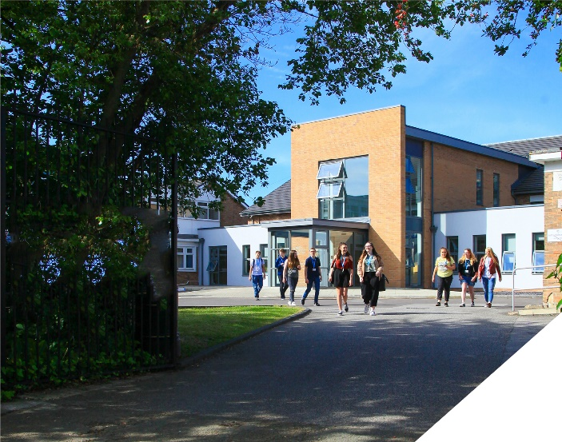
This is an exciting opportunity to teach GCSE Maths in one of the leading sixth form Colleges in the country.
reports to: Head of Maths
hours: Full Time
salary: £25,826-£42,149
start date: 23rd August 2022
about the role.
We seek to appoint a committed and hardworking teacher who is keen to teach GCSE Maths at Post 16 level. The Maths department support the College’s foundation programme which is a one year course that prepares and develops students so that they can access a level 3 study programme the year after. The Maths GCSE resit course plays a huge role in the success of this foundation programme.
This role will focus supporting students with a grade 4 in Maths on our foundation programme. These students continue with GCSE Maths to become more accomplished in the subject. Grade 4 students will be taught in small groups of up to seven per class and will retake their exam in the summer with the objective of making further progress. This is aimed at preparing them for the numeracy involved in level 3 courses rather than students having a year without any Maths education. Many students who were previously not eligible for level 3 make rapid progress which gives these students a wider range of opportunities in their progression.
Both experienced teachers and NQTs are encouraged to apply. Whatever your experience you will be supported in a way that best supports your development in a College renowned for its innovation as well as the exceptional progress of its students.
You will be joining a high performing Maths department which is made up of 5 teaching staff and is a successful part of an ambitious College, with highly effective and dedicated teachers. Within the department there is a real team ethos with regular opportunities for collaboration and dialogue with colleagues.
about the College.
You will be joining a highly successful, innovative and nationally recognised sixth form College. The College was awarded the UK Sixth Form College of the Year by the TES in 2018 and this followed being graded outstanding in all areas by OFSTED in December 2016. All staff play a vital role in the experience that students have with us and ultimately their success.

The College currently has a 16 to 19-year-old student population of 1450 and is oversubscribed. Student applications continue to increase year on year due to this high demand for places. Due to this high demand the College has recently expanded with the opening of a 1.7m new state of the art teaching facility in September 2021.

In response to the pandemic and disruption to the learning of students the College introduced a new timetable to combat the deficits that students have. This includes teaching time increasing by 60 minutes for the majority of other institutions. This will enable teachers to give their students more attention and tailored support to make up for any loss of learning during the past 18 months.

The College is committed to its core values of Positivity, Ambition, Resilience and Thoughtfulness, and these values shape everything we do. Our ethos is centred on the scientific evidence that tells us that everyone can achieve success through purposeful hard work as opposed to the talent myth, and this enables learners to make rapid progress unshackled by any limits previously placed upon them.

person specification.
Qualifications | essential | desirable
Degree in Maths or an equivalent qualification | 
Qualified Teacher Status | 
Experience
Experience of teaching GCSE Maths | 
Experience of teaching A-level Maths |  | 
Experience of working in a demanding environment where high levels of organisation are required | 
Knowledge / Skills / Abilities
Ability to teach GCSE Maths | 
Up to date knowledge & understanding of educational developments relating to the curriculum area | 
Ability to work flexibly as part of a team | 
Ability to form & maintain appropriate relationships & personal boundaries with young people | 
Ability to respond flexibly & creatively to new challenges & opportunities | 
Ability to prioritise & meet deadlines | 
Ability to use Information Technology effectively | 
Excellent communication, interpersonal & organisational skills | 
To demonstrate a commitment to
The Colleges values of Positivity, Ambition, Resilience & Thoughtfulness | 
Personal development and training | 
Safeguarding & promoting the welfare of students | 
Equality & diversity | 
how to apply.
If you are ambitious and determined to make a meaningful difference in one of the country’s leading sixth form Colleges then we would be thrilled to have you join our team.

- Please complete the Teacher Application Form which is available on the College website: www.bsfc.ac.uk
- Please provide your last 3 years of examination results (if appropriate – if you are an NQT please skip this part of the application procedure)
- On a separate document, answer the following specific questions (each question should be answered separately with each answer being no more than 150 words):

- Aside from your stated qualifications, please outline what you believe makes you academically suited to the position applied for.
- The College does not currently operate a gifted and talented programme. What is your view on this approach?
- Please identify one or two skills or techniques you have used in the classroom to drive learning.
- Select one of the College values and describe ways you demonstrate this in your day to day work.
- You should have provided an accompanying sheet summarising the results you have achieved over the last three years. Is there any context or background you would like to give to these?

Please email these to: hrdept@bsfc.ac.uk

closing date: 12 noon on Tuesday 26th April

Interviews – Friday 29th April

Application Form can be downloaded from the College website: www.bsfc.ac.uk

