TEACHER OF MATHS
ECT/MPS/UPS
Recruitment and Retention allowance available for the right candidate.

Candidate Pack

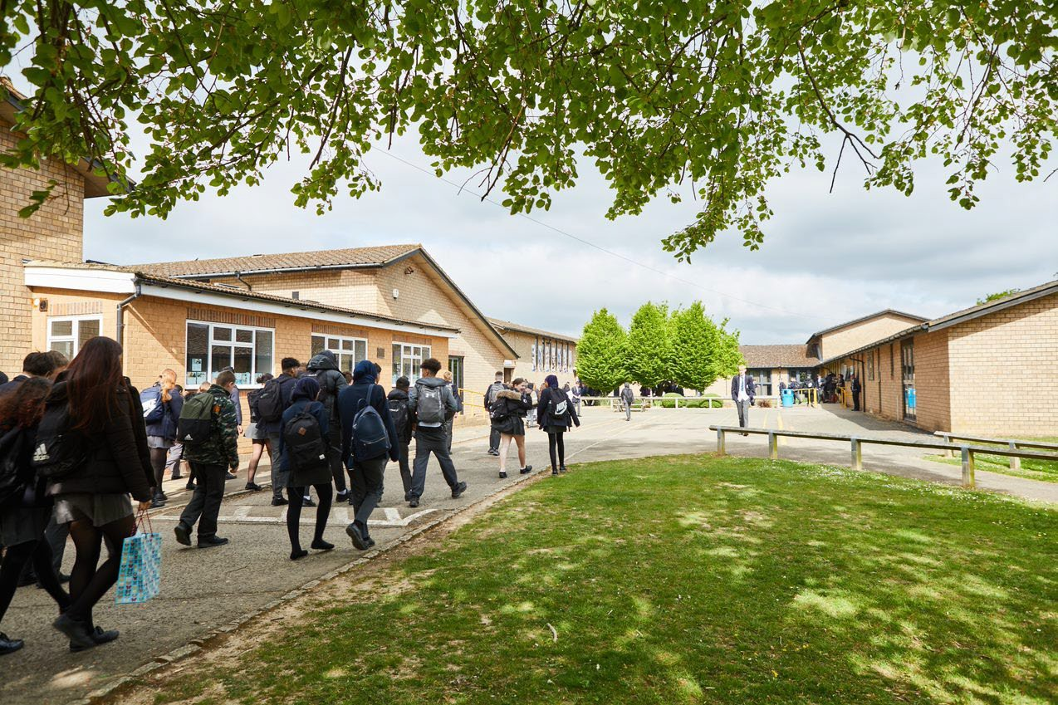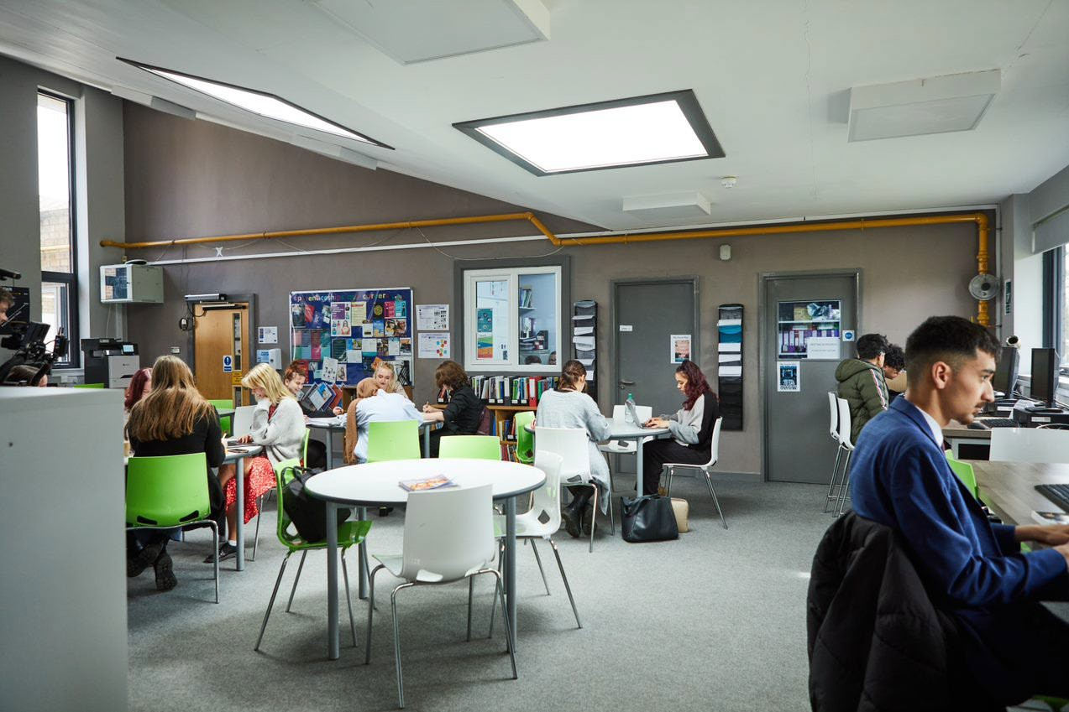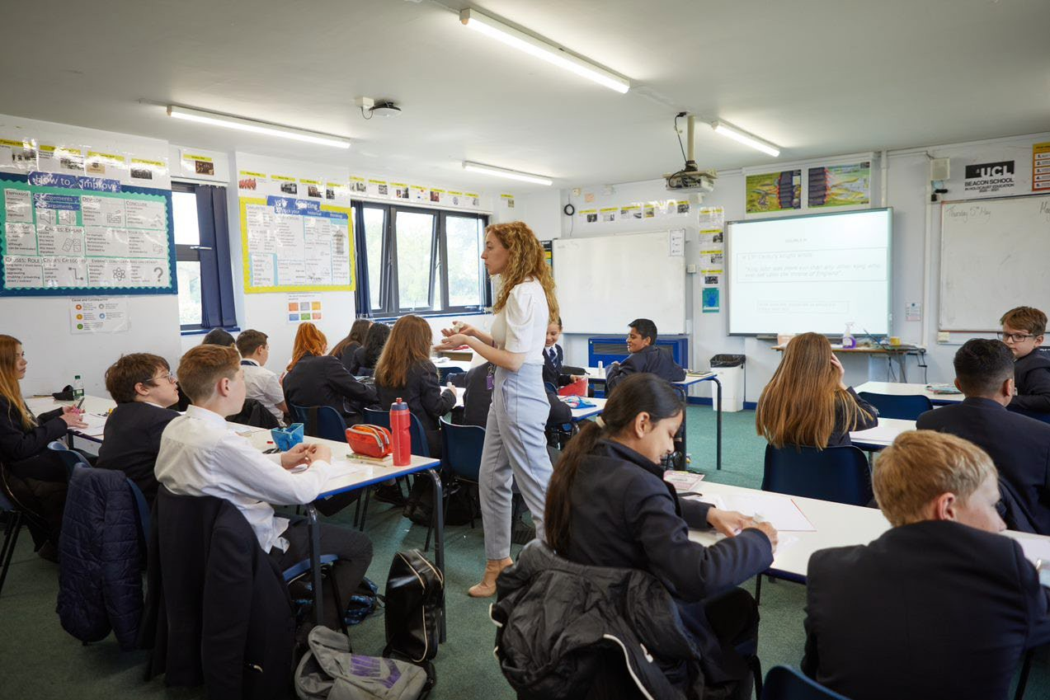
Welcome Letter from the Headteacher

Dear Prospective Candidate

Thank you for your interest in the position of Teacher of Maths at Sir William Ramsay School.

I joined Sir William Ramsay School as the new Headteacher in May and am committed to getting the school back to ‘Good’ as quickly as possible. Clarity, consistency and rigour are central to our plans to ensure that all students enjoy learning and make good progress. Our plans include significant developments in high quality teaching and learning, the introduction of ambitious targets, a focus on developing excellent teaching, meaningful homework and improvements in behaviour for learning. We are also rolling out a digital learning 'One to One Device' strategy across the school to ensure that students can receive innovative teaching and access state of the art resources at both home and school.

We are looking to appoint a dynamic Teacher of Maths to contribute to the development of this successful area. The ideal candidate will have a belief in the ability of all students to achieve and a passion for raising student achievement. You will have a desire to strive for continuous school improvement and a commitment to team work as well as a sense of fun.

If you would like to find out more about the role or to arrange a conversation with the Head of Faculty, Mr Iqbal, please contact HIqbal@swr.school.

I will hope to meet you in the near future.

Yours faithfully
Paul Ramsey
Headteacher

Vision and Values at Sir William Ramsay School

Empowering Everyone to Achieve

Vision
A community where every voice counts, where talent and creativity are brought to life, where students grow in confidence, build resilience and are prepared for the rest of their lives.

Values
- We are respectful – we always treat people, property and the environment with kindness and consideration
- We are ambitious – we ask for help when we need it and strive to be the best we can be
- We are reliable – we do what is asked of us and deliver on our commitments
- We are resilient – we prepare for the future and adapt and grow from challenges

Mission
We aim to achieve our vision by:
- Raising students above the ordinary by developing and delivering lifelong learning which transforms lives
- Ensuring every person feels valued, safe and happy
- Enabling students to feel proud of themselves, and to take pride in the success of others
- Promoting a culture of mutual respect where everyone is treated as a valued member of the school community
- Encouraging positive communication so that words and actions are thoughtful, supportive and motivational
- Placing parents and carers at the heart of the life of the school
- Having highly dedicated and well-qualified staff who are committed to continuous professional development
- Adopting an ethos of continuous improvement within all aspects of school life

Equality
Sir William Ramsay is an inclusive and diverse community. We work to eliminate all forms of discrimination on the grounds of ethnic origin, religion, sexual orientation, gender, disability or ability. This is achieved via the following principles:
- Ensure that students have the opportunity to reach their potential in all areas of school life
- Ensure that parents and students can make choices free from prejudice and stereotyping
- Oppose any form of racism, sexism, disability discrimination, homophobia or any other form of discrimination
- Value every student’s language and cultural background
Job Description

Job Title: | Teacher of Maths  ECT/MPS/UPS (R&R available for a suitable candidate)
Aim and Main Job Purpose: | To teach, enthuse and inspire students about Maths

Teaching and Managing Pupil Learning
Teacher of Maths will:
- Be able to teach effectively across the full range of age and abilities.
- Possess high expectations of students in relation to standards of achievement and behaviour.
- Have an active input in the creation, consistent implementation and improvement of schemes of work which encapsulate key school learning strategies.
- Monitor the progress of students including those requiring additional support and challenge them to ensure students are engaged in their learning and achieve success.

Assessment and Self-Evaluation
Teacher of Maths will:
- Implement policies and practices for assessing, recording and reporting on student achievement and to assist in setting targets for further improvement.
- In conjunction with the Head of Maths, use data effectively to identify students who are underachieving and, where necessary, create and implement an effective intervention plan.

Relationships with Parents/Carers
Teacher of Maths will:
- Establish a partnership with parents to involve them in their child’s learning of the subject, as well as providing information about targets and attainment.
- Communicate effectively, both orally and in writing, with parents.

Managing Own Performance
Teacher of Maths will:
- Prioritise and manage their own time effectively.
- Take responsibility for their own professional development.
- Share good practice resulting in a tangible impact on student learning.
- Form constructive relationships with staff including team working and mutual support.
- Actively implement the key aspects of the school’s behaviour management policies.
- Be a form tutor.
- Make a contribution to the wider school life including specialist Maths enrichment activities.
- Contribute to faculty planning and developments.

Strategic Leadership
Teacher of Maths will:
- Contribute fully to the Faculty Development Plan which contributes positively to the achievements of the School Development Plan.

Other Responsibilities
- To promote the School’s vision, values and aims.
- To be aware of and comply with the codes of conduct, regulations, policies, procedures.
- To work as part of a team.
- To be generally responsible for safeguarding and promoting the welfare of students.
- To be responsible for own and team health and safety including well-being.
- To actively participate in the School’s appraisal system.
- To do Continued Professional Learning as agreed with the Line Manager.

This job description is current at the date indicated below but, in consultation with the postholder, it may be changed by the Headteacher to reflect or anticipate changes in the post commensurate with the grade or job title.
The Maths Department

Teacher of Mathematics
We are looking for an enthusiastic, well-qualified and dedicated team member who will inspire and motivate our students.
The Mathematics Department currently has eight members of staff, who have a breadth of experience and subject specialism. We are an able and enthusiastic team with a clear focus on raising standards to ensure that the teaching and learning within the department has pace, challenge and addresses the needs of all our students.

Some truly outstanding results this year have been achieved through the hard work and determination of our staff and students. This success can be seen in the school’s consistent improvement, resulting in 13 grade 9’s across 10 different subjects.

The results in Summer 2022 gave us 70% 9-4 grades across the school made up of 13x Grade 9, 28x Grade 8 and 121x Grade 7.

2022 Grades for Maths:
- 68% GCSE Mathematics Pass Rate (Grades 9 – 4) (2019 pass rate: 60.5%)

The Maths Curriculum
In Key Stage 3 and Key Stage 4 students are set in half year groups. Students start the GCSE course at the beginning of Year 9.
In Key Stage 3 and Key Stage 4, students are taught mathematics for 8 hours per fortnight. A-Level student are taught for 9 hours per fortnight.
Year 11 students are entered for the Higher or Foundation Tier of the Edexcel GCSE in Mathematics. Higher ability students will have the option to be registered for the Edexcel A Level Mathematics course, studying Pure Mathematics, Mechanics and Statistics in both Year 12 and Year 13.

Extra-Curricular Activities
Students are supported beyond their usual lessons through afterschool interventions and boosters for all year groups.

The department benefits from opportunities to take part in courses at the local Maths Hub, which offers exciting initiatives providing career development through Mathematics research and pedagogy. The department also hosts a Maths Feast competition as well as other Further Maths Support Program events.

This is an exciting time for the school, and we are looking for applicants with a passion to work with young people to drive their success even further. In return, you can expect effective support from our strong leadership team along with a hardworking, talented, and passionate staff body. We are committed to professional development and there is considerable opportunity for career development within the school.

How to Apply

If you wish to discover more about this exciting opportunity, need any further information or you wish to have an informal discussion, please contact Head of Faculty: HIqbal@swr.school or 01494 815211.

Please email your completed application form to: jointheteam@swr.school

Closing Date: Noon – Monday 27th March 2023
Interviews: Thursday 30th March 2023

Sir William Ramsay School is committed to safeguarding and promoting the welfare of children and young people and expects all staff and volunteers to share this commitment. We will ensure that all our recruitment and selection practices reflect this commitment.

All successful candidates will be subject to DBS checks along with other relevant pre-employment checks.

