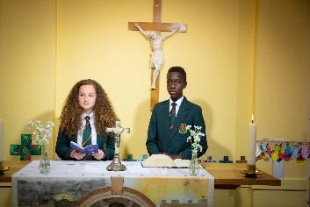

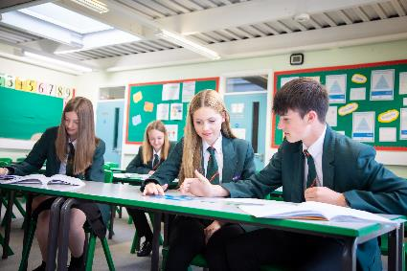

Why Blessed William Howard?

* A Christian community with a caring, secure and

disciplined environment.

* A wide range of extra-curricular activities.
* High academic standards.
* A commitment to success for all.
* Ongoing CPD for all staff

“*There is a warm atmosphere and the quality of relationships between all members of the school community are a particular strength. Pupils and staff are friendly, helpful, polite and welcoming to visitors*.” Diocesan Section 48 Report (December 2017)

About the role:

A vacancy has arisen in our maths department that would suit an NQT

or an experienced qualified teacher, ideally with a maths degree to teach

both Key Stage 3 and 4. This is a permanent position to start September 2022

The successful candidate will;

* **be inspirational** – able to engage with our students and create an

atmosphere of enthusiasm in the classroom.

* **be determined** to get the very best out of our students, seeing

them reach their full potential

* have a genuine **passion for Maths**

Find out more on our jobs page – [www.bwh.staffs.sch.uk](http://www.bwh.staffs.sch.uk)

**APPLICATION DEADLINE – Tuesday 25 January 2022 at 9am**

Are you looking for a new challenge in an innovative and supportive 11-18 Catholic school? Now part of the newly expanded Painsley Catholic Academy, the largest multi-academy in the Archdiocese of Birmingham, Blessed William Howard is looking to recruit dynamic, forward-thinking and inspirational staff to join its journey to success. With a strong Catholic ethos that puts ‘love’ at the heart of its community, the school provides a haven where all can flourish. Situated just outside the town centre and easily accessed by train, bus or the M6, Blessed William Howard is proud of its strong community links and its beautiful grounds.

Blessed William Howard

Catholic High School, Stafford ST17 9AB  
 Part of the Painsley Catholic Academy

Informal enquiries, further details and application forms from Mrs K Collins on 01785 244236 or [kec@bwh.staffs.sch.uk](mailto:kec@bwh.staffs.sch.uk) All applications should be returned to Mrs Collins.

The position is subject to a criminal records check from the Disclosure & Barring Service (formerly CRB) which will require you to disclose all criminal convictions. Further details regarding this check are available by visiting [www.gov.uk/dbs](http://a.cinco.purlsmail.com/sendlink.asp?HitID=1366018506220&StID=22036&SID=6&NID=428534&EmID=42223271&Link=aHR0cDovL3d3dy5nb3YudWsvZGJz&token=0826788d40fe24de8e66b2a8f87cd8665ef643b2) This school is committed to safeguarding and promoting the welfare of children and young people/vulnerable adults and expect all staff and volunteers to share this commitment.

*Blessed William Howard is proud to part of the Painsley Catholic Academy,* *A company limited by guarantee registered in England & Wales with company number 08146661. Registered Office Address: Station Road, Cheadle, Staffordshire ST10 1LH. Telephone: 01538 493777 Email: office@bwh.staffs.sch.uk Web: www.bwh.staffs.sch.uk*

Teacher of Maths  
MS/UPS

