Glossopdale School and
Sixth Form
Information for Applicants

To aspire, endeavour and thrive together

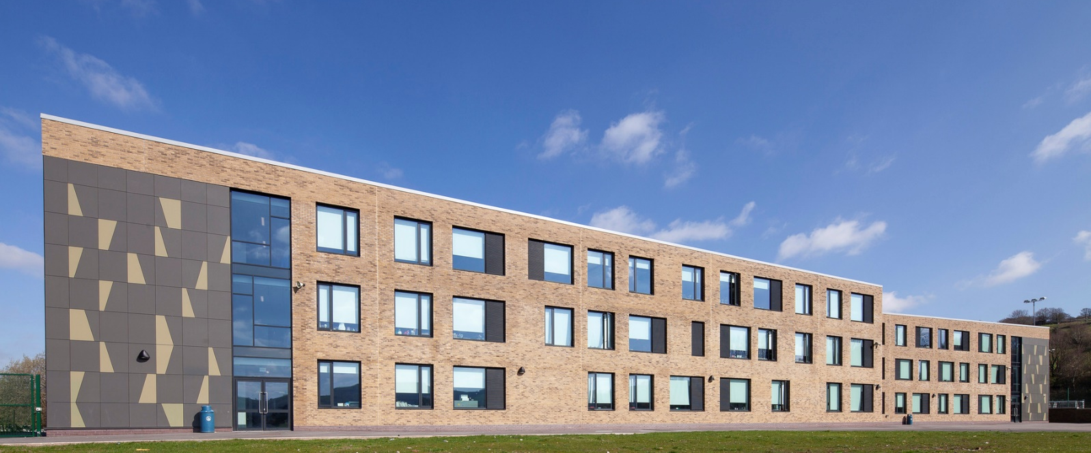

Glossopdale School and Sixth Form
Newshaw Lane • Hadfield, Glossop • SK13 2DA
https://www.glossopdale.school

WELCOME FROM EXECUTIVE HEADTEACHER
Dear Applicant,
Thank you for your interest in joining Glossopdale School and Sixth Form. Our School is a warm and caring community for all of our 1,200 students, from when they join us in Year 7 to when they leave us in Year 13. We are a school that has the highest expectations of students and ourselves, where every student is expected to work hard, behave well and contribute positively to the school community.
Our core purpose is to support students of all abilities and backgrounds to develop high aspirations and achieve their potential. We do this by nurturing and building ambition for our students, we open opportunities, broaden horizons and introduce challenges ensuring everyone can thrive, both academically and personally, to be the best that they can be.
While with us, we encourage every member of staff to stretch themselves and we give everyone access to a wide range of learning and development opportunities. We have just started our journey to become a research based school with the aim to develop highly effective, evidence-based teaching, learning and assessment, where we collaborate as a whole staff to persistently improve our pedagogy and where we evaluate our practice habitually.
Everyone also has the ability to get involved with school life beyond their core role – whether that’s supporting one of the many extra-curricular activities and clubs, or becoming part of the student support structure we have in place for each year group. There’s always some way you can push yourself towards your own goals while inspiring and supporting our students.
We have some of the best facilities in the area having fully re-built our school in 2018. This not only provides both staff and students with everything they can expect for modern teaching and learning, but also gives us exceptional environmental credentials.
Just like our students, we welcome people to join our school from a diverse range of backgrounds. We welcome interest from enthusiastic, dedicated and hardworking individuals who wish to share in our and, more importantly, our students’ success.
I am extremely proud to be the Headteacher of Glossopdale School and Sixth Form and consider it a privilege to be a part of such a vibrant and caring learning community. If you think this sounds like your sort of school, then we very much look forward to receiving your application to join us.

Debbie McGloin
Executive Headteacher

THE TRUE LEARNING PARTNERSHIP

This is an exciting time to be joining our School. We are very pleased that Glossopdale School and Sixth Form joined The TRUE Learning Partnership in 2020. This follows a period of close partnership working where it was clear that the vision and values of Glossopdale were closely aligned with the Academy Trust. Academisation will bring many opportunities for the staff and students at our school.
In December 2018, Poynton High School and Lostock Hall Primary School became the founding partners of The TRUE Learning Partnership (TTLP). In April 2020, Disley Primary School also joined the Trust and in November 202 Hague Bar Primary school joined.
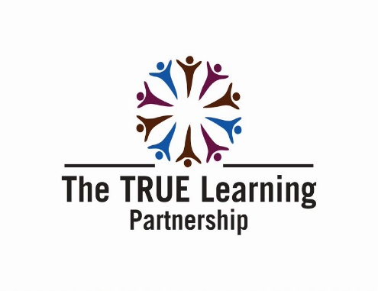
OUR STUDENTS

As a new school where all age groups are together we expect everyone to make a contribution.
Students readily volunteer to represent our school in many ways: welcoming visitors; outreach work with local primary schools; work experience; voluntary and charitable work and much more. Everyone has something to offer and we celebrate our students’ generosity, maturity and willingness to help.
Students are encouraged to aim high—in their work, conduct, attendance, punctuality and dress. We expect them to achieve their best and to take responsibility for their own learning, working independently and collaboratively. We aim to meet our learners’ needs in a rich and varied way.
We listen to the student voice and we encourage them to become involved in the work of the school. The health and well-being of our students is important and we endeavour to support their emotional, social and moral development to enable them to flourish. Working with a range of professionals, we listen to and guide young people throughout this time in their lives.
We are very proud of our school community and expect our students and their families to join with us in this pride and embrace our values and aspirations for all.

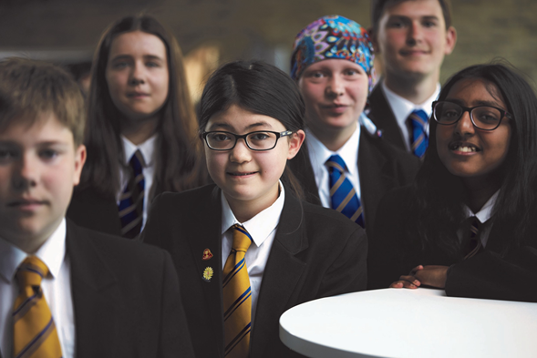

OUR STAFF

We are exceptionally proud of our staff and the dedication they display every day to support our students to reach their potential. Whether a member of our Leadership Team, Teaching Staff or Support Team – all have a vital role to play in providing an environment where all can achieve.
New Staff joining us will have a full induction and will be paired up with an existing member of staff to support them in their first few months of employment. The induction process is for all staff and is tailored to the needs of each individual. New teachers at the start of their teaching career are well supported through the NQT and RQT process and we are pleased that many staff have stayed with us throughout their teaching careers, enhancing their skills and developing their pedagogy through our ongoing training offer.
We are also looking forward to being part of The TRUE Learning Partnership CPD programme which will enable all our staff to access development opportunities across the multi academy trust.
Staff Wellbeing is a priority for us as we aim to support all of our staff to enable them to support all of our students. The Headteacher takes the lead for this area and the need to manage workload and work smarter is a key focus. Student and Staff Committees focus on welfare and wellbeing for all, with further external specialist guidance and support provided by The TRUE Learning Partnership.

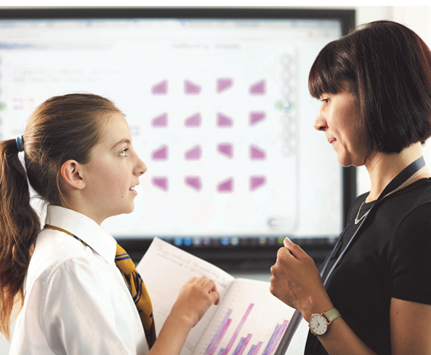

OUR VISION AND VALUES
Our vision for Glossopdale School and Sixth Form is very simple - to aspire, endeavour and thrive together.
We aim to deliver this through an understanding of what is expected of each and every one of us - staff and students. We achieve this as a staff body through good communication, clear expectation and working together.
We inspire the students to understand and personally act on our vision by breaking this down into a clear message. We feel these values are encapsulated by the acronym THRIVE. Each of the letters stand for a character trait we want to see our students develop during their time at Glossopdale School.

T | H | R | I | V | E
Tenacity | Hard Work | Responsibility | Independence | Visionary | Excellence

We are able to use this in all our interactions with our students to help them build the skills and traits to enable them to aim high and achieve their potential. We firmly believe that strength of character is the fundamental cornerstone of academic success.
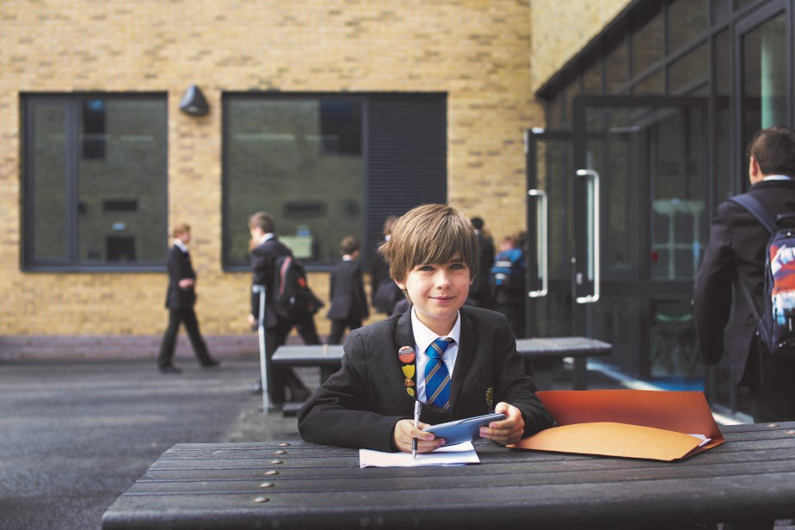
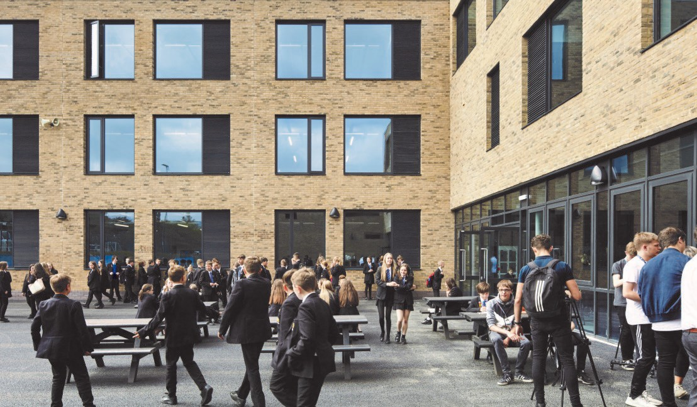

OUR ENVIRONMENT

We are in the very fortunate position to work within a new purpose built school which opened in September 2018. This has benefitted staff and students in so many ways. Our students learn in a modern, open and inclusive environment.
Students have access to the latest music technology along with six practice rooms, a Drama studio and Theatre, Dance and Fitness studios, a professional standard Sports Hall, tennis courts, Astro-turf, Technology suites, Art studios, eight fully equipped Science laboratories, specialist sixth form teaching rooms and an 80’’ touch- screen interactive board in every classroom.
Our non-teaching facilities are also first class and enable the support functions to work effectively and collaboratively across the school.
Our fantastic building was designed to reflect and compliment the local landscape. The open skies and green peaks surrounding the school are its source of inspiration and our staff and student body are wholly committed to respecting and preserving the environment around us; local, national and global. We are one of very few schools in the country to separate all of our waste to reduce landfill, raising students’ ethical consciousness and consideration for the world around them, present and future. Our cups are compostable, all of our food packaging is recyclable and even the school ties are made from recycled tyres!
However, we are determined not to be complacent and we continue to focus on making our school even more eco-friendly and continue to look for new ways to enhance our sustainability.

PASTORAL CARE
We have built strong relationships with our partner primary schools and our aim is for our incoming Year 7 students to already feel part of our family before they join us for their first term. We organise many events in which primary pupils can get involved such as cooking club, dance tuition, the training band and sporting events. These events ensure the new students to overcome any understandable nerves regarding the transition and mean they can look forward to the move as a new and exciting step.
From their first day we want our students to feel that they belong here, irrespective of when they join us. Our pastoral structure invites students to create strong partnerships, within and beyond their year and tutor groups. Each year group is akin to a family; a Year Manager, Progress Leader and member of the Senior Leadership team dedicated to each year group give students the confidence to know they have staff and students who really know them and will take the time to listen. Our Form Tutors are a vital part of the pastoral team and the majority of teaching staff will take on this role each year.
We also know that students have diverse needs, academic and emotional. We have a range of bespoke facilities, services and areas of the school where students can access the individual support they need, including Learning Support, The Hive, The THRIVE Centre, Year team offices, Family Support, the School Nurse and counsellors.
Our Learning Support team is multi-skilled, including a large number of experienced learning support assistants who provide specialist intervention in lessons, at lunchtimes and after school. We are proud to be inclusive and welcome students with a wide range of needs.
We have an experienced and highly skilled Family Support Team which covers Glossopdale, New Mills School and our cluster primary schools. This team is committed to providing support to ensure all children in the local area get the best start in life. We understand that family life can be difficult at times and our aim is to offer support to families within the community with children from primary through to secondary school in order to provide continuity with their outcomes.

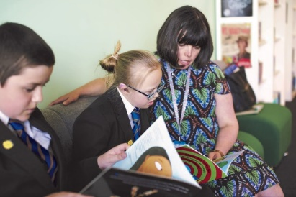

CURRICULUM
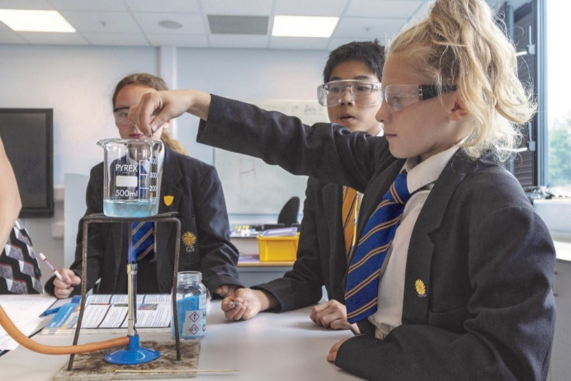
The quality of teaching and learning is our priority. We want our students to gain satisfaction through hard work and engagement with their studies. We know that a determined focus on excellent progress and grades will take them to Post-16, University and beyond.
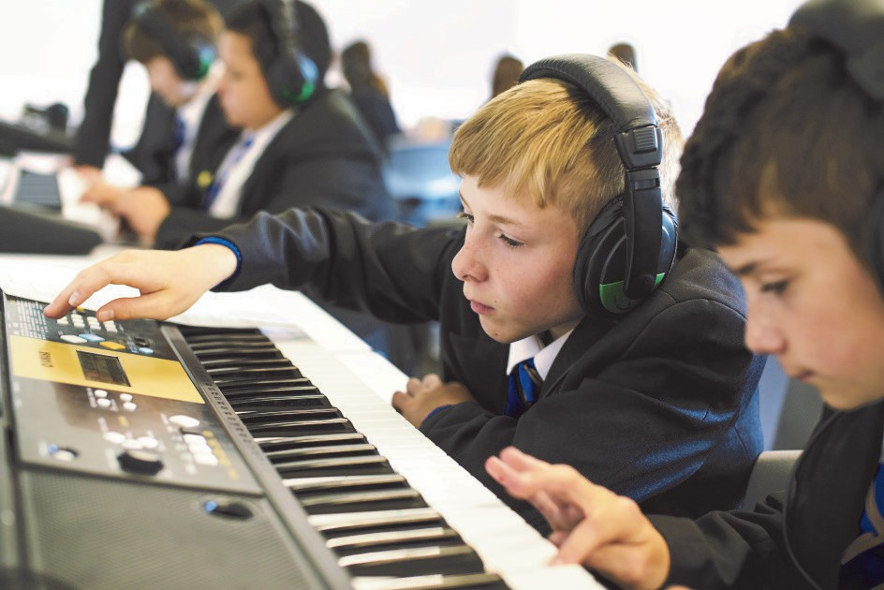
We have a flexible personalised curriculum which provides for the needs of all our students. Traditional GCSE subjects in English, Maths, Sciences, Humanities, Languages, Arts and Technology sit side by side with some more vocational and technical courses in Sport, Performance, Social Sciences, Business and Catering. Targets are set and progress is closely monitored.
Year 7 to 9 students follow a core curriculum. This includes: English, Mathematics, Science, Technology, Humanities, Art, Music, Dance, Drama, Computer Science, Physical Education and a language.
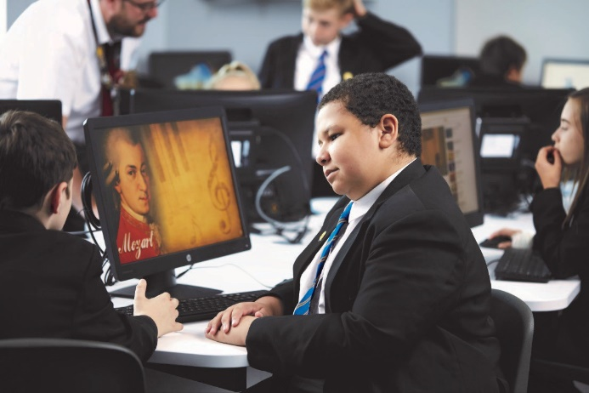
In Year 10 and 11 students have the opportunity to design a curriculum matching their interests and skills. Those who are especially talented in one or several areas may have the chance to accelerate their learning. Students can choose purely academic pathways or routes that are work related, such as Design Technology & Catering as well as a range of BTEC subjects such as Sport, Business studies and Health and Social care.
The curriculum is designed to give every student the best possible chance of leaving Glossopdale School with strong qualifications and high aspirations.
Across all subjects, we want students to be excited and enthused, to express themselves confidently and eloquently and to rigorously expect the best academic standards of themselves.

EXTRA-CURRICULAR ACTIVITIES

We are very proud of our extra-curricular provision at Glossopdale. We firmly believe that involvement in these activities encourages our students to think creatively in all aspects of their learning, to develop enquiring and creative minds and to build positive attitudes about themselves.
Our staff are committed to this provision and it is valued highly by the students and parents who can clearly see the benefits gained through this offer. Involvement in these activities is encouraged for all of our staff and we are always looking for new ways to enhance the opportunities we offer to all our students from Year 7 – 13.
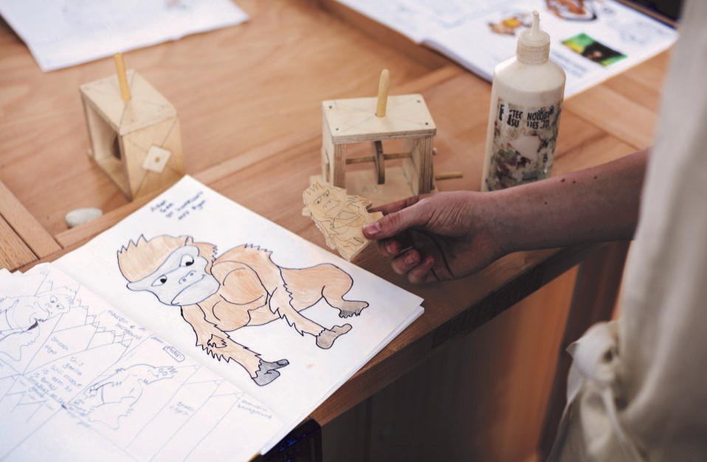
We have a particularly vibrant music and performing arts scene, with a range of music ensembles, concert and drama performances and recent appearances in the finals of the National Music for Youth competition. Students are encouraged to take part in a full range of visits in the UK and abroad.
We have had great success in a range of competitive sporting fixtures across many sports including Netball, Football, Rugby and Hockey. This complements the full range of recreational sports that we offer throughout the year.
Clubs, work placements and ‘masterclasses’ widen their experiences and perspectives and support the delivery of our curriculum.

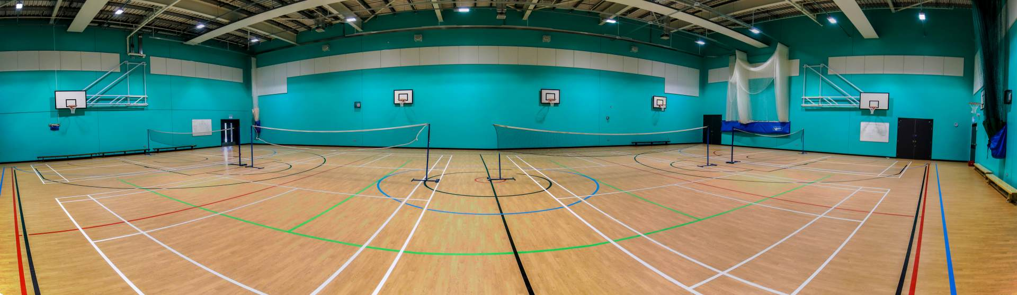

SIXTH FORM
We have a thriving and popular Sixth Form, offering 300 students a wide range of academic and vocational courses with brand new state of the art facilities. We have the latest ICT equipment and practical suites for Performing Arts, Science, Music Technology, Creative Digital Media and Art as well as bespoke seminar rooms and communal social and study space. At Glossopdale our post 16 provision is extensive and primarily offers courses at level 3 (A Level) and some at Level 2. Courses can be purely academic or vocational or a mixture of both.
The Sixth Form students continue to benefit from our strong pastoral support as well as our links with universities and businesses in the Glossopdale community and throughout Greater Manchester. As with the rest of the school, regular assessment, feedback and supportive intervention gives students clear targets and allows them to take ownership of their educational achievements and future career aspirations. Typically, students leave our Sixth Form having secured their university courses or apprenticeship pathways and our careers guidance and work experience programme ensures all students are well prepared for their future choices.
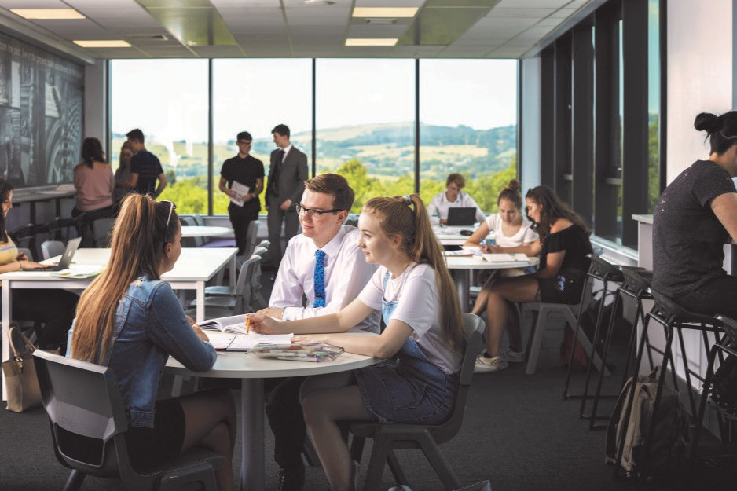

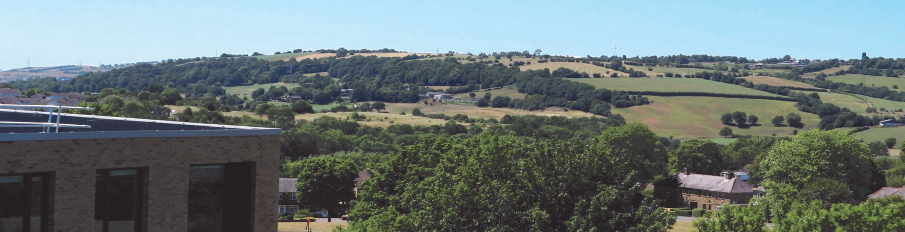

More Information about Glossopdale School and Sixth Form can be found on our school website https://www.glossopdale.derbyshire.sch.uk.

More Information about The TRUE Learning Partnership can be found on the MAT website https://truelearning.org.uk

