
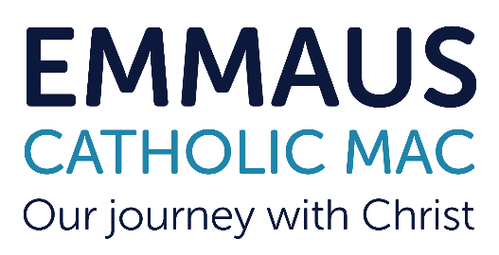


Hagley Catholic High School is looking to recruit a teacher of Maths as soon as possible. It is essential that the candidate can teach across all year groups from KS3 to KS4 with the ability to teach at A Level desirable or an area of future growth for the successful candidate. The successful candidate would be expected to contribute to teaching and learning development in Maths across all key stages and all abilities and we are looking to appoint an ambitious, committed and conscientious practitioner.
The Maths Department is a very well regarded team of 7 teaching staff. The curriculum intent is strong, and schemes of learning are well sequenced, while students make very good progress and outcomes are consistently in the top 5 schools in Worcestershire.
Maths is taught to all pupils in Key Stages 3 & 4 with A-level provision including further maths at AS Level. The appointed candidate would be expected to provide a secure specialist knowledge of the Maths curriculum.
In 2024, 100% of the cohort achieved grades 9 - 1 with an average grade of 5(b). 31% achieved 7 or more, while 82% achieved 9 - 4 and 64% 9 - 5. At A Level a 100% pass rate was secured again with an average grade of a B and an A- in Further Maths.
The school welcomes applications from candidates of all faiths and backgrounds. A commitment to promoting the ethos of the school is also very important.

We welcome applications from both Catholics and non- Catholics but expect all employee to support the Catholic ethos and values of the school. If you meet the requirements of the job description and person specification and feel that you make a positive difference to our school, then we can’t wait to receive your application.
We are recruiting for a Teacher of Maths
The post has the potential for a shared TLR 2b as Second in Maths and the successful candidate will have the opportunity to apply for this post.
Required for a January 2025 start
Salary Range: Main Scale/Upper Hours: Full Time or 0.9FTE/Permanent

Emmaus Catholic MAC is committed to safeguarding and promoting the welfare of children and young people. This position is subject to an Enhanced Disclosure check under the Rehabilitation of Offenders Act 1974.
All applicants must be able to provide documentation to prove their right to work in the UK.

Effective from September 2022, KCSIE states as part of the shortlisting process school and colleges should consider carrying out online searches, as part of the due diligence on shortlisted candidates. This is to determine suitability to work with children and keep them safe. All shortlisted candidates are now subject to an online check and if
there is anything concerning, then the shortlisted candidate will be asked to comment on it at interview.
Contact Us
A full application pack is available from West Midlands Jobs, or by contacting the Principal’s PA or downloading the pack from the Emmaus website:
Email - principalpa.hchs@emmausmac.com
Phone - 01562 883193
Online - www.hagleyrc.worcs.sch.uk

We warmly welcome visits to the school. For specific questions about the role and/or to request a visit, please contact Anne Holland Head of Maths via email at; aholland@emmausmac.com
Closing Date: 27th September 2024 at 9.00am
Interviews - 2nd October 2024

