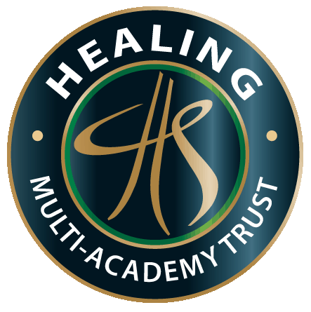 | Healing Multi-Academy Trust is committed to a policy of equal opportunities and it is our approach to select the right person irrespective of disability, race, colour, sex or marital status. Please complete this section of the form which is voluntary and will not be made available to people who read the application form itself. The form will be used to monitor the effectiveness of the equal opportunities policy.  THIS FORM IS NOT PART OF THE SELECTION PROCESS

Last Name |  | First Name(s)
Post applied for |  | Date
Department |  | Date of Birth

My ethnic origin is: |  |  |  | Age range:
White |  |  |  | (please tick)
 | White British | A1 |  | Under 25
 | White Irish | A2 |  | 25-34
 | Any other White background | A3 |  | 35-44
Mixed |  |  |  | 45-54
 | White and Black Caribbean | B1 |  | 55-64
 | White and Black African | B2 |  | 65 or over
 | White and Asian | B3
 | Any other mixed background | B4 |  | Are you:
Asian, or Asian British |  |  |  | Male
 | Indian | C1 |  | Female
 | Pakistani | C2 |  | Married
 | Bangladeshi | C3 |  | Single
 | Any other Black background | C4
Black or Black British |  |  |  | Is there anyone dependent on you for Care?
 | Caribbean | D1 |  | Yes | No
 | African | D2
 | Any other Black background | D3
Other ethnic groups
 | Chinese | E1
 | Any other ethnic group | E2

Do you have a disability/health problem, which affects you in employment? | Yes | No
If so, please give brief details
Have you any special requirements for interview (e.g. sign language, interpreter, wheelchair access):
If you would like additional help with completion of the application form please ring

Where did you see this post advertised? (IMPORTANT: Please specify)

Please return this form to hr@healingmultiacademytrust.co.uk

