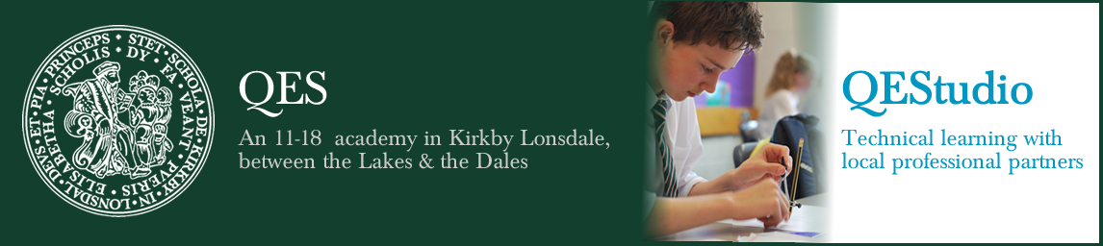

Job Details

Teacher of Maths – Maternity Cover
Post | Teacher of Maths – Maternity Cover
Hours | Full Time
Start Date | November 2022
End Date | July 2023
Pay Scale | MPS/UPS

Thank you for accessing details of the above post. We hope these details will give you an impression of an exciting opportunity to make an important contribution to our schools. We would strongly urge you to get more of a ‘feel’ for the life of the school by visiting our websites: www.qes.org.uk and qestudio.org.uk We appreciate that there is much in addition that you would want to know and can assure you that at the interview stage we will share with you as much as is feasible. If there is anything specific you wish to know at this stage please don’t hesitate to get in touch.

The Post
This post requires someone who is able, willing and with the confidence to teach Maths across KS3 and KS4 across both our schools – QES and QEStudio; plus taking on responsibility for a Year 7 form group.
The Person
Working across our schools is demanding but the rewards are commensurate with a strong, highly motivated staff, very good facilities, a lovely environment and pleasant, friendly and motivated pupils.
We expect to appoint a teacher of Maths who has:
- a keen intellect and an excellent academic background with a very good degree
- a great track record of success
- compelling personal qualities, an ability to form positive relationships with people and the ability to enthuse and inspire pupils
- impeccable administrative abilities and a highly efficient demeanour
- an ability to communicate effectively
- the ability to work hard under pressure
- a sense of humour and proportion
- a commitment to enhancing the school community
The person appointed can expect much help, guidance and support from all members of the Maths department and from across our schools.

