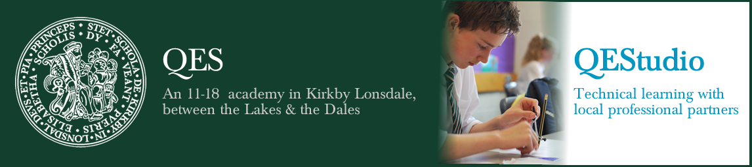

Department Details

Maths
There are currently 11 teachers of mathematics several of whom are part-time or have a leadership responsibility. The Department has four classrooms all close together with an office and central resources area. These classrooms surround a large open access area furnished with tables, a Promethean board and a suite of computers which are predominantly used for maths lessons. All of the surrounding rooms are equipped with ceiling mounted projectors.
In Year 7, pupils are taught in two populations, each with 5 teaching groups respectively. In Years 8 and 9 there are 3 populations, with 3 groups in each.
Maths groups are set by ability based on regular internal assessments, which take place at key times in the year, and ongoing in-class monitoring.
For Years 7 – 11, the Department has adopted the structure of the White Rose scheme of learning with its emphasis on visual representation and small steps approach. We have embraced the creative teaching ideas and are in the process of linking our own materials to our schemes of learning. We also have an annual subscription to MyMaths, Mathswatch, MathsPad, and MathsBox. There exists a strong, positive team ethos and colleagues regularly share ideas and examples of good practice and willingly support each other’s lessons.
At KS4 pupils prepare for the AQA 8300 examinations. We use a mixture of CGP textbooks at the appropriate level supplemented by worksheets and some White Rose resources. Assessments take place at the end of each half term with whole school mock examinations in the Spring Term of Years 10 and 11.
Colleagues readily make themselves available for students to ‘drop in’ and seek guidance relating to work issues. Help is always on hand for homework or further explanations of demanding topics. This applies to all levels and all key stages. The Department prepares a massive amount of revision materials for key exams and organise lunchtime revision classes and utilise in-school study leave to deliver focused exam preparation.
Maths is a very popular subject choice at KS5. We offer A2 Maths and AS and A2 Further Maths. For A level we follow the new OCR syllabus A H240 course. We use Hodder textbooks written specifically for OCR. These are supplemented by extensive department resources including Susan Wall activities and materials from the MEI TAM course. In further Maths we follow the OCR syllabus with options in Statistics and Mechanics. We have links with Lancaster University through the Advanced Maths Support Programme and students attend problem solving sessions and revision opportunities. Students and teachers have access to Integral Maths.
The successful candidate will be joining a strong team of enthusiastic and caring professionals who see pupils as individuals with differing needs and who take these into account when teaching. The Department work well together, share a passion for mathematics and accept a joint responsibility for developing understanding and enthusiasm for the subject throughout the school. We are a forward looking and dynamic department committed to improving our own skills and to providing enrichment opportunities for pupils of all abilities. It is Department policy that all staff, as far as possible, teach across the full age and ability range.

