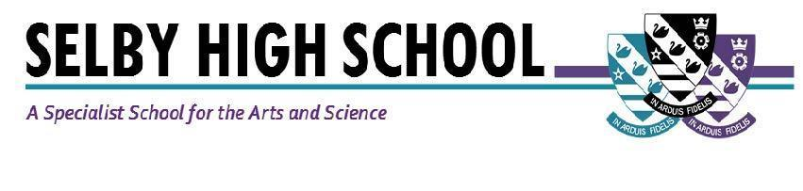

Teacher of Maths (Maternity Cover- 1 year in the first instance)
Required: September, 2021
Salary: MPS/UPS (suitable for an NQT)
Are you ready for an exciting role as part of our successful Maths team from September, 2021? This is a superb opportunity to join our successful maths faculty which has achieved excellent results in recent years and to work in a forward-thinking school where students achieve and make sustained progress as a result of our ‘can do’ ethos. Whilst this is a maternity cover in the first instance, there may well be opportunities to join the team on a more permanent basis in the future.

If successful, we can offer a supportive school environment, where your contribution to the Maths team and the school as a whole, will be valued. Working in a friendly school community, we invite you to join us in our commitment to inspire every student with the skills, resilience, independence and confidence they need to achieve their potential. As a school, we have an extensive CPD programme to support you in your career. We also provide all our staff with a laptop computer.

Excellent learning and teaching is at the heart of all that we do and is supported with a full professional development programme and outstanding induction programme. If you are an NQT or RQT, we offer a high quality support programme to ensure you make a great start to your career.

We can’t arrange visits to the school at the moment, but the Principal would be delighted to talk through the role with you if you are interested. Selby is located in picturesque North Yorkshire and benefits from good commuter links with York and Leeds.

Selby High School is an equal opportunities employer. We have a robust child protection policy and are committed to safeguarding the welfare of our children and young people.

Full details and an application pack are available from the school website: www.selbyhigh.co.uk. A conversation with the principal can be arranged by contacting the SLT PA, Caroline Airth on 01757 244833 or admin@selbyhigh.co.uk.

Closing date: Noon on Monday, 19th April, 2021.

Selby High School
Leeds Road, Selby, North Yorkshire, YO8 4HT.

