Back to school with a new hub home to look forward to
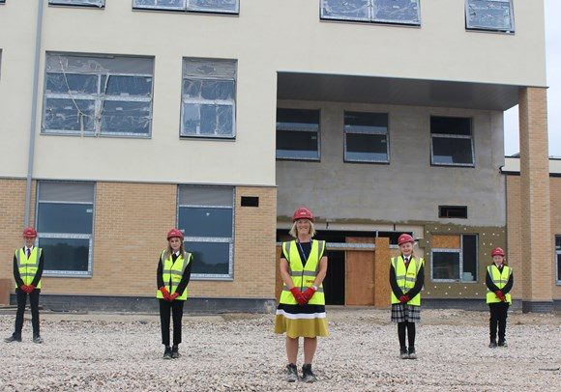
Download

It’s back to the classroom for staff and students at Mildenhall College Academy and the start of a school year that will see them move to their new hub home.
Mildenhall College Academy has been welcoming back students including new year 7 students and year 11 starting their final year.

It’s the academy’s final year at the Bury Road site. In 2021 it will move across to its new site at the Mildenhall Hub, next door to its existing 6th form centre, MCA6. That move is likely to take place within the first half of 2021 although that is subject to Covid19 not having further impact on the build programme.
For Academy principal Nicola Hood, the move away from the outdated buildings on Bury Road, to a modern, fit for purpose, shared facility, cannot come quick enough.
“The hub and all the good things it brings together, is so important to me, my staff, our students and our wider academy family,” Miss Hood said. “Finally, the students and the community of Mildenhall are going to have an educational building that reflects the outstanding work and achievements of our staff and students.

“Standards at the academy have improved but it is hard to raise the profile of the academy in the community even further with the buildings we currently have. We need a building that reflects this and our ambitions for the future – and that is the Mildenhall Hub.”

As well as a new school, the multi-million-pound hub will also bring together leisure facilities, a health centre, library, children’s centre, Citizens Advice and Job Centre, as well as desk space for Suffolk Police, West Suffolk Council, Suffolk County Council and the NHS.
R G Carter was awarded the contract for construction of the Mildenhall Hub and started work on site last year.

Cllr Jo Rayner, West Suffolk Council’s Cabinet Member for Community Hubs said: “The hub is about delivering modern facilities including education, leisure and health, shaped to the needs of local residents now and into the future. It’s also about a culture change in how all of the various organisations work together for the simple benefit of the residents in and around Mildenhall that we serve. It’s unique, it’s ambitious and it’s about services that are more resilient to some of the future funding challenges that we may all face. More than anything though, it is about people and that’s the thing that makes it so exciting and why it’s great to hear the enthusiasm from the academy as it looks ahead to its big move.”

The Mildenhall Hub website is currently being updated with information for local residents and other users of the hub.
For more information on R G Carter visit www.rgcarter-construction.co.uk
For more information on Mildenhall College Academy see www.mildenhall.attrust.org.uk

