

Teacher of Maths
Candidate Pack

MPS1 – UPS3
£32,916 - £51,048

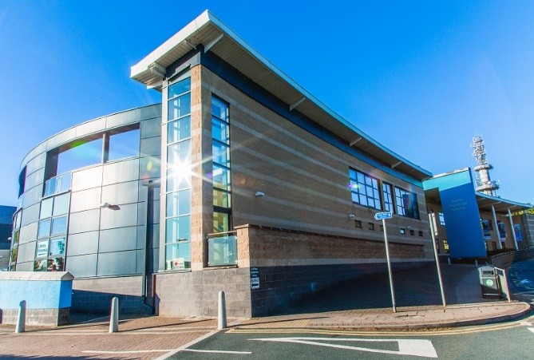

Ralph Thoresby School, recruitment@ralphthoresby.com Headteacher: Will Carr
Holtdale Approach, 0113 3979911
Leeds, ralphthoresby.co.uk
LS16 7RX

Welcome

Dear Candidate,

Thank you for expressing an interest in working at Ralph Thorsby School.
We are keen to recruit high calibre staff with a passion for leading student learning and if successful, you would be joining an exceptional team of staff, dedicated to challenging students and follow the high expectations of the school. We are proud to be a successful, truly comprehensive school serving a diverse local community. RTS is a fantastic environment in which to work and study. Our innovative curriculum is implemented by a talented and cohesive group of staff. The calm and purposeful atmosphere around school is underpinned by an emphasis on restorative practice and a clear focus on staff and student well-being.
Our school motto is ‘ambition and achievement for all’. We firmly believe in giving all students the opportunity to achieve their very best regardless of the circumstances in which they find themselves. We also have a strong emphasis on staff well-being with a professional staff coach, a staff well-being committee and a range of well attended social, sporting and fun activities. Our staff are proud to be at RTS and the team spirit is second to none.
We are excited about the future here at Ralph Thoresby and, having read the information included in this pack, I hope you feel you can play an important p and submit an application. Please also ensure that you visit our website which will give you an insight into the work of the school. I look forward to welcoming you to the school as a candidate in the near future.
Yours faithfully,

Mr Will Carr (Headteacher)


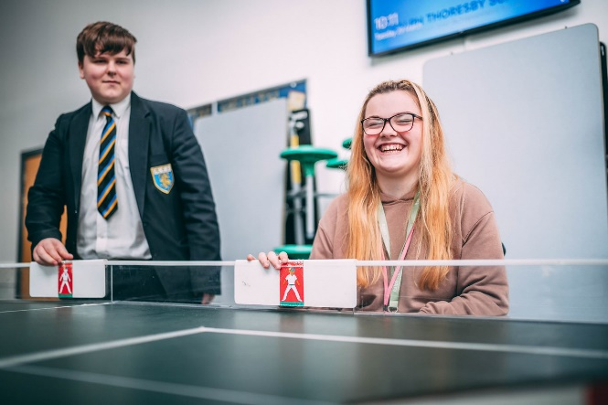




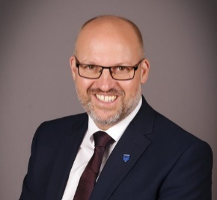

About Ralph Thoresby School

The school is a mixed community school with over 1,000 students on role. Approximately 30% of our students come from ethnic minority backgrounds and we have a resource provision for physically impaired students which really adds to the positive and harmonious atmosphere around school. Our superb, modern school building further enhances the atmosphere and supports students’ learning. ‘This is a school where staff and pupils celebrate diversity and promote values of tolerance, mutual respect and care for others’ (Ofsted).
The school has repeatedly been judged good by Ofsted and we have a strong record of academic achievement, whilst ensuring that all students are well supported. Students make good progress here because, ‘the working atmosphere in classrooms is positive’ and ‘pupils take pride in their work’ (Ofsted).
We have an excellent 6th form partnership arrangement with Lawnswood School (another good local school) and together we offer post-16 provision to rival the best in the city – ‘The quality of provision for post-16 students remains good. Students make consistently good progress over time’ (Ofsted). We are a Trust school in partnership with several of our local partner Primary schools. We have a strong relationship with the Local Authority and are also part of the highly regarded Red Kite Alliance teaching school hub, ‘Partnership working is strong’ (Ofsted).
Our school motto is ‘ambition and achievement for all’. We firmly believe in giving all students the opportunity to achieve their very best regardless of the circumstances in which they find themselves.
Why work for us - https://www.ralphthoresby.co.uk/why-work-at-ralph-thoresby/









Information for Candidates – Maths Department

The Mathematics Department currently consists of the Head of Maths, two members of SLT, and seven Maths teachers. The department has seven standard classrooms, each with a networked computer with internet access. We also have tablets that connect to these whiteboards, allowing freedom of movement whilst teaching. Additionally, we have an A-Level classroom and a specially designed intervention room for our KS3 students. The department is very well resourced with a wide range of mathematical equipment available such as manipulatives and laptops which can be booked for use with any group. Student learning is enhanced by a significant extra-curricular offering, including local and national competitions, work with industry partners and a visit to Paris.

Where appropriate, Ralph Thoresby School’s students receive additional support to ensure accelerated progress. This takes the form of an innovative KS3/ KS4 intervention programme and in-class support.


Teachers within our department enjoy an outstanding professional development programme, which have led to nationally recognised qualifications and the opportunity to work with professionals from across our extended network.

Key Stage 2

We have formed strong links with our local primary schools – We host regular problem solving workshops for Year 6 students. We also run transition days focusing on problem solving and team building which helps to smooth the transition between primary and secondary school.

Key Stage 3

Pupils perform well at Key Stage 3 and are working on developing maths and problem-solving skills from a newly developed and innovative scheme of work.

Students are not set when they arrive at RTS, and will be in mixed ability groups for a large part of year 7. They will start to be set from year 8, although streaming of sets doesn’t take place fully until year 9. There are 7 sets in each year group and classes have roughly 8 hours of Maths per fortnight. Students who are working below key stage are taught in small groups.

Key Stage 4

The successful candidate will be joining a forward-thinking team, who have developed their KS4 curriculum to follow on from a mastery curriculum at KS3.

Pupils are set into appropriate groups dependent on their Key Stage 3 results, target/predictions and teacher recommendation.

All students follow the Edexcel linear course with some of our most able students also completing the AQA Further Maths qualification


Key Stage 5

We follow the Edexcel A-Level Specification in both Mathematics and Further Mathematics, with a good uptake in both year groups. We also deliver AQA Level 3 Mathematical Studies.

Our strong links with local and national universities allow those interested in pursuing STEM subjects to work with academics to be truly competitive in their UCAS applications.

This is a strong and supportive department with a team of enthusiastic, committed and successful colleagues who work well together to provide a supportive and stimulating environment for teaching and learning.

Job Description
Teacher of Maths

Accountable to:
HoD/ Leadership Team
Line Managing:
N/A
Post type:
Permanent
Salary/Grade:
MPS1 – UPS3
Liaising with:
Leadership Team, Subject Leaders/Teachers, Support/Administration staff, Parents/Carers.

Safer Recruitment Statement:
We are committed to safeguarding and promoting the welfare of children and young people and we expect all staff and volunteers to share this commitment. This post requires Enhanced Disclosure (DBS). We promote diversity and want a workforce which reflects the population of Leeds.
- Work towards and promote the vision, beliefs, aims and expectations outlined in the School Improvement Plan
- Support and contribute to the achievement of every child’s outcomes
- Support and contribute to the safeguarding of all students
- Undertake professional development activities to enhance personal development and performance
- Maintain high personal professional standards of attendance, punctuality, appearance, conduct and positive relations with students, parents and staff.
Purpose of the role:

- Be a role model to students through personal presentation and professional conduct.
- To make a positive contribution to the wider life and ethos of the school
- To take responsibility for improving teaching through appropriate professional development, responding to advice and feedback from colleagues
- To communicate effectively with parents about students’ achievements and well-being
- All staff lead a small coaching group of students supporting attendance and building strong relationships with students and families
- To make a significant contribution to the Maths Department so that the department meets the school’s aims and vision.

Wider professional responsibilities

- To identify clear teaching objectives, specifying how they will be taught and assessed.
- To set tasks which challenge students and ensure high levels of achievement.
- To ensure students meet national and school targets.
- To provide clear structures for lessons maintaining pace, motivation and challenge
- To use an appropriate range of teaching methods to ensure that all students achieve their potential
- To ensure that students acquire and consolidate knowledge, skills and understanding
- To plan teaching to achieve progression for students’ learning
- To support positively all students’ individual learning needs, including students with specific learning support needs
- To ensure full coverage of examination board syllabus requirements
- To ensure the effective and efficient deployment of any classroom support

Teaching and Learning

- To assess how well learning objectives have been achieved and use them to improve specific aspects of teaching
- To regularly mark and monitor students' work, providing feedback and setting targets for progress and development
- To assess and record students' progress systematically, keeping appropriate records.
- To undertake assessment of students as required by examination boards and departmental/School procedures
- To use comparative data to set clear targets for student achievement and follow reporting procedures within the School.
Monitoring, Assessment, Recording, Reporting, and Accountability

- To have clear rules and routines for behaviour in classrooms, and take responsibility for promoting good and courteous behaviour both in classrooms and around the school, in accordance with the school’s behaviour policy
- To have high expectations of behaviour, and establish a framework for discipline with a range of strategies, using praise, sanctions and rewards consistently and fairly
- To manage classes effectively, using approaches which are appropriate to students’ needs in order to involve and motivate them
Managing behaviour effectively to ensure a good and safe learning environment

- All staff will make themselves familiar with the requirements of the Health and Safety Policy which are relevant to their work and ensure that they lead their faculty in Health and Safety requirements
- This Job Description is to be performed in accordance with the provisions of the School Teachers’ Pay and Conditions Document and within the range of duties set out in that document so far as relevant to the postholder’s title and salary grade. The post is otherwise subject to the Conditions of Service for School Teachers in England and Wales (the ‘Burgundy Book’) and to locally agreed conditions of employment to the extent that they are incorporated in the postholder’s individual contract of employment. Copies available upon request.
- Given the dynamic nature of the role and structure of Ralph Thoresby School, it must be accepted that, as the School’s work develops and changes, there will be a need for adjustments to the role and responsibilities of the post. The duties specified above are, therefore, not to be regarded as either exclusive or exhaustive. They may change from time to time commensurate with the grading level of the post and following consultation with the postholder.
Additional duties



Person Specification
Teacher of Maths
Essential
- Qualified Teacher Status (QTS) and good Honours degree relevant to subject
- Outstanding classroom practice that inspires students and adds value to their progress
- Proven track record of having impact on students’ outcomes in current post/teaching practice school
Desirable
- Further formal Professional Development
Qualifications & Experience

Essential
- Substantial knowledge and understanding of developments in the teaching and learning of the relevant subject
- Ability to relate to teaching staff, other professionals, parents, students and Governors.
- Experience of new technologies to support teaching and learning.
- Ability to use data effectively to monitor student progress
- Ability to work as a member of a team and /or independently
- Desirable
- Ability to support other school staff in their use of the relevant subject in teaching and learning
Skills & Knowledge

Essential
- Enthusiastic, sensitive, flexible, hard working with a sense of humour and ability to remain calm
- High level skills of communication, time management and prioritisation
- Ability to keep confidences
- Excellent interpersonal skills and organisational skills
- Ability to support and challenge
- Ability to inspire, motivate and influence others
Desirable
- Ability to ask for help if required
- Concern for the welfare of all members of the school community
Personal qualities and skills

Essential
- Excellent punctuality and attendance record
- Willingness to participate in the extracurricular life of the school

Special Requirements

THE SELECTION PROCESS
How to Apply
Thank you for taking time to read and digest our information. If you wish to apply for the post of Maths Teacher at Ralph Thoresby School, then you should:

- Complete fully the enclosed application form including the section for a personal statement, ensuring all details are accurate and all declarations are signed. Please ensure you enclose two professional referees with one being your current employer (with email addresses if possible). Do not enclose additional CVs.

- Submit your application form via email by Thursday 14th May 2026 at 2pm on this date to recruitment@ralphthoresby.com
________________________________________

Timetable for the selection process

- Post advertised in LCC Website: 28th April 2026
- Closing date for applications: 2pm Thursday 14th May 2026
- Short listing: Thursday 14th May 2026
- Invitation to interview by telephone: Upon shortlisting.
- Reference requested: Upon shortlisting.
- Selection day scheduled: W/C Monday 18th May 2026

