

**Welcome to The Bishop Fraser Trust from the Chief Executive, Tania Lewyckyj**

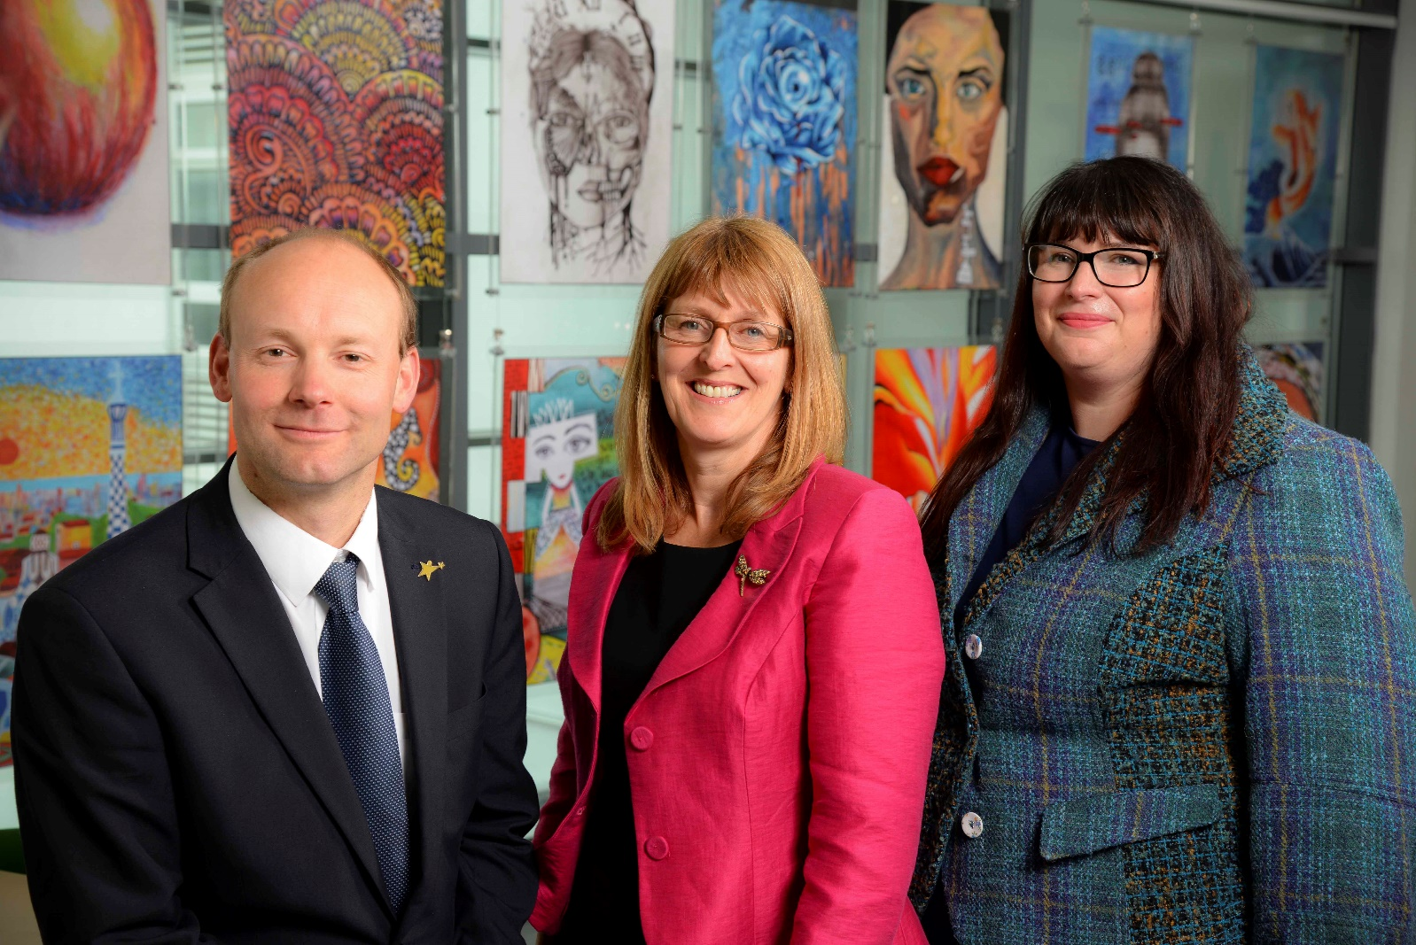The Bishop Fraser Trust is Multi Academy Trust which was set up on the 1st December 2017 with St James’s Church of England High School (11-16) and Canon Slade School (11-18). Bolton St Catherine’s Academy (3-16) joined the Trust on the 1st May 2018. Bury Church of England High School (11-16) joined the Trust on 1st January 2022.

Three of our schools are situated in Bolton and Bury Church of England High School is close by. We are an outward facing Trust and constantly look to learn and collaborate with others. We are also part of St James’s Train Teach Lead Partnership, which offers excellent CPD and school to school support. Our links with Manchester Diocese, GMLP and the Bolton Learning Partnership continue to be strong.

We became a Trust to secure the special nature of our individual schools as we do not think that one size fits all. We also wanted to secure our ethos and distinctiveness, enabling us to work together and to become the Trust of choice for local families and staff. Our employees are very important to us as we rise or fall by the professionalism and dedication of our staff.

It is an absolute privilege to have the opportunity to make a difference in the lives of our young people. From 2 to 18 years old, we have the potential to enhance life chances in all of our schools and improve the local communities at the same time. Our focus is on more than exams; it is about the development and wellbeing of the whole child, allowing them to effectively thrive in this fast-moving world in which we live. If this is the first time you have heard about us, we hope you are inspired and feel that you could thrive within our positive and aspiring Trust.



**Tania Lewyckyj**

**Chief Executive Officer**

***Tania started her career in teaching over 35 years ago and has worked in a number of schools across the North of England, as well as a year teaching English in Japan. Tania has been a Headteacher for 10 years, is an NLE and set up the St James’s Train Teach Lead Partnership in 2012, which has gone from strength to strength, offering excellent training and development opportunities from ECT to Headteacher level for the Trust and beyond. Tania also leads on the Christian Leadership Programme on behalf of the Manchester Diocese, training future leaders.***

**About the Bishop Fraser Trust**

The Bishop Fraser Trust is a Multi Academy Trust founded in 2017 which currently runs with a family of four schools:

* St James’s CE High School (11-16) Judged ‘Outstanding’ by Ofsted
* Canon Slade School (11-18) Judged ‘Outstanding’ by Ofsted
* Bolton St Catherine’s Academy (2-16) Judged ‘RI’ by Ofsted but Primary is seen as ‘Good’
* Bury CE High School (11-16) Judged ‘Good’ by Ofsted

Our schools are supported by The Train Teach Lead Partnership.

The Trust’s vision is based on our strongly held Christian values:

**“To allow all children to experience ‘life in all its fullness’, no matter what their starting point.”**

We aim to offer:

* A high quality, inclusive and distinctive education
* A caring and nurturing environment based on our Christian values, recognising the uniqueness of each child.

Recruiting the right teachers helps us to achieve the goals we set for our children. We are always keen to hear from educators who are passionate about working for the schools and communities we serve.

We try to articulate clearly our vision, values and expectations when putting together information for applicants to ensure that we recruit staff who share the same positive ethos that runs through our Academies.

We aim to recruit staff who:

* + are excited by their role and by the prospect of working with young people, even those who are less well motivated;
  + love the processes of learning and teaching and are keen to continually develop their own skills;
  + recognise that teaching can be a demanding job but react positively to those demands with resilience;
  + wish to make a real difference in the lives of others;
  + will subscribe to the ethos of the Trust and ‘go the extra mile’ in terms of time and commitment to get the very best from our young people;
  + are quick to praise and slow to criticise; and are not afraid to admit to seeing themselves as potential leaders of the future.



Dear Applicant,

Thank you for your interest in our current Bishop Fraser Trust vacancy.

This is a really exciting opportunity for an existing teacher of maths who is ready for the challenge of teaching in a new context or a new teacher to the profession who is looking to start their career in an outstanding school.

The successful applicant will spend at least their first year with the Trust based entirely at St James’s High School. You will be joining a vibrant team of maths teachers who are committed to ensuring all our students achieve their full potential.

We are a research focused and we are passionate about developing maths pedagogy. We are looking for a passionate teacher of maths who can contribute to this work. In return we will invest your development and will ensure you have a healthy work life balance.

Your first year with the Trust will be solely based at St James’s covering a maternity leave absence. Next February we will meet with you and discuss the opportunities that are arising across the Trust and there may be an opportunity for you to move to a different Trust school to grow your experience further from September 2023.

You will find further information about the school and the Trust on our websites and through our TES site. We hope that you will find the details informative and of interest to you. If there is anything else you would like to know please contact me.

If you have not been contacted within ten days of the closing date please assume your application has been unsuccessful. Whatever the outcome, we thank you for the interest shown.

Yours sincerely,

Catherine Anderson

Headteacher

**About St James’s Church of England High School**

**St James’s Church of England High School**

St James’s is a Church of England Secondary School, judged ‘Outstanding’ by Ofsted.

The school motto of **‘Caring for Others † Achieving Excellence’** is central to everything we do. When young people join the school, they become part of the school family and through this develop their potential through academic success, personal and social development and self -discipline, based on the beliefs and values of Christian faith.

The school curriculum offers a personalised approach, meeting the needs and abilities of each young person, whether they are high attainers or have special educational needs.

It is very important that students feel confident and secure at school and display the Christian values of respect for self and others. The whole school, including its Pastoral Care provision, was rated ‘Outstanding’ by Ofsted and the school takes pride in the close links it has with parents and carers. Work within the community, locally and internationally, allows students to see how they can take an active role in society and make a difference in the world.

Pupils and parents are expected to be fully supportive of the Christian principles which form the foundation of the education and care provided. The school intake reflects the commitment of parents to our Christian foundation and also recognises other faiths and service to others.

**About Other Schools in The Bishop Fraser Trust**

**Canon Slade School**

Canon Slade School has a long and distinguished history, originally founded in 1855 by the then Vicar of Bolton, Canon James Slade. Over those one and a half centuries, the school has served families throughout Bolton and much farther afield in providing an outstanding education set firmly within a strong Christian ethos.

Though the school has changed much since its inception, our motto **“Ora et labora”** (Pray and Work) is still the guiding principle. It is this commitment to work and the Christian life that ensures the success of the school and its ability to flourish in a constantly changing and challenging world.

A visit to the magnificent school chapel bears witness to the centrality of Christian faith. Every member of the school community is involved in an act of Christian worship each day and everyone is expected to do their best in every aspect of their work. High standards of behaviour are demanded and mutual respect is part of the embedded culture.

Christian values of compassion and love for one another allow each individual to grow in a safe, caring community which has high expectations for all.

The Ofsted inspection of December 2012 rated the school to be outstanding in each of the four categories judged under the Inspection Framework. The National Society Statutory Inspection of Anglican School Report was also judged to be outstanding.

Canon Slade School is a friendly, vibrant and exciting place in which every member of the school community is recognised and valued for the individual they are, made in the image of God, and where each is given every opportunity to fulfil their potential.

**Bolton St Catherine’s Academy**

Bolton St Catherine’s Academy educates children and young people from 3 to 16 years of age. The values of Bolton St Catherine’s Academy are underpinned by a growing Christian ethos. They are an inclusive Academy for those of Christian faith, for those of other faiths, and those of no faith. St Catherine is the patron saint of students and scholars and at Bolton St Catherine’s Academy, learning is at the heart of everything.

The entire Academy is geared to support every single child as they develop and progress, guaranteeing success for each individual. Bolton St Catherine’s Academy is located in a £36million building with innovative spaces and state of the art facilities to support children’s learning. These facilities are amongst the very best in the country and support in delivering a rich, varied and relevant curriculum.

Challenging targets and goals are set for every single student and staff work tirelessly to ensure these are achieved. Children learn and develop most effectively when they are happy and secure. At Bolton St Catherine’s Academy staff strive to develop an environment in which learners thrive, working to develop trust and mutual respect between everybody within the Academy and beyond.

It is through these values that the Academy continues to build on the progress it has made. In 2016 Ofsted judged the Primary School as ‘Good’. The Primary school has also gained the best KS2 results of any school in the BL2 postcode area in 2017.

**Bury Church of England High School**

Our Christian faith is fundamental to what we do in a church school, yet we do not often stop to think how that faith directly impacts on the way we ‘do school’. The school motto of “**Luceat Lux Vestra**” (Let your light shine) is central to what we are about as a learning community.

Our ‘Believe, Achieve, Inspire’ approach is all about putting the teaching of Jesus into practice. Jesus explained that the reason He had come was so that people “may have life in all its fullness” To embrace life to the full, young people need to believe in themselves, in God’s goodness and purpose for them, and that they can make a positive difference in this world. To enjoy that fullness of life, they need to achieve the best qualifications of which they are capable, the life skills to engage with the wider world with confidence and a sense of being at peace with God and themselves. To experience the breadth of that fullness they need to inspire others by their gifts and abilities, with their vision and passion and to join them in the adventure of life. In short, we are called to enable them to ‘Let their light shine before people that people may see their good work and give glory to their Father in heaven’.

**How to apply**

We hope that you have enjoyed reading about The Bishop Fraser Trust and our school and that you will feel able to apply for this post.

**To apply, please complete the TES application form attached. Please direct any recruitment enquiries to** [**recruitment@thebishopfrasertrust.co.uk**](mailto:recruitment@thebishopfrasertrust.co.uk)

Please do not send CV’s or open references as part of your application as these will not be considered.

It is important that you provide a complete employment history from when you left full time education. If the application form is not fully completed or has unexplained gaps in your employment history, your application will not be considered. Copies of your qualifications will be required at the interview stage; please do not send these with your application.

Please also include within the body of your application form **a statement of no more than two sides of A4** to explain why you want to work at our school, why you are the best candidate for this post and what you would contribute to our Trust and school, with examples from your recent work if possible. We are keen to learn about your impact and your educational philosophy.

Please let us have both the supporting letter and the application form by the closing date on the front of this pack as we will not be able to consider late applications.

In accordance with the General Data Protection Regulations, the details provided in the application form will be used for selection and interview procedures, and for employment records if your application is successful. Our recruitment privacy notice with further details is available both on our TES and school website.

If you do not hear from the school within two weeks of the closing date, then please assume that your application has been unsuccessful on this occasion.

The school has an Equal Opportunities Policy**.**  If you are disabled, please give details of how we can ensure that you are offered a fair selection and interview process or if you would prefer, please contact [recruitment@thebishopfrasertrust.co.uk](mailto:recruitment@thebishopfrasertrust.co.uk)to discuss any requirements.

Successful candidates will be asked to provide, prior to taking up the appointment, documentary evidence (including National Insurance number) showing their entitlement to work in the UK. We will also carry out reference checks, an enhanced DBS and declaration of health check.