WALTHAMSTOW SCHOOL FOR GIRLS
Mathematics Faculty Information

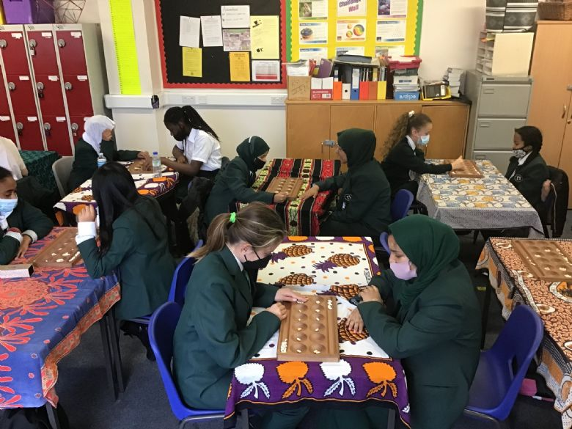
Thanks to the exceptional attitudes of our students and the dedication of their teachers, maths is flourishing at Walthamstow School for Girls. GCSE results are consistently outstanding compared to national averages.
In year 7, students are initially taught in mixed ability groups. During the second half of the Autumn term students are grouped based on their class work, assessments and home learning. Students who have not met standard at the end of KS2 are set in a smaller group from the start of year 7 to provide them with focused support immediately. All groups learn the same core content with targeted extension and support to promote progress for all students. Students in years 7 and 8 are taught in two, year halves of four groups and follow an adapted White Rose Scheme of Work that allows Maths Mastery and interleaving practice to be a focus.
We currently offer a three-year KS4 curriculum where fluency, reasoning, problem solving, and retrieval practice are the cornerstone of ensuring every student makes exceptional progress. Our curriculum is designed so that all sets follow a core set of objectives with key topics over both foundation and higher taught in years 9 & 10 with targeted extension and support to promote progress for all students. Students are encouraged to aim high, so tiers of entry are not finalised until year 11. Department assessments take place at the end of each half term to monitor student progress.
The successful candidate will be expected to teach in every year group and cover the full range of ability levels.
December 2023
