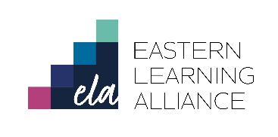

Impington Village College

Person Specification

Teacher of Media and Film

To support your application candidates should be able to show evidence of the following:

Criteria | Essential | Desirable
Qualifications and Experience:
A teaching qualification | √
Honours degree | √
The ability to teach Media and Film to KS3-KS5 | √
Can demonstrate excellent classroom practice | √
The ability to support extra-curricular activities |  | √
Knowledge and understanding :
Knowledge of recent curriculum developments including the reformed GCSE specifications and associated change at KS3 | √
A range of teaching and learning styles | √
Strategies to raise standards of student attainment | √
An effective curriculum to meet the needs to different learners | √
A significant interest in Media and Film that will engage and excite students | √
Leadership & Management skills:
An educational philosophy | √
A commitment to comprehensive education | √
Motivate and inspire both children and adults | √
Potential for leadership | √
Personal & Professional attributes:
Good interpersonal skills | √
Initiative, resilience and stamina | √
Innovation, creativity and critical reflective thinking | √
Good organisational skills and ability to meet deadlines | √
ICT competence | √
A sense of humour | √
An ability to communicate clearly to a range of audiences | √
An ability to command the respect of others | √
An ability to work hard under pressure | √
An ability to share high expectations of achievement and behaviour | √
A willingness and desire to contribute to the life of the College, including offering extra-curricular activities or an iCAS experience |  | √
Safeguarding and promoting the welfare of children
At interview candidates should be able to demonstrate:
Demonstrate the ability to form and maintain appropriate relationships and personal boundaries with children | √
Emotional resilience in working with challenging behaviours | √

