APPOINTMENT PACK

TEACHER OF MFL

Let your light so shine before others, that they may see your good deeds and glorify our Father, which is in heaven. Matthew 5:16


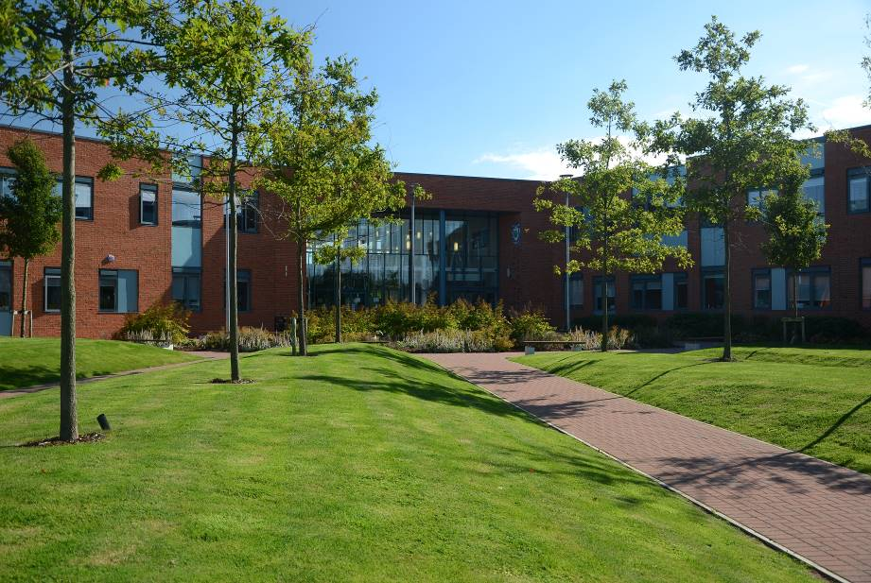
God be merciful to us and bless us: and cause his face to shine upon us. Psalm 67:1

THE SCHOOL
Thank you for applying for the post of Teacher of MFL, at Woodchurch High School Church of England Academy.

We are a highly successful, oversubscribed, state funded Church of England Academy, which is co-educational and covers the 11 – 16 age phase. There are plans to expand to expand the age range of the school to include Key Stage 5 in future years. There are over 1,400 pupils on roll, supported by 109 teaching and 131 support staff. This high staff – pupil ratio results in smaller class sizes and so greater personalisation of learning.

Woodchurch High School is an extremely popular school, attributable to its ‘Established Excellence’ in every aspect; including leadership and management, pupil progress and attainment. In addition, there is an ordered, disciplined environment, and extremely positive relationship within the school, and with parents / carers and the local community.

At Woodchurch High School, we always place pupils at the centre of all we do and this had been reflected in our last five Ofsted Inspection reports (please see the school website to access these reports).

Woodchurch High is committed to providing the best possible education for all our pupils and we work in partnership with parents to achieve this goal. “The staff are exceptional and strive to get the best out of our children; the pupils couldn’t have gone to a more supportive school. It motivates and encourages its pupils to success in everything they do and definitely lives up to its outstanding reputation” (‘A typical positive comment from a parent’. Ofsted)

Success in public examinations is important, as these are the qualifications which are required for further and higher education, as well as for employment opportunities. Our excellent results and the improvements we have sustained in recent years reflect our ability to successfully prepare our pupils for the next phase of their lives. Our pupils make excellent progress, regardless of their starting point; they tell the staff that they like their school and are proud to be part of Woodchurch High School.

To ensure that all our pupils succeed, an extensive enrichment programme is provided including a breakfast club and a homework club. There are additional lessons at lunchtime, after school, during holidays and on Saturday morning.

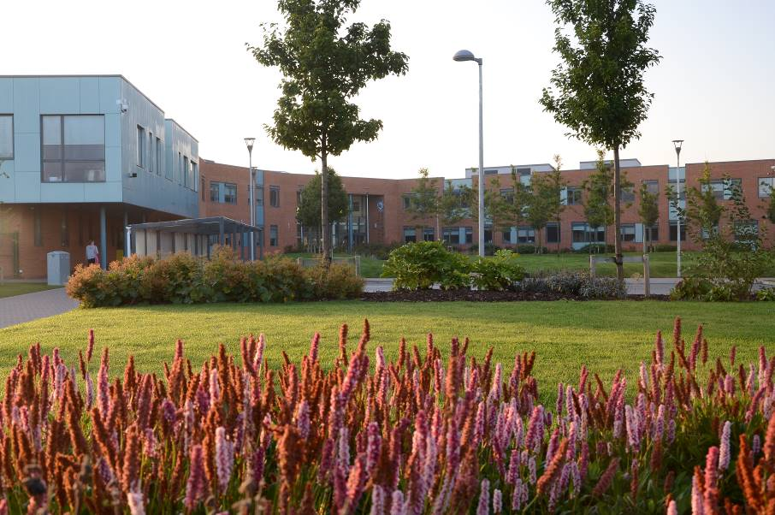

PASTORAL WELFARE
For pastoral purposes the school is divided into year groups. In charge of each year group is a Pupil Progress Leader and
an Assistant Pupil Progress Leader. The year groups are split into 2 bands, X and Y. Pupils are in mixed gender and ability forms of approximately 22. Each tutor group is registered by the same Form Tutor throughout the 5 years. This continuity ensures that pupils, parents and carers can forge strong links and positive relationships with the key pastoral staff.

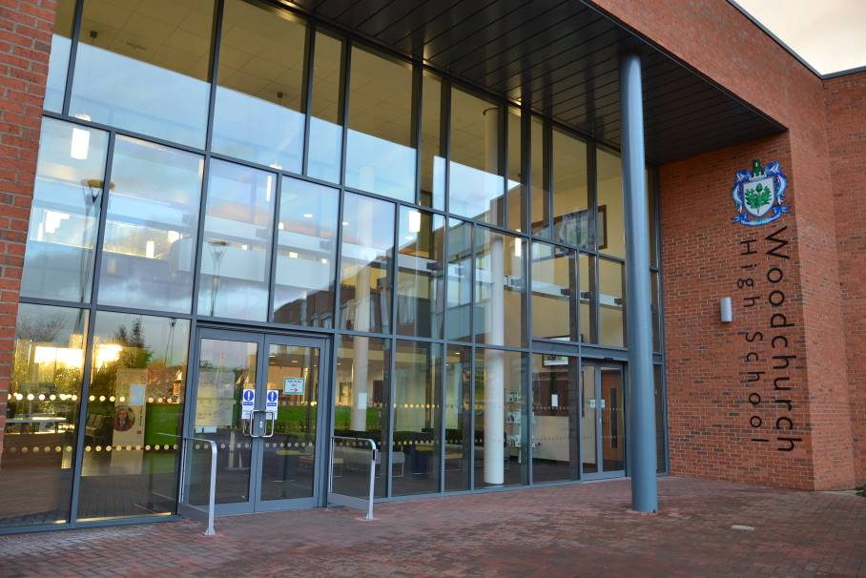

PUPIL VOICE
Pupils regularly evaluate lessons and are included in whole-school decisions, such as the appointment of staff. In addition, there is a strong School Council, comprising of representatives from each Year Group. The Head Boy / Head Girl and Deputies also attend Full Governors meetings, when appropriate, at which they make a valuable contribution. Pupils also regularly comment on curriculum subject via online polls/surveys.

In this way pupils are motivated to achieve, develop self-awareness and empathy skills, and so manage their own feelings and have good social skills. In addition, school now also undertakes peer mentoring and support to further enhance pastoral welfare.

The pastoral support means all pupils have the benefit of the facilities and curriculum of a large school, and at the same time, enjoy the same supportive organisation associated with a small school.

COLLECTIVE WORSHIP
Each day all pupils take part in Collective Worship unless withdrawn by their parents. As a Church of England Academy, we believe it is important to promote the spiritual, moral, social and cultural development of our pupils and to prepare them for the opportunities, responsibilities and experiences of adult life.
BEHAVIOUR FOR LEARNING
We believe an ordered, disciplined atmosphere is the best environment for learning. All our school rules are based upon the simple principles of self-discipline and mutual respect. We place great emphasis on the positive aspects of behaviour by rewarding pupils with praise in lessons, IRIS rewards, letters of commendation and prizes for effort and attainment in all subjects. We also promote good attendance by presenting prizes and certificates to pupils achieving 100%.

We hold an annual Awards’ Celebration when pupils are presented with their prizes. This is always an enjoyable event encompassing the musical and cultural talents of pupils which are shared with parents / carers and the community.

Pupils devised their own code of conduct, putting them at the heart of all we strive to do as a school.

CHAPLAINCY
As a Church of England Academy, we are affiliated to the Diocese of Chester.

Our Christian ethos makes the school distinctive, as it fosters certain characteristics and aims, which form the basis of daily life and all we do. The Christian Values, which the school promotes, serve to reflect a fully inclusive approach with strong pastoral support for all pupils and staff, good opportunities for reflection, the encouragement of strong personal relationships, respect for all and celebration of
diversity within the school family. Work of the Chaplaincy Team underpins all of this work in the school community and beyond.

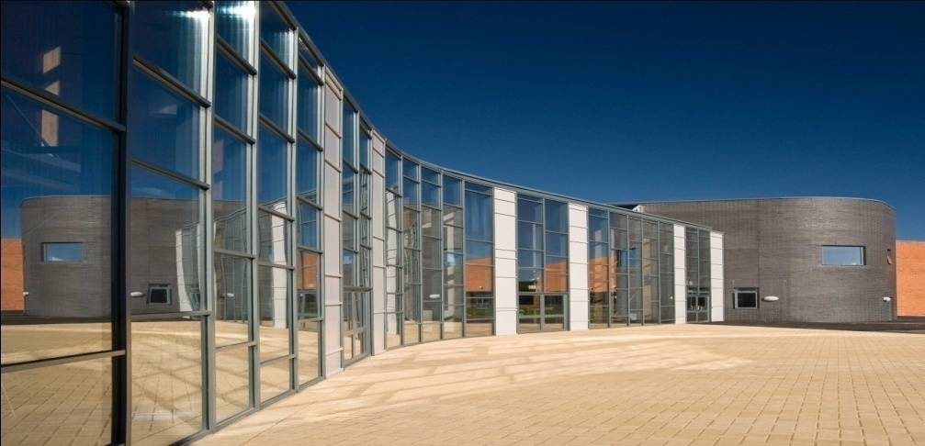

Our Christian Values are:
- Justice
- Endurance
- Service
- Wisdom
- Forgiveness
- Compassion
- Hope
- Thankfulness
- Integrity
- Humility
- Trust

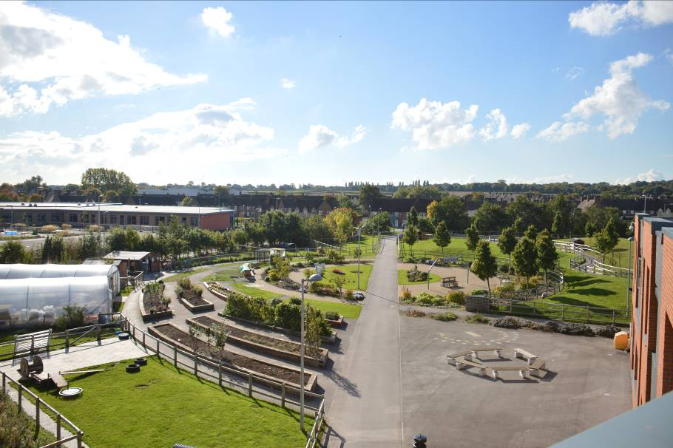

INCLUSION
We are committed to ensuring that every pupil in our care is given an equal opportunity to develop socially, to learn and achieve, and to enjoy community life at Woodchurch High School.

To achieve these aims we:

- Develop strong links with our primary school partners to support transition
- Deliver a curriculum appropriate to each child’s individual needs
- Put in place strategies to ensure that all pupils, including those who face barriers to learning and those who are able make progress
- Work in partnership with external support services to ensure a total care package is provided.

A BASE FOR PUPILS WITH AUTISTIC SPECTRUM DISORDER
Woodchurch High has special provision for pupils who have Autistic Spectrum Condition. Our policy is that pupils follow a bespoke learning programme combining small group social skills classes with mainstream lessons, if necessary with the help of Teaching Assistants.

PUPIL PREMIUM
At Woodchurch High School 42% of our pupils access pupil premium funding. The Pupil Premium team lead initiatives
through the school and monitor and evaluate the success of programmes and interventions. Please refer to our website for further details.

OUR FACILITIES
Our school building was opened to pupils in September 2010, and officially opened by the Archbishop of York Dr John Sentamu in March 2011.

The state of the art faculties enables our pupils to experience a 21st Century education. The cutting edge ICT facilitates their learning so that they can participate, enjoy and achieve their full potential.

The school grounds have also been redeveloped as part of this build and include a third generation all weather pitch as well as flood-lit multi-use games areas. These facilities are in addition to a well resourced built Sports Hall. This houses a dance studio, fitness suite and indoor sporting facilities, used for football, badminton, basketball etc.

There is also a well-established School Farm and environmental area.

We look forward to meeting you in the near future.

Yours sincerely

Ms R Phillips
Headteacher
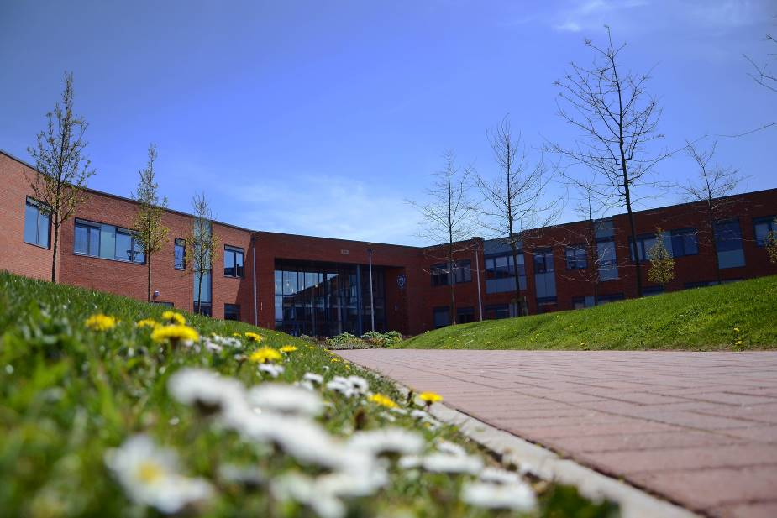

THE ROLE

We are looking for a candidate who can support us to build on our strengths and make a significant difference to our everyday practice as well as pupil outcomes.

We need someone who is highly effective and a forward thinking and creative practitioner, who is dedicated to raising standards for each pupil and improving life chances.

We are looking for a candidate of the highest calibre, with a proven track record and innovative approaches to teaching and learning.

We will be looking for a candidate who can demonstrate:

- Integrity, drive, vision, enthusiasm and ambition
- A willingness to work hard
- Creativity and innovation
- A commitment to meeting the needs of all pupils and all ability ranges.
- The ability to promote the caring ethos of the school
- Outstanding interpersonal skills
- A commitment to intervention, extracurricular activities and community liaison

- An enthusiastic teacher with excellent subject knowledge
- Committed to raising attainment of all pupils
- Able to teach Spanish to GCSE and French to KS3

THE SUBJECT

The Curriculum Area is a well organised and effective team whose teaching and support enables pupils to achieve their full potential. We offer a range of teaching strategies which are suitable for the pupils and that challenges them to expand their knowledge and skills within the subject. Our pupils are encouraged to be ambitious in the work they produce and are given the opportunity to develop skills that they can use across the curriculum.

Within lessons, pupil’s individual needs are catered for as teachers are expected to vary the teaching and learning techniques they use. This allows pupils to work independently and as part of a team to develop deeper understanding of the topics which are covered.

STAFFING
There are currently five full time members of staff and one part time member of staff working in the Curriculum Area. The Curriculum Area is also keen to welcome Associate Teachers from a variety of institutions and welcomes other visitors, such as those seeking to start a career in teaching.

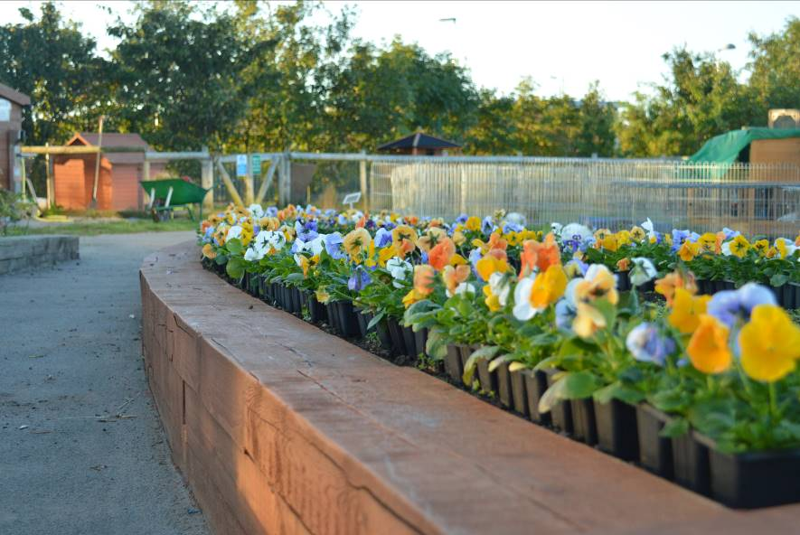
CURRICULUM – KEY STAGE 3
At Key Stage 3, pupils follow the programme, as detailed below:
Year 7:
My family and I
My studies
My home
Free-time
Holidays

Year 8:
Media and technology
My town
Tourist Information
Fashion
Food

Year 9:
Festivals and birthdays
Healthy Living
Art & Music
Careers and ambitions
The environment
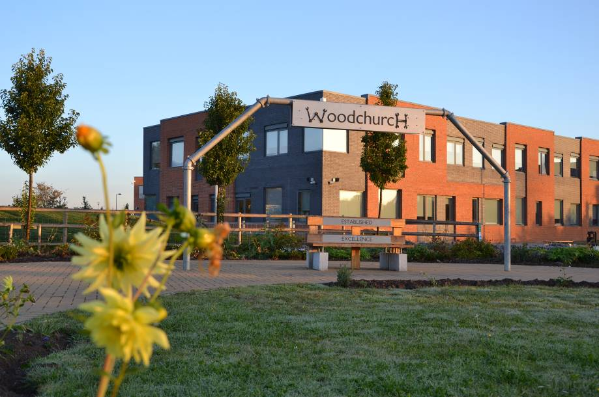

CURRICULUM – KEY STAGE 4
At Woodchurch High School, Key Stage 4 begins at the start of Year 10.

At Key Stage 4, pupils follow the programme, as detailed below:
Year 10:
Me, my family and friends
Cinema, TV, music, sport
Technology in everyday life
Customs and festivals
Home, town, neighbourhood and region
Healthy and unhealthy lifestyles

Year 11:
Travel and tourism
My studies, life at school, education post-16
Jobs, career choices and ambitions
Social issues & global issues
Relationships, marriage and partnerships

This programme is accredited by AQA.

Schemes of work in both Key Stages are fully interactive and we strive to help our pupils be aspirational so that they can develop their mathematical skills and talents and achieve their full potential.

Each year is split into two bands and there are 4-5 groups in each band in Key Stage 3 and 4-6 groups in Key Stage 4. Average set size in Key Stage 4 is 20 pupils.

Where setting is used, pupils are grouped according to their language ability and sets are reviewed every term.
All pupils’ progress is monitored to trace their periodic assessments against age related expectations. Relevant intervention will be put in place if required.

RESOURCES

The school is extremely well equipped with six dedicated MFL rooms and bookable laptop trolleys available. All rooms have interactive technology and are equipped with SMART boards. All computers have the Google Suite, Adobe CS4 and many other software packages including Scratch and Audacity. The Curriculum Area makes full use of the application within Google Suite the school has to support work both in classroom and at home. This allows students to complete homework as well as housing Schemes of Work and revision resources. We have a dedicated Technical Team who support teaching and learning within lessons.

Members of the MFL Curriculum Area are supportive and friendly working well with each other as well as other staff within the school.

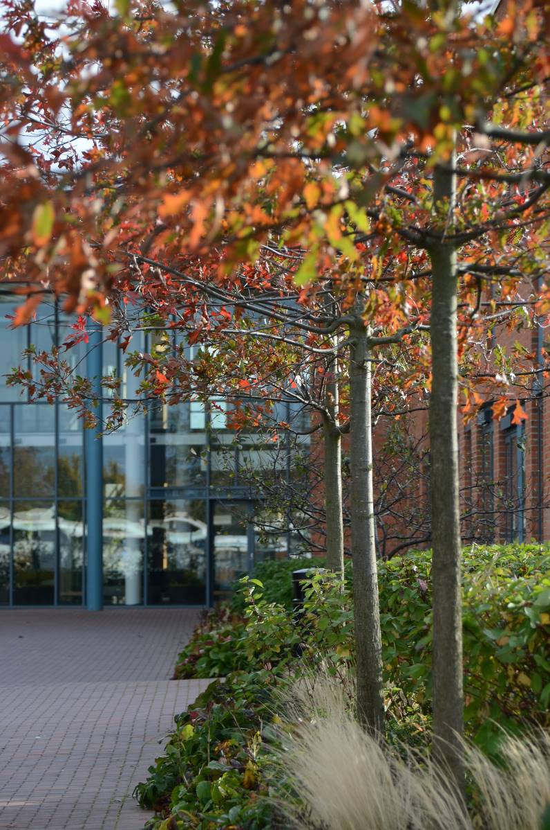

MAKING YOUR APPLICATION

Please complete the application form provided with this information pack and attach a covering letter which should address the following issues:
- Your ability to communicate with pupils, in an inclusive school environment, in a way which promotes their academic spiritual and social development, and their personal welfare.
- Your understanding of the role of tracking/monitoring systems to identify pupils’ academic progress.
- Describe how your teaching and learning strategies have both motivated and raised the achievement of students across a range of abilities.

Please email your application to: whsrecruitment@woodchurchhigh.com

Deadline for completed application: Monday 16th May 2022, 9.00am

If you would like to discuss your application, please contact: Ms R Phillips rebekah.phillips@woodchurchhigh.com

