

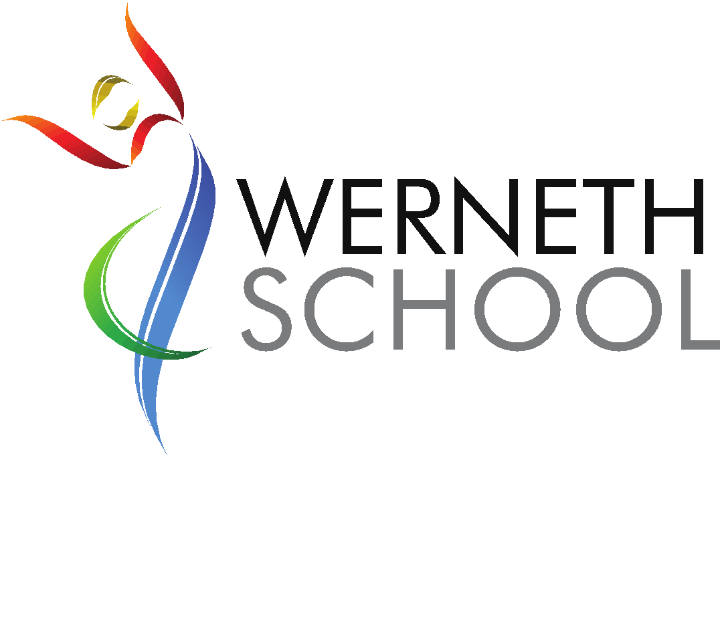
Directorate: Children & Young People

Service: Secondary School – Werneth School
Post Responsible to: Headteacher
Grade: Mainscale

(Postholder must attain Enhanced DBS Certificate)

Main Purpose of the Job:
You are required to carry out the duties of a school teacher as set out in paragraphs 37-40 (inclusive) of the schoolteachers' Pay and Conditions document l995.

You are required to carry out such particular duties that form part of sub-paragraph ll and 12 of paragraph 39 of the l995 document as the Headteacher may reasonably direct from time to time.

The person appointed to this post will:

- Be a qualified teacher educated to a standard equivalent to degree level to enable them to teach their subject confidently and accurately at KS3 and KS4.

- Have a secure knowledge and understanding of the subject content, level descriptions and end of Key Stage descriptors specified in the relevant National Curriculum in order to effectively deliver the programmes of study for KS3 and KS4.

- Create a purposeful working environment in which to deliver well-planned, interesting tasks, which motivate and stretch pupils.

- Be able to identify pupils who have Special Educational Needs, are very able or are not yet fluent in English and be able to apply the SEN Code of Practice in the management of their education.

- Exploit opportunities to improve pupils' basic skills in literacy, numeracy and ICT.

- Plan opportunities to contribute to pupils' personal, spiritual, moral, social and cultural development.

- Follow the school's policies as laid down in the Staff Handbook, e.g. Equal Opportunities, Health and Safety, Assessment, Recording and Reporting, Pastoral Care and Bullying.

- Take responsibility for their own professional development as identified by the Performance Management process.

- Set a good example to the pupils they teach through their presentation and their personal and professional conduct.

- Understand the role and purpose of the school governing body.

