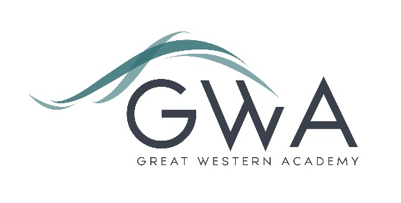

Information for Applicants

Teacher of MFL (French) (start date 1st Sept 2024)
(Full or part-time)
Great Western Academy opened in September 2018 and now accommodates over 900 students in years 7 to 11 and the Sixth Form. The results of our first three A-level cohorts in summer 2021, 2022 and 2023 were excellent and enabled 98% university applicants to take up their offers, including three to Oxford and Cambridge; students have also secured prestigious apprenticeships with companies such as Airbus and Rolls Royce. Our first GCSE results in summer 2023 showed that the progress made by the large majority of our first cohort of year 11 students has been excellent, particularly in English and Maths. This includes students of all abilities.
The foundations we have laid in languages are excellent: our current teachers have set up an innovative provision, exploiting the fact that every student has a laptop to assist with their learning; students are enthused by their language lessons and we have an excellent take-up at GCSE Spanish and French, including many double linguists. The faculty underwent a very successful ‘Deep Dive’ last year as part of a strong Ofsted inspection.
The role will provide the successful applicant with the chance to further develop and teach an exciting curriculum in KS3 and KS4 as well as teaching A-level if desired. You will need to be able to teach French to KS4 (ability to teach A level would be an advantage) and ideally Spanish to KS3 level. You will be part of a dynamic and growing teaching team and you will therefore have the chance to significantly shape the experiences of our students in the subject as they progress through our growing school.
An applicant’s briefing pack with full information about Great Western Academy and the role is available on the GWA website at http://www.gwacademy.co.uk/joining-us/vacancies. If you have any questions prior to application you are very welcome to contact us.
Application process

Please complete the application form supplied and enclose a supporting letter, either in the space provided on the application form or as a separate document. The application form should be completed in full in black ink or type. A CV is not required and should not be submitted as part of the application.

Your supporting letter should be no more than 2 sides of A4 (with a font size no smaller than 11) and should enhance your application by providing further information, matched to the person specification, about your suitability for the post. This should include evidence of the impact on student outcomes you have made in your career to date.
Electronic applications should be returned via email to recruitment@gwacademy.co.uk .

Closing Date: 9am Wednesday 1st May 2024. However, we will review applications as they come in and may close this vacancy early, so please don’t delay your application. Interviews will take place as soon as possible. The interview process will include observation of teaching, and a variety of other tasks and activities.
Great Western Academy is committed to safeguarding and promoting the welfare of children, young people and vulnerable adults and we expect all staff to share this commitment and undergo appropriate checks. All posts within the Trust are therefore subject to an Enhanced DBS and barred list check.

References: References will be taken up prior to interview.

