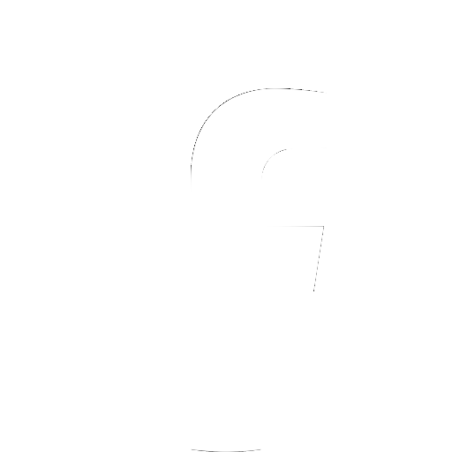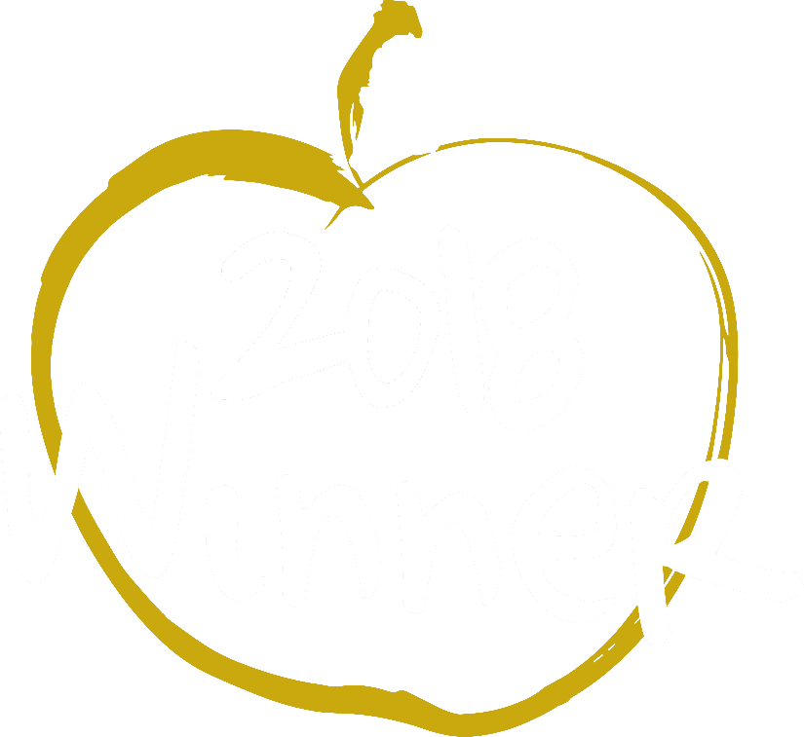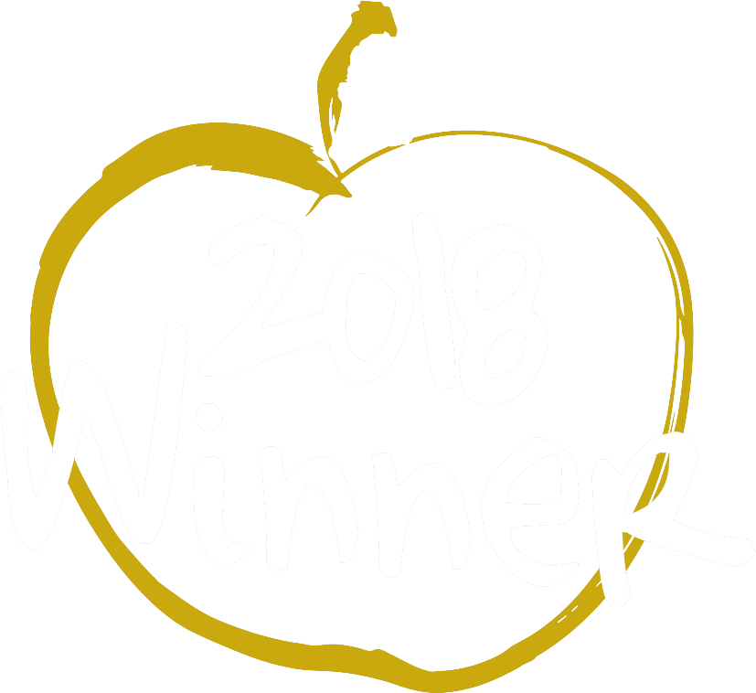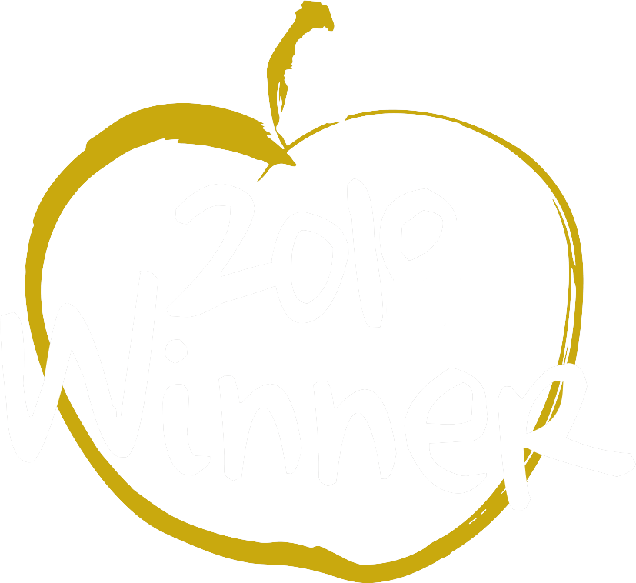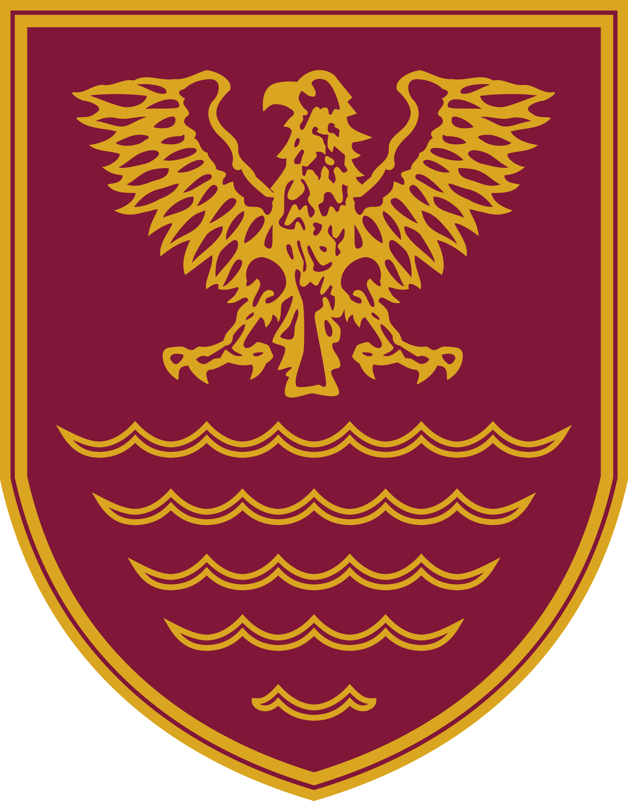

# Teacher of Modern Languages – French

Required from 1st September 2022 as a permanent position.

*We are looking to recruit an enthusiastic teacher of French to join our successful, growing and vibrant modern foreign languages department.*

*’Relationships throughout the school are excellent.’ Ofsted, 2018.*

*The teaching of modern foreign languages is a real strength of the school. Students enjoy the subject and do extremely well.*

*The candidate should have the ability to deliver French in Key Stages 3 and 4, with a desire to teach A level French in Key Stage 5.*

*‘There is great mutual respect between pupils and their teachers.’ Ofsted, 2018.*

*The school is located on the fringe of the Lake District National Park; a great place to live and work.*

*‘The supportive and can-do culture in classes inspires pupils to learn.’ Ofsted, 2018.*

*If you require any further information, please contact the Headteacher, Mr David Tromans on:*

***Tel:*** *01900 813434*

***Email:*** [*d.tromans@netherhall.cumbria.sch.uk*](mailto:d.tromans@netherhall.cumbria.sch.uk)

***Closing date for applications: Monday 28th February, 2022***

***Interviews to be held on: Week beginning Monday 7th March, 2022***

*References will be requested before candidates are called for interview.*

*Netherhall School is committed to safeguarding and promoting the welfare of young people and expects all staff and volunteers to share this commitment.*

*The successful candidate will be subject to pre-employment checks including an enhanced DBS (CRB) check.*

‘*Staff and pupils say, without question, the Headteacher has been an inspiration, giving them belief that all can achieve. Throughout his tenure, the Headteacher has demonstrated passion, integrity and highly skilled leadership. This school has been transformed in a remarkably short period of time.’*

Ofsted, February 2018.

Netherhall School

An Ambitious, Caring Community

##### ‘Pupils love coming to school’ | ‘Pupils are proud of the school’ - Ofsted, February 2018

#### BEST SECONDARY SCHOOL 2018

#### BEST STUDENT & BEST TEACHING PROFESSIONAL 2019

**Find us on Facebook: @NetherhallSch**

[www.netherhall.cumbria.sch.uk](http://www.netherhall.cumbria.sch.uk)